FILL-SMOKE CONES TEXT
Black Swan® introduces
World’s First Herbal “Fill-N-Smoke”
Pre Rolled Empty Cones
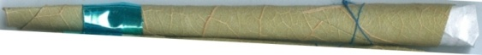
Bigarette & Co. is the world's first to offer most innovative herbal pre-rolled ready to use empty smoking cones or blunts simply based on “Fill-N-Smoke” concept, branded as Black Swan® “Fill –N- smoke” cones. Fill-N-Smoke cones, wrappers or Pre Rolled Empty Blunts are Purely Herbal unprocessed Top Quality Tendu leaf (Indian Ebony). Tendu is one of the most important herbal/Natural non timber forest products cultivated in deep forests of Central India and popular in smoking due to various characteristics; unique even and slow burning (burns much slower than a cigarette paper) flavorless, and it is best described as a non tobacco herbal wrapper.

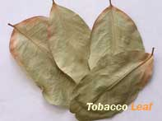
Black Swan® have introduced first time a revolutionary new slow burning empty cone (smoking wrappers) in a natural and Herbal leaf, which is not homogenized or tobacco leaf, it is purely natural unprocessed readymade pre-rolled smoking concept, ready to use cones are prepared on just “Fill N Smoke concept”, technically hand rolled and air tightens without any adhesive. They’re NOT a rolling paper and they’re NOT a cigarette tube! They’re a totally new concept in smoking – “Herbal Leaf Cones”

World’s most cost effective smoking option (Pre –Rolled Cones)
The concept of Empty Pre-Rolled Cones or Blunts in natural tendu leaf simply based on "Fill-N-Smoke Concept" means pack your favorite blend and smoke. We have come up with this innovative product because a lot of our smokers requested us to offer different flavors in different blends, for this we came up with this innovative idea to manufacture and offer herbal flavored empty pre-rolled cones in all the flavors; now tobacco smokers have a wide and open option to smoke and enjoy any flavor, specially pheromone blend, in his own choice of blend.
This open option in pre rolled cones is the most cost effective and wide option for both tobacco smokers as well as herbal mixture smokers, as we have offered pre rolled cones in two types; Natural as well as flavored, if a person wish to have his blend like Mild Seven, Rothmans, 555, Dunhill or any blend (loose tobacco of that brand is widely and easily available in the market) can enjoy his cost effective blending in Natural Cones and if a smoker is interested to enjoy flavors for them specially flavored pre-rolled cones are available as the most cost effective smoking option.

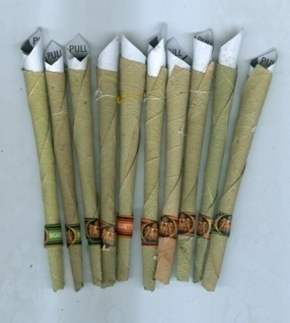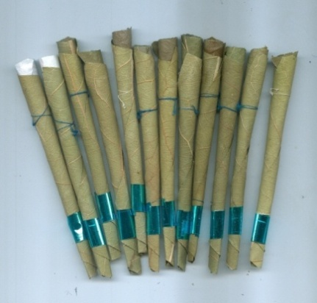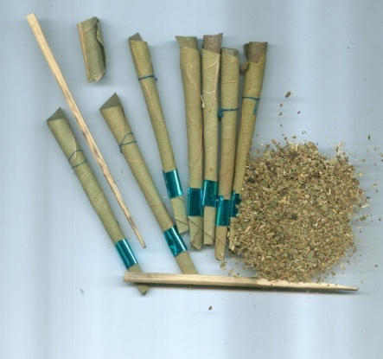
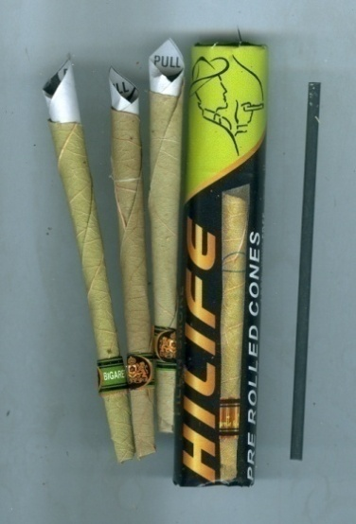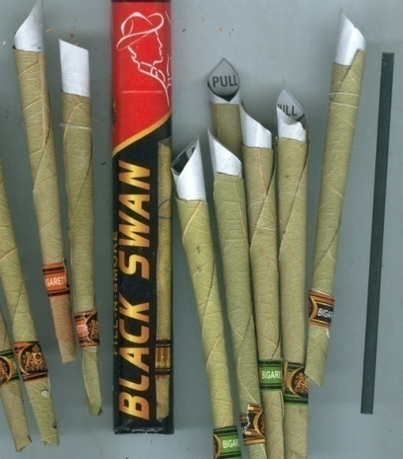

Why Herbal Empty Cones: A very cost effective smoking option offered as Empty cones in Tendu due to its various characteristics; it corresponds very well with the taste of filled smoking mixture, quality of tendu leaf is to create a good balance between the various characteristics of smoking mixture without leaving any taste of tendu leaves on blending, another great quality of tendu leaves is even burn quality and a good aroma, due to its herbal quality is not harmful like paper, because when cigarette burns, along with cigarette obviously paper also burns, paper on burning releases carbon monoxide and so many other harmful chemicals and substances which are more harmful, another reason paper also leaves its effect on the blending of smoking, for this reason we have especially offered pre rolled cones in Natural “Herbal Tendu Leaves”.
GENERAL INFORMATION on Tendu Pre Rolled Cones.
- Tendu Pre rolled Blunts or Cones are natural, Herbal and unprocessed wrappers
- It corresponds well with the taste of filled smoking mixture
- It creates a good balance between all characteristics of every smoking mixture
- Unfiltered Blunt Wraps are more enjoyable than the filtered one and the end tip are especially developed to hold back smoking mixture.
- It does not leave any taste of the wrapper while smoking.
- It has a great smooth even burn quality and with a good natural aroma
- It burns slower so that the burn rate would match Cavendish tobaccos
- It’s much less harmful due to its natural and herbal quality
- It does not emit carbon mono oxide on burning like paper
- Tendu leaf has a minimum of ash
- Pre naturally rolled without glue or any adhesive
- No saliva is required for sealing the cone as it already air tighten and technically rolled
- Pre rolled cones are simple, ready to use, natural, sturdy and Herbal
- Each Pack comes with a little stick that is dead useful for packing your smoking mixture into the readymade cones
- Tendu wrappers pre-rolled cones are also available in different flavors
- The flavored rolled are offered keeping in view smoker’s common complaint about the burning sensation on the throat or tongue after 3/4 blunts.
- Flavored pre rolled blunts are available in different Flavors; Kush, Grape, Musk, Saffron, Vanilla, Cherry, Pineapple, Mango, Melon, Kool (mint), Clove (Hot) and a unique pheromone blend “Temptation” and Just-ONE.
- In flavored rolls, you just lick your lips after 2/3 puffs and the nasty taste goes away and is replaced by the wonderful flavor.
- The flavored cones are most through the favorably and protectively packed.
- Each cone is hand-made and packed individually to preserve the unforgettable flavor.

More about Herbal Empty Pre-Rolled Cones / Blunts or Rolls?

Black Swan® cones or Blunts are one of the most favorite and innovative herbal cones of the smoking world, prepared on “Fill N Smoke” concept. Revolutionary new smoking cones are unique and technically hand rolled by skilful people; however rolling in such a shape is a difficult and messy process for everyone, for this Bigarette & Co. offered instant solution of this problem as Pre-rolled cones. The pre-rolled Black Swan® long conical shape allows the user to easily place their smoking mixture within the cone with no spillage. The cones are unfiltered but the smoking tip is technically made to hold back the smoking mixture. Each cone is long conical in shape, about 8 CM (80 MM), long enough to hold required smoking mixture.
The Products (Types of Pre Rolled Cones)
1. Un-Filtered Rolled Fill-N-Smoke Cones
Importance of Unfiltered tips of Empty Rolls

Cones are offered unfiltered but specially designed and technically built smoking tip act as perfect filter. Smokers says the pleasure of unfiltered pre rolled Blunt Wrap is more enjoyable; it tastes better than the filtered one, because tar and nicotine gets accumulated in the lower part of the wrap, in this case, the tobacco present in the lower end acts as a filter. The matured taste grows more and more with each puff, smoker says “The last puff is really the most enjoyable puff which is unexplainable”.

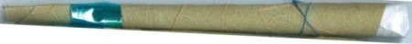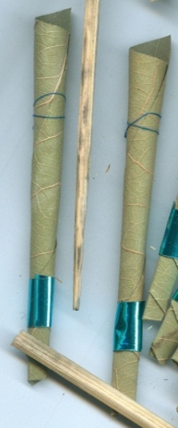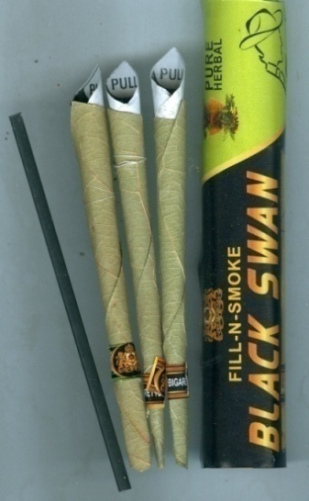

2. Filtered - Fill-N-Smoke Cones

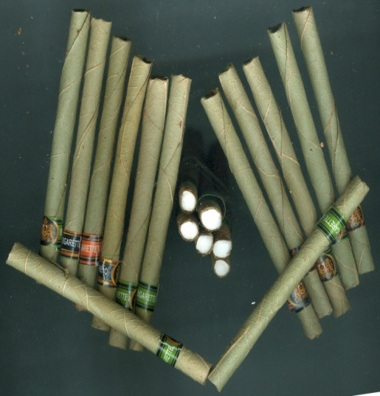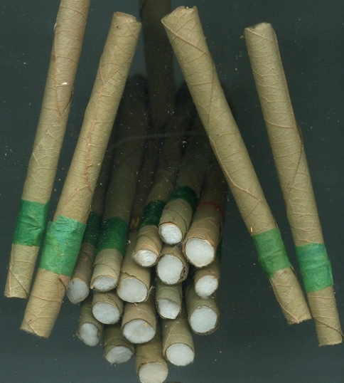

Filtered Fill-N-Smoke Rolls (Empty Rolls)

Filtered Rolls are also offered in Tendu leaf filter as well as like a normal cigarette filter which are offered as tube pack as well as economy pack.

Both types of above rolls are available as natural as well as flavored
1. Natural Pre Rolled Fill-N-Smoke Cones
2. Flavored Pre Rolled Fill-N-Smoke Cones
3. Most Innovative Pheromone and Temptation Fill-N-Smoke Cones

Natural Pre Rolled Fill-N-Smoke Cones

Black Swan® is the world's first to offer natural herbal pre-rolled and ready to use tendu smoking cones in its natural herbal aroma. Natural Empty cones are Purely Herbal unprocessed Tendu leaf (Indian Ebony) revolutionary new slow burning empty cone (smoking wrappers) in a natural and Herbal leaf, which is not homogenized or tobacco leaf, it is purely natural unprocessed readymade pre-rolled, ready to use smoking concept based on “Fill-N-Smoke” concept. Natural rolls are flavorless but give a unique herbal aroma in smoking; it is best described as a non tobacco herbal wrapper.

Flavored Pre Rolled Fill-N-Smoke Cones

Black Swan’s Empty pre rolled flavored cones is the latest improvement in smoking! Black Swan® is the world's first to offer flavored tendu cones or pre-rolled empty blunts. Flavored cones are offered keeping in view smoker’s common complaint about the burning sensation on the throat or tongue after 3/4 blunts.
In flavored rolls, you just lick your lips after 2/3 puffs and the nasty taste goes away and is replaced by the wonderful flavor, a wonderful flavor which keeps you licking your lips and wanting more!
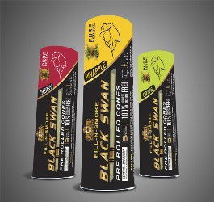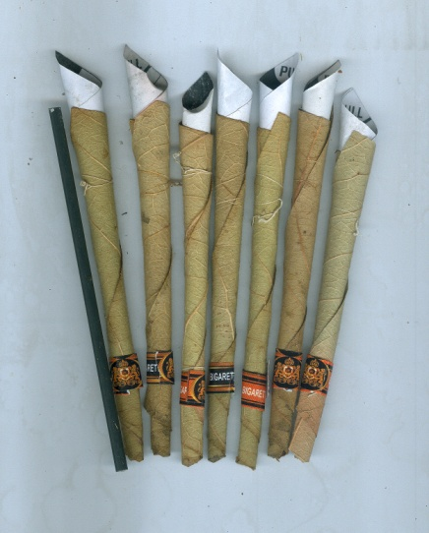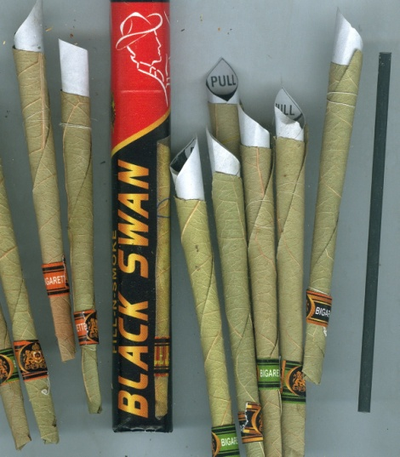

199 - Exotic Flavors are available to enjoy (You just name it, we have it!)
Fruit, Flower, Herbal and Tobacco Flavors available like Kush, Grape, Pineapple, Musk, Saffron, Clove, Vanilla, Cherry, Mango, Melon, Kool, (Mint) with unique flavors like “Just-ONE, Enigma, Temptation and a unique Pheromone Fill-N-Smokes are available to enjoy Unique Flavored Smoking!
Flavored Empty Cones are 100% pre-rolled, each cone is hand-made and technically rolled however to give flavor to a natural leaf is again a difficult task and messy process, but Black Swan® has specially offered ready to use Pre-rolled flavored cones and packed carefully in an air sealed tube to preserve the unforgettable flavor.
Brief about Innovative Pheromone and Temptation Fill-N-Smoke Cones - Pheromones have received a lot of attention in recent years, which inspired us to offer fill-N-Smoke cones based on the Pheromones theory of Herbal Science. The smoke is based on the theory of “The world of attraction” or the “Law of Attraction”. The blending and formulations and giving flavor to this product is based on World’s ancient therapeutic methods, the medicine of ancient India – Ayurved and Unani Herbal Methods.
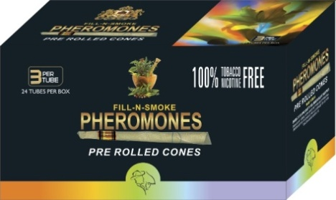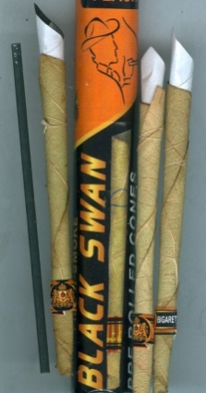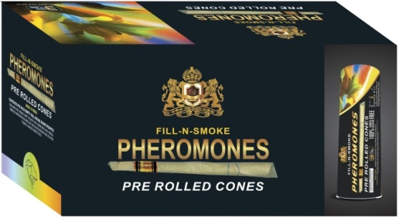

(Brief about Pheromones: Pheromones are odorless chemicals, or signals excreted or otherwise introduced to the environment by human beings which sends subconscious signal to same species and intends to communicate something or induce some specific kind of response from same species, by this people can develop their ability to express complex thoughts easily).
http://www.herbalsmoke.in/short-intro--pheromones.html
As the ingredients of Pheromones, we have used extract of some exotic, potent and aphrodisiac herbs and gave flavor to these cones; on smoking the herbal extract acts on certain bio mechanism to act on libido and enhances production of Pheromones or such secretions/ chemicals in the smoker’s body, also helps the body and mind by increasing brain function, enhance concentration and promote mental clarity. Simply more secretion of pheromones means more messages to the environment or more signals to subconscious minds, these signals intends to communicate and stimulate specific kind of response from same species.
How this Smoke Works (Pheromones & Smoking………?)
This product simply acts on the same principles of smoking and flow to entire body through the blood stream. By releasing or excrete more pheromones sends more positive silent messages and play a major role to change other’s behavior and brain psychology. Smoking aphrodisiac herbal extract acts same for both the sexes and maintains physical attraction by enhancing production of pheromones, bio-chemicals or such secretion in the body which develops body appearance, confidence and physical attraction especially acts to attract the opposite sex.
This is one of the unique herbal smoking options ever offered. Pheromone Blend works amazingly on the theory of pheromones, we are confident the unique pheromone blend will disclose all the secret of Attraction with a holistic approach to overall personality development.
Packaging:
All Pre-Rolled Smoking Cones (3 Per Tube Pack) - Black Swan Pre-Rolled cones or Empty Blunt Wraps are 100% pre-rolled and packaged in an air sealed tube (3 Cones in a Tube) to ensure lasting freshness. Easy filling tips “How to Fill” is inserted in each cone, which shows how to “Fill-N-Smoke”. A hard plastic stick packing tool is made available in each tube for easy filling and packing of your favorite smoking mixture. It is packed in a reusable tube which can be used as a snuffer or to extinguish the smoke end. Black Swan Cones packed as 3 There are 3 Cones are packed in each tube, 24 tubes per box (72 Empty Pre Rolled Cones per Box).
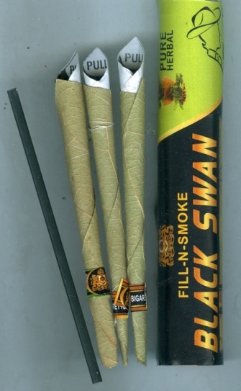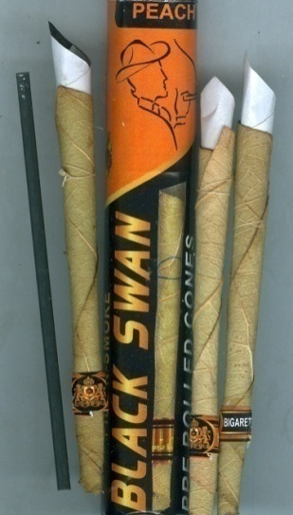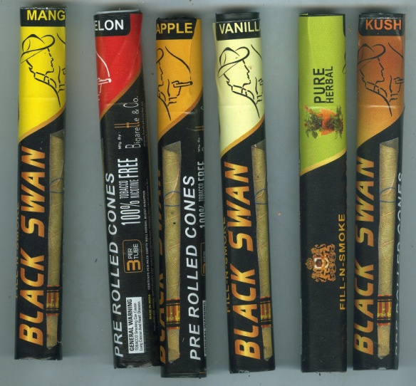

Natural Pre-Rolled Smoking Cones (100’s Multipack OR Economy Pack)
Multi pack is an economy solution pack of pre-rolled smoking cones or blunts, both the types Natural as well as the flavored, are offered as economy pack also, which are packed as in a freshness-guaranteed air tighten box of 100’s. The advantage of this economy pack is; this is economic as well as time consuming too, you can fill all the cones at once and drop it back in its box and smoke it when required.
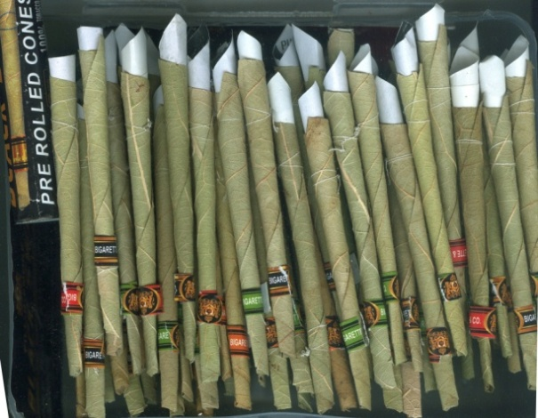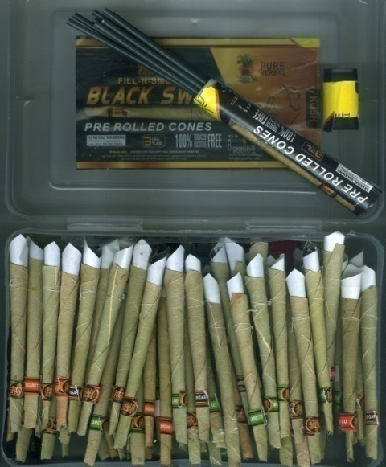
At Black Swan Collection, we carry a variety of quality cones which have an open option to wrap your favorite blend smoking mixture in different option of flavors. Not only this method proves to be cheaper than buying cigarettes but consumer tends to like the fruity flavored taste. These wrap make your smoking even more enjoyable because tendu cones possess unique slow burning quality.
Prices:

Business Terms and Conditions

Retail Customers
Herbal Smoke – Terms, Conditions and Delivery instructions for Retail Business
- Buying Process: Buyer may contact through our website in order to buy any product, by registering on the emails; info@bigarette.com or rich@bigarette.com.
- Payment method: 100% Payment with Order Confirmation.
- All the payment made on our website is completely safe and we never sell your personal information to anyone.
- SHIPPING & DELIVERY TIME: We Ship worldwide for individual orders, delivery time varies as per the distance normally one to two weeks.
- We never re-bill unless you re-reorder.
- All the Laws will be applicable as per the country policy.
- Return Policy: If you are not satisfied with your purchase, you can return any unopened, undamaged item for refund within 30 days of receipt of your order. Shipping charges are not refundable.
- None of Our Products are for Sale to MINORS.
- Adult signature is required on delivery.
- Minimum Order Quantity for retail Shipment – ONE CARTON.

Wholesale/Bulk Customers
Black Swan is always eager to conquer new territories worldwide and looking for new business alliances that can market our pure herbal smoking quality products. We are confident; this is the next generation smoke. We welcome new business partners, (Retail and wholesale) distributors around the world.
Terms and conditions for Wholesale/Bulk/Distributor or Business Alliance
You must comply as under;
- You should have a valid Business Resale License and physical retail store.
- You should have a valid business listing in the phone book.
- You should have a valid business address and credit card to place orders
- You should have to meet our minimum purchase order requirement of $5000.00
- We can also consider on-line merchants under certain conditions only
- You must be over 18 years to make any business order with us
- As a Wholesaler/Bulk Purchaser/Distributor or as Business Alliance you have to complete all the necessary government formalities and complete required approvals of your province to sell the product.
- For traders we can print or put stickers of "Statutory Warning" as per the Country requirements (If required).
- No Claims should be made on BIGARETTE & CO. for Black Swan Herbal Smoking Products due to customers’ country policy.

Wholesale/Bulk Pricing

All Wholesale and Retail Customers must understand that we have displayed both the prices. This varies on ordered quantity and different terms and conditions. To get more information on bulk orders or to know more about our wholesale and bulk prices, you may contact us at info@bigarette.com or rich@bigarette.com, the concerned representative from Black Swan Herbal Smoke will be in touch with you shortly by phone or e-mail to answer all your questions.
If you are having a problem placing an order, or simply feel more comfortable placing an order by phone, feel free to contact us on direct number (India’s Day time only) +91-9760-931-000. Anytime before or after this you can mail us and a representative will return your mail as soon as convenient.
Contact Information

BIGARETTE & Co. (Herbal Smoke)

Postal Address: P. O. Box 10, Rampur (UP) PIN – 244901 India
Head Office: 27- Peela Talab
Rampur - Uttar Pradesh, PIN- 244901, India
Tel : +91- 595 – 2327900, Fax : +91- 595 – 2326700
Mobile : +91 – 9760-931-000
Websites: www.herbalsmoke.in and www.bigarette.com
E-mail : rich@bigarette.com, OR info@bigarette.com
………………………..

