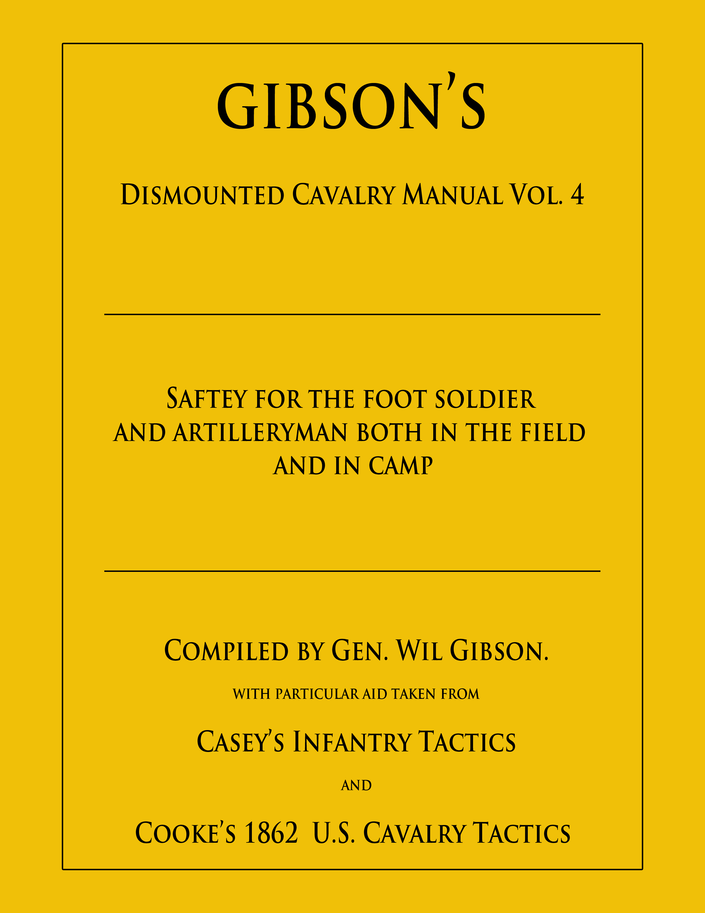

From the Desk
of the
Ordinance Officer

From the Desk of the Ordinance Officer
by Bart Saunders
edited by WRGibson
Artillery Safety
“KA-BOOOOM!”
“Service the piece…”
“Aye, aye sir. Vent on!”
“Vent on.”
“Sponge…,”
“Captain…, Yankees are advancing to our right ‘bout 300 yards out sir.”
“I see ‘em Corporal. Tell the Powder Monkey to prepare a stand of grape, followed up with double canister and stand by. Load and hold.”
“Aye, aye sir.”
“Captain…, the Yankees are at 200 yards.”
“Captain…, ready to fire sir!”
“Trail left, train, and stand by… at 100 yards we’ll fire. Is that double canister ready?”
“Yes sir!”
“They’re closing to 100 yards now sir…!”
“Clear the hubs… Fire!”
“KA-BOOOOM!”

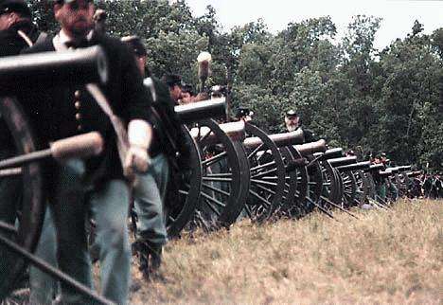
135th Gettysburg

By now I’m sure you have recognized some differences between cavalry and artillery commands on the battlefield. In a cavalry unit with flying or horse artillery attached, such commands are common place.

With reenacting growing in many ways – increasing membership is perhaps the most obvious. However, as numerical numbers grow, its not just new recruits joining up. Often times veteran reenactors sign on, and, for a variety of reasons. Veterans may be looking for something new or different, a previous unit may have folded, or perhaps the veteran member has moved in from a different part of the country. Whatever the reason, veterans are bringing a multitude of experiences and a wealth of knowledge and some expectation; additionally, new opportunities are appearing within the ranks.

I can tell you from personal experience, when a small cannon is moving around on the battlefield with the dismounted cavalry, the gun crew becomes an eye catching, show stealing, topic of conversation with the spectators. After the battle, almost everyone coming through camp wants to talk with the crew operating the little cannon – and take photographs.

With this in mind, I offer the following artillery safety guidelines that troopers may become artillery conscious and have a resource for study and review should they desire to serve on a gun crew. Additionally, because these guidelines have existed for some time and are somewhat modified from unit-to-unit and state-to-state, what follows may be easily recognizable from other sources.
General Information
The following safe shooting procedure presumes the crew is firing blank charges with a muzzle loading artillery piece made (or altered) to modem safety standards. The bore should be lined with a seamless steel tube possessing a 3/8-inch minimum wall thickness and yield strength of 85,000 psi or greater. The breech plug should be threaded and pinned; welded and pinned breech plugs can be equally strong but require expert installation by competent manufacturers. Sand-cored bores are not recommended. The vent should be drilled in a threaded copper bolt similar to original cannon vent liners of the 1840-1865 period in order to provide an unbroken passage through the casting and the liner, into the bore.
Safety Zone
Establish a 50-foot wide safety zone between the spectators and the gun. No one is to be forward of the muzzle at any time. Only crew members or authorized personnel are to be in this zone.

Crewmen and Equipment Required
A gun crew should consist of four crewmen minimum.
Ammunition boxes should be constructed with a self-closing lid restricted to opening at no greater than 80-degree angle. Additionally, ammunition boxes should be equipped as follows: vent brush (or cleaning device), vent pick, thumb stall, heavy leather gloves, leather haversack (for use as ammunition pass box and another for priming materials), rammer, wet sponge, dry sponge, worm, water bucket, primers, priming power device (if used), linstock and slow match or lanyard, stopwatch, gimlet, individual safety containers for powder charges, and a high intensity flashlight.
Ten-Step Standard Procedure
I: Clean the vent.
Cleaning the vent is the first step in each cleaning, loading and firing sequence. Use a .22 caliber, or appropriately sized, bronze, bore cleaning brush on a suitable rod; and brush the entire vent – twice. If no brush is available, the alternative method is to run the priming pick or gimlet up and down the vent twice, twisting it to make sure the vent is completely free of obstruction.
II: Stop the vent.
Seal the vent with thumb pressure during the entire cleaning and loading procedure. This means no air should escape the vent from the time the worm enters the muzzle until the rammer is removed after the projectile has been seated. Use a leather thumb stall or heavy leather glove to protect your thumb and make a tight seal.
III: Worm the bore
Using a tool with two sharp steel points, replicating the original cleaning worm, worm the bore twice. Give two complete turns of the worm at the breech each time to pick up any powder container remnants and loosen powder residue. The worm should fit closely so the points will easily pick up debris.
IV: Wet sponge the bore
Sponge the bore with a wet (but not sopping) tight-fitting sponge with a head of lambs wool or wool carpeting over a wooden cylinder affixed to a shaft at least one foot longer than the bore. The end of the sponge head should conform to the shape of the breech plug (hemispherical or flat).
Seat the sponge against the breech with hand pressure and give two full rotations of the shaft. Withdraw the sponge half-length of the bore, twist, reseat against the breech and give another two full rotations.
Remove the sponge. If any powder container remnants or unburned powder comes out with the sponge, repeat the entire process, beginning with Step III above.
V: Dry sponge the bore
After wet sponging, repeat Step IV with the dry sponge.
The dry sponge should be cleaned and dried off periodically with an absorbent towel-type rag. (The purpose of the dry sponge is to remove excess moisture from the bore; if water is left in the bore it may cause incomplete burning of the next powder charge, leaving hot glowing embers and powder residue).
VI: Load the powder charge
Use a plain wooden rammer made from a pole without a head or with a smoothly tapered head (so that it might force the hand open should a premature ignition occur). Rammers should be constructed of dense hard wood such as ash, maple and oak.
Mark the rammer in advance in two places, one to show the amount of shaft which should be protruding out the muzzle when the charge is fully seated and the other to show when the rammer is fully seated at the breech.
The ammunition chest should be located 25 feet behind the gun. Powder charges should be prepared in advance in accordance with Safety Rules 1 and 2 below and wrapped in heavy-duty aluminum foil. Each charge should be kept in an individual safety container within the chest to prevent breakage during transport or accidental upset of the chest. Fiberboard military shell cases, fuse cans or other similar tightly sealed containers are recommended.
Open the chest only long enough to remove one safety container and transfer it to a leather haversack. Do not open the chest following a warning that a gun is about to fire – until 10 seconds have lapsed after said gun has been discharged. (This is to prevent hot vent debris from falling into chest).
Carry container within a leather haversack to the gun. Do not proceed to load unless 3 minutes have lapsed since the gun was last fired (even though cleaning procedure has been completed). Use a stopwatch.
Open the safety container. Remove foil-wrapped charge and, while wearing heavy leather gloves, place the charge in muzzle of the cannon with one hand. While wearing the heavy gloves, stand to the side of barrel with as much of your body as possible behind the forward most plane of the muzzle. With one hand, grasp rammer (palm up, thumb-to-the-side and pointing away from the muzzle). Seat the charge with smooth, short strokes. Do not pound the rammer against the charge.

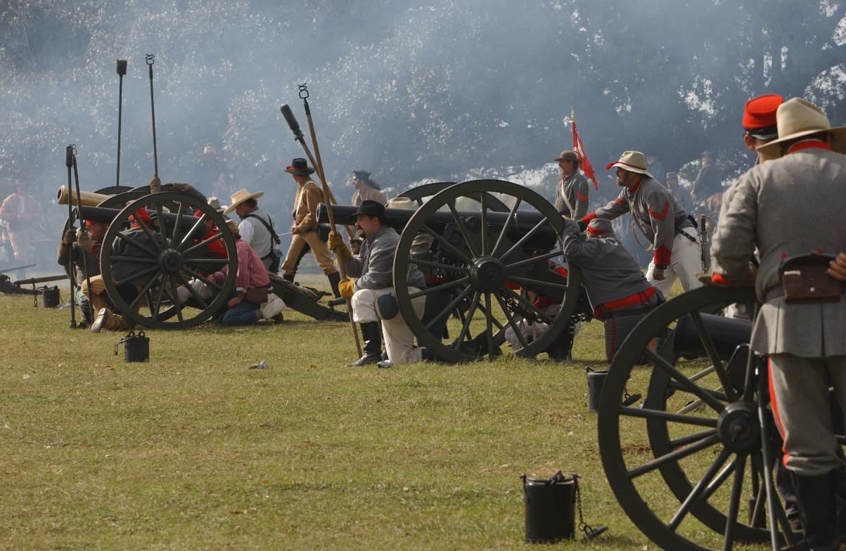
Immediately upon feeling the charge reach the breech, drop your hand away from the rammer. After 10 seconds have lapsed and ensuring the charge is fully home (according to the rammer marks), remove the rammer – using only one hand as mentioned above. This may require grasping and releasing the rammer shaft a few times. At no time should more of the body than absolutely necessary be forward of the face of the muzzle and never in front of it. Finally, never grasp the rammer with both hands during the loading procedure.
When the rammer is removed, the vent may be released.
VII: Prick the charge.
To insure ignition, prick the powder charge through the vent with a pick or gimlet held by the shaft, between glove protected fingers.
The pick should not be so long that it reaches the bottom of the bore when fully inserted – such repeated and forceful contact may result in pitting of the bore directly under the vent.
VIII: Prime.
Priming the vent depends on the type of ignition in use. Typical systems are: linstock and priming powder, fuse, priming quills, friction primers, .22 caliber blank cartridges, and percussion caps.
IX: Alert the ready.
After the charge has been pricked and primed, place the rammer and sponge on the carriage wheel hubs and pointing skyward (top of the wheels for small cannon) alerting all that the piece is ready to fire.
X: Fire the gun.
With a loud voice, the crewman designated to ignite the charge (the No. 4 man in Civil War period drill) calls out ready to fire! – alerting other crews on the line that his gun is about to fire and notifying the gun captain that the piece is loaded and primed. At this call, any open ammunition containers are immediately closed. The gun captain makes a quick visual inspection of the blast cone/safety zone forward of the muzzle, ensuring no one is in danger, and then commands:
FIRE!
The primer is then ignited.
Priming powder, fuse and priming quills are ignited with a linstock, which is long enough to allow the crewman to stand outside the wheels. The linstock holds the burning slow match made of cotton rope impregnated with potassium nitrate or lead acetate to make it burn.
If a lanyard is used to ignite friction primers, or to activate a lock using percussion caps or blank cartridge, it also should be long enough to allow the crewman to stand outside the wheels and out of the way of recoil. After the firing, the gun captain then commands:
Service the Piece!
After servicing the piece, use a few moments to reset the piece, check elevation, and then got back to step I. As long as the drill includes servicing after firing, and again prior to loading, the “3 minuite rule” can be discarded.

Misfires
If the primer ignites, but the gun fails to fire:

Command: "Do not advance, the primer has failed." Start the stopwatch and wait 3 minutes.

When 3 minutes have lapsed, step inside of the wheel from the front of the axle so you will be out of the path of recoil should the gun discharge unexpectedly. Do not get in front of muzzle at any time. If gun is less than full-size or the barrel is less than 60 inches in length, this position might put you in danger of muzzle flash so you will have to work behind the axle. Use good judgment. Estimate recoil distance and stand well back from axle.

Wearing heavy leather gloves, use a gimlet to clear the vent. Grasp the gimlet by shaft only. Keep your face and head away from vent. When vent is clear, re-prime and repeat Step X.

If three attempts fail to fire the gun, use a C02 fire extinguisher (with horn removed) to blow down vent and force powder (and projectile) from the barrel. If C02 is unavailable, flood bore and vent with water and worm after thorough soaking.
Ten Basic Safety Regulations
- Maximum blank powder charges for properly constructed guns should not exceed 2 oz. of Fg, or 3 oz. of Cannon Grade, black powder per inch of bore diameter. Use reduced loads with projectiles. (See North-South Skirmish Association regulations for a guide to projectile and powder charges.)

- Prepare powder charges in advance using light-weight plastic baggies with the end twisted closed. Leave 2 inches of twist; cut off excess plastic. Fold twist to bag. Enclose bag in a triple layer of double-thickness heavy-duty aluminum foil (six layers total). Take care not to break plastic baggie. The bag prevents escape of powder dust and keeps granules from getting trapped under folds of aluminum and helps insure a complete burn. (Although this may seem impossible to those familiar with smaller caliber guns, aluminum foil wormed out after firing often yields unburned powder.)

- All crew members should use ear protection.

- No one should cross in front of the muzzle at any time during the cleaning, loading or firing procedure.

- The ammunition box shall be located 25 feet behind gun, attended at all times, or locked. The interior shall be lined with a non-sparking material and the box itself stoutly constructed of wood or metal.

- No smoking at any time within the safety zone.

- No drinking alcoholic beverages for 10 hours prior to serving on a cannon crew. Any crew member showing signs of the effects of alcohol or other drug should replaced.

- Projectiles shall be constructed so that they easily pass through a sizing gauge with thumb pressure only. The sizing gauge to be a length at least 1.5 times the length of the projectile and the inner diameter no greater than bore diameter (when the barrel was new).

- Projectiles should not weigh more than one half the weight of projectiles used in original issue guns of same bore diameter.

- When firing blanks, wadding should not be used, nor should any be necessary for a realistic report.

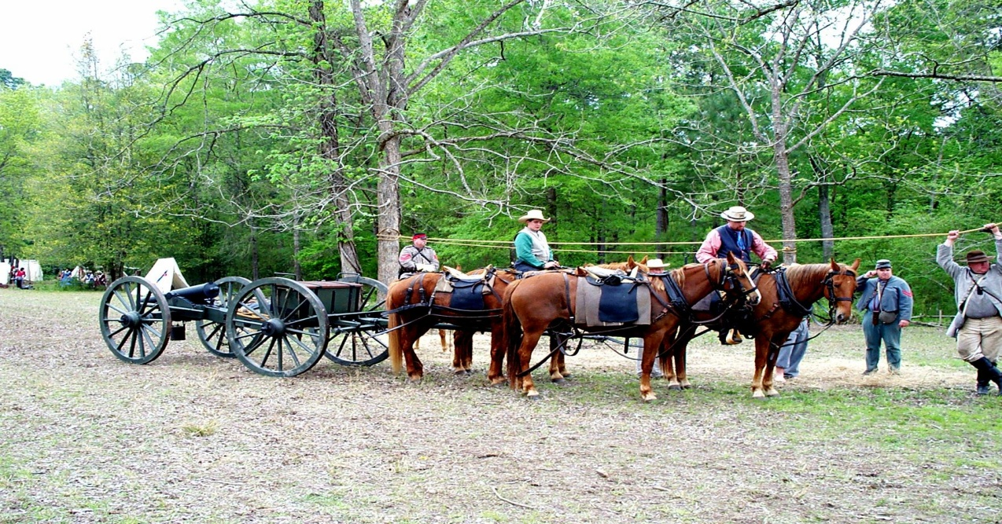

Key Points for Safe Shooting
- Service the piece after firing, and again before loading next powder charge.
- Use black powder only. Inspect your gun tube regularly for signs of stress.
- Maintain the 50-foot safety zone with a rope or string marker.
- Walk, do not run and always work at a smooth steady pace.
- Train your gun crew. Run through a dry fire evolution at least twice before commencing operations each day. Be sure each crew member performs his duties smoothly and accurately.
- Make sure each crew member has knowledge of procedures and safety rules.
- Have the No. 1 man (rammer) repeat the step instructions as they are called out by the gun commander (or No. 3 man tending the vent). This serves as a procedural check so that none of the 10 steps are omitted by error. Memorize this sequence: 1. Clean vent, 2. Stop vent, 3. Worm, 4. Sponge, 5. Dry sponge, 6. Load powder, 7. Load projectile, 8. Prick charge, 9. Prime, 10. Fire.
- Use good common sense. If something is done wrong, stop and think it through. Then act to correct it. The stop and think approach gives more opportunity to avoid accidents than the press onward-out-of-sequence method.
WARNING:
Loading and firing antique or replica muzzle loading cannon is a highly dangerous activity, land can result serious injury or death. Structural integrity of the barrel, powder charge preparation, premature discharge as a result of burning embers remaining in the barrel from previous cannon fire, reliance on others to follow proper procedures and other unforeseen and unanticipated conditions may contribute to accidents, serious injury or death. You should not engage in this activity unless you are thoroughly trained by competent instructors and fully aware of the potential dangers.

DO NOT RELY ON THE INFORMATION CONTAINED HEREIN TO PROTECT YOU FROM THE DANGERS OF ENGAGING IN THE LOADING OR FIRING OF ARTILLERY.

This document is only a summary of the essential safety rules and procedures to be followed while participating in this extremely hazardous activity. The aforementioned information, safety rules, procedures and regulations, have been adopted in part by the North-South Skirmish Association, American Artillery Association, Union and Confederate Volunteers, National Muzzle Loading Rifle Association and other such groups participating in loading and shooting antique artillery during recreational and living history events.

Be advised SEVERAL DISMEMBERMENTS AND AT LEAST ONE DEATH HAVE RESULTED in the United States and Canada while loading and shooting antique artillery and replicas. In addition, gun tubes have failed, sending fragments in all directions at high rates of speed causing damage and injury.

If you decide to engage in this activity, use only black powder in Cannon Grade or Fg grade only.
Remember, just because the color of the powder is black it doesn't mean it is "Black Powder."

Know your propellant and get it from a reliable source in labeled containers.

Revolver Chain Fires
“Pow!whoosh”

That is the best way I can explain the sound of a revolver chain fire.
Visually, the shooter sees a bank of white smoke emitted from the muzzle of his revolver followed by a stream of fire spewed from adjacent chain firing chambers in the cylinder.

If the reenactor is handling his revolver safely, a chain fire is a little embarrassing at worst. However, in close quarters such as company fire, the arm of a trooper next to the shooter could easily get burnt.

As you can see, this would require a certain amount of stress management from the burnt pard. As for damage to the revolver, a chain fire while shooting blanks does no more than apply a lot of soot, carbon, grease and fouling to the side(s) of the revolver.

Now consider live fire… All of the above occurs, but add to it a projectile (or more) ricocheting from the side(s) of the revolver. Depending on the physical contours of the revolver’s frame, locking pin, and loading lever, various amounts of lead are shaved from the projectiles; and, said projectiles are launched in several directions, including the arm (or other anatomical parts) of those troopers near by.

At best, this fosters strained interpersonal relationships between the shooter and shootee.

“How do I prevent my revolver from chain firing?”

I’m glad you asked.

Let’s first review how a chain fire occurs: Fire or heat emitted from the ignited cylinder reflects (or is directed) from the aft end of the barrel into an adjacent cylinder. Any loose grains or residue of powder is ignited creating more heat and flame. If there is the slightest void, opening, or trail of powder (same as a fuse) between the cylinder wall and wadding or projectile, the chamber charge is ignited. It works just that simple.

If a revolver’s cylinder is in good condition a chain fire will not occur at the nipples. After a cap is affixed to the end of a nipple, the heat created from the ignited nipple and cylinder would have to blow the hammer back, reflect around the nipple recess in the cylinder, get between the revolver frame and the aft end of the cylinder, and somehow get down into an adjoining nipple recess, back up between the nipple shaft and tightly installed cap, finally igniting said cap.

I ain’t puttin’ my money on such a probability!

Because a chain fire originates at the forward end of the revolver’s cylinder, that is where the prevention must be applied.

The surest and safest way, I have found, to prevent a chain fire is as follows:
- Load each chamber with your revolver ¾ full.
- Fill the barrel half way with Cream of Wheat and rotate the cylinder, completely filling each chamber with Cream of Wheat.
- Compress the powder/Cream of Wheat charge with the loading lever, going around at least three times. Afterward, pour out the excess Cream of Wheat from the barrel, and rotate the cylinder rapidly to dislodge any extra material.

Warning! Do not compress the powder prior to covering with Cream of Wheat – traces of powder will mix with the Cream of Wheat and create a fuse condition straight into the chamber charge.

Local Rule: Do not cover blank charges with grease – depending on the volume covering the blank charge, grease balls can develop and become projectiles.

Cap each nipple and prepare for battle.

It should be noted that there are several acceptable procedures for preventing chain fires and yours
may be every bit as good, and safe as mine. This is offered to those new to cap and ball revolvers, and, reenacting.

Note: I am about to enter upon sensitive and sacred ground…

If you have not yet purchased a revolver, consider this – how many revolvers do you intend packing around? Mounted troopers can easily carry additional revolvers in pommel holsters and saddlebags; however, if you are dismounted… Have you ever observed from the spectator’s point of view a trooper walking around the battlefield with two, three, four or more revolvers protruding from his persona? It is a bit embarrassing to observe the laughter of the spectators and hear what they have to say.

So… having raised some hackles and (inadvertently) stepped on toes, I offer the following. Rather than pack around several revolvers, carry one, two or more, extra cylinders. Certainly these are less expensive than additional revolvers and much lighter.

If you desire to carry additional cylinders, you must consider which revolver design affords the greatest ease for accomplishing a cylinder change in the field. The answer to that, in my humble opinion, is the 1858 Remington. All that is required is position the hammer at half cock, drop the loading lever, pull the cylinder pin forward, remove the spent cylinder, insert a fresh cylinder, rotate the cylinder (for proper indexing) while pushing the cylinder pin to the rear, raise the loading lever to the locked position, pull the hammer to the rear and fire. A little practice with your revolver and cylinders will increase your speed dramatically – this is practice that can be accomplished while sitting around watching the boob tube. And, a cylinder change looks way cool from the sidelines.

Wonder Wads, or any other wading, should be used only when live firing. Wading (or grease) used with blank charges become projectiles.

Reenactor Powder Charges
KA-BOOOOOM! POW! BANG! BOOM! Ka-Pow! pop. poof…

As commanding officer of a CS Marine Corps unit that employed artillery in addition to muskets and revolvers, I can tell you there is nothing more disheartening and embarrassing than to give the command “Fire!” and hear a report of “poof”…
To watch and hear such a report as a spectator is laughable and the catcalls are unbearable.
Many reenacting units and associations provide maximum powder volume per caliber limitations/restrictions; but, no guidance is offered for developing the best bang for your buck.
So how do we develop a good reliable charge, with a properly loud db report, shot after shot?
First a little background –
As fouling in a musket barrel and breech increases, it transforms into obstruction thus becoming a projectile. During the heat of battle, at close quarter, have you ever felt the spray from the opposing unit’s volley? That is a mixture of un-burnt powder and fouling (build up of spent powder residue) being dislodged and blown out of the barrel.
Well…!
What about the powder in the breech (forced to the rear or sides of the charge) that is not blown forward? It continues to build up and becomes caked in the breech. With repeated firing, the breech fouling develops hot spots that transform into hot burning embers. Naturally when loose powder is poured on top of these glowing embers you will get a flashback . If you’re lucky, burnt fingers is all that will result; however, if you are not controlling the muzzle in a safe direction, burnt face, damaged or lost eye sight, and injury to a close pard will result.

If you are not already shooting FFFg, consider this… Triple F burns at a higher temperature, generating greater breech pressure, and burns much cleaner and more completely than double F. Resultant condition is less powder volume for the same db report, and more importantly much less fouling!
If you are switching from FFg to FFFg reduce the volume of your charge by around 33%. Fire a few shots. Then increase your charge volume by 5 grains and fire a few more shots. Continue increasing the powder volume by 5 grain increments, soon you will feel a little recoil at the butt of the musket and hear a sharp report – you’re getting close. Continue increasing the powder volume until you will reach a point of diminishing return – this is when the recoil increases and the db report seems to remain constant. Stop and return to the powder volume that produced the largest increase in db report – that is the best cartridge powder volume for your musket.
This process is very much like developing the correct powder volume for maximum accuracy during live fire.
If this seems simple, it is – amazingly so.
One consideration last, observe unit and event sponsor safety standards dictating maximum cartridge powder volumes. After you have developed the best db report possible for your musket, you are obligated to observe any existing maximum powder volumes for reenactor blanks.

Finally, clean that musket private!

Powder Volume
What follows is an excerpt from my book (still in manuscript form) Muzzle Loading Rifle Accuracy -vs- Hoodoos and Shooter Error. This information is usable for patched round balls, minies and maxies, and I hope it serves you well.

- Powder Volume:
NOTE: Use black powder or black powder substitutes "ONLY" in muzzle loading firearms.

The volume of powder that shooters pour down their rifle barrels is probably the variable that is tinkered with, and misused the most. Sort of like some folks automobile carburetor, as soon as the motor starts to misfire, cough, spit or sputter, what do most mechanic wannabes do? That's right, they adjust the carburetor and really screw up the works, when maybe just one or two spark plugs needed a little cleaning. If you just have to play with that powder volume, let's start with the volume that worked best in the past, in the case of a new rifle, begin with the volume that the manufacturer recommends. Also, to begin with, let's start with some bench shooting at 50 yards.

A point to keep in mind here is any decent barrel will perform well at this distance, shots are easy to get "on the paper" and into the bull's eye. After a little work your groups will generally look very good; however, the real proof comes after you have developed a five shots touching group and then extend your distance to 100 yards. At 100 yards you develop your real or true accuracy; at most competitive shoots, this is the distance where many shooters are separated from the top ten; while hunting this is the distance that you should be sighted in for.

WARNING: Always pre-measure each powder charge, and pour it down the barrel from a separate powder measurer, don't ever pour powder down the barrel from a can, flask, powder horn, or any other bulk powder container. Most of these containers will hold upwards of 1/2 pound of powder. If you pour powder down a barrel containing a hot ember, the charge could ignite and flash back up the barrel. This would undoubtedly set off the 1/2 pound black powder bomb you are holding less than 18 inches from your face, and very close to your heart. I'd wager that your entire day would be ruined.

The idea here is to figure out what volume of powder gives your present set (combination of patch, ball, and lube or bullet and lube) the tightest group. Five shot groups seem to work best and swabbing between shots is an absolute must. Powder volume can easily be considered as an amount of energy, like the amount of energy required to spin a toy top at just the right speed. When the top is spinning to fast, it wanders all over the place. When it is spinning to slow, it wanders around again, as it slows more it begins to wobble, finally the top looses its centrifugal balance, and falls over. However, as the top decelerates from to fast to to slow, it passes through a resonate speed where it spins in just one spot, and appears to be standing still. In developing our powder volume, we need to develop just the right amount of energy to get our set in resonance with (matched to) the barrel's rate of twist. This resonance will enable our shots to enter the target at almost the same spot shot after shot, and not wander or wobble around the target (Swiss cheese and flyers); the powder set will produce a small, or tight, group.

Not all muzzle loading rifle barrels have the same rate of twist. Larger caliber barrels generally have a slower twist than do smaller caliber barrels, and conical projectile barrels have even faster rates of twist than round ball barrels. Normally a good .54 caliber round ball barrel will have a twist that measures one complete turn in around 72 inches. Rifle barrels are not that long so the ball wont even make one complete revolution before leaving the muzzle. A good quality .45 caliber barrel will generally have a rate of twist that measures around one turn in 60 inches. The stabilization of a round ball does not require as fast of a twist as a conical projectile. Conical barrels (or slug guns) are normally quite fast, a .54 caliber barrel with one turn in 28 inches is common and some are even faster. The heavier longer projectile takes a faster spin to stabilize. Comparing the required rates of spin for maximum accuracy between conicals and round balls is similar to comparing the rate of spin required for an accurately thrown football and an accurately thrown baseball. Too little spin on the football and it wobbles all over the place, while too much spin on the baseball causes it to curve off course. One thing that is constant with both types of projectiles is the smaller the caliber the faster the rate of twist. Naturally for every rule there is an exception, some muzzle loading rifle manufacturers produce barrels with a compromise twist that allows the shooter to shoot either round balls or conicals fairly accurately. The compromise rate of twist in a .54 caliber barrel may be something like one turn in 48 inches.

While developing the resonance between a barrel’s rate of twist and its most accurate load (which will become the rifle’s set), I find it most convenient to use a target with either five or six bulls eyes, and I pre-mark each one indicating which variable I'm working with.

If you use a multiple bull’s eye target, all of the constant data can be written in one corner (see the example below) and the variable annotated at each bull’s eye. What ever size target you choose, use the same through out your testing.

EXAMPLE:
Date: 15 March 2000
Rifle: 54 cal. Hawken
Range: 50 yards
Powder: GOEX FFg
Volume: ________
Bullet: .530 cal. Buffalo Balls/220 gr.
Patch: Pillow ticking/.013 compressed
Lube: Buffalo Bart's/medium wet
Cap: CCI #11

From the above example, note that the only variable which is not constant (the one that is left blank) is powder volume. In this case you would pre-mark each bull’s eye indicating the increasing/decreasing five grain increments of powder. Five grain increments are preferable to work with because each change in powder volume is obviously reflected on the target, and most powder measurers are marked in five grain graduations. If you are starting at 80 grains, then the targets would be marked 80, 85, 90 etc, or 80, 75, 70, etc..

Observe your group diameter changes. If your group is getting tighter with each five grain change (up or down), and all of the sudden it starts opening back up – STOP! Go back to the powder volume that produced the tightest group, and work up or down in smaller increments. Normally the five grain incremental steps will put you awfully darned close to your smallest possible group.

Once you have achieved your tightest, or smallest, diameter five shot group, WRITE IT DOWN. Be sure to write down all of the constant data as well as the best shot group variable.

Hunting Loads
"Yeah, 85 grains of 2F is my most accurate target load, but I shoot 110 grains for hunting!" How many times have you heard something like that? I used to think that way too, but I got that stupid idea out of my head, and I'm better now. Why in the world would someone go to all the trouble of establishing the most accurate powder volume for a muzzle loading rifle, and then when it comes to something as important as hunting, throw it all out the window thinking "I gotta hit the critter harder?” This is a manifestation of a serious psychological condition known as "Magnumious Brainicus" (resulting from flashbacks to center fire activities), it is highly contagious to the unknowing, and must be treated immediately. An intensive indoctrination into the realms of "Muzzle Loading Rifle Accuracy,” with a follow-on (and in depth) education of the merits of selective shot placement is the only remedy. Your most accurate load provides your best shot placement, and ample knock down power. If you want to hit a critter harder get a larger caliber rifle and develop its most accurate load. When you add powder volume in order to increase velocity and energy (or knock down power) at longer distances, you are sacrificing accuracy, and at that point you shouldn't even shoot. The trade off isn't worth it.
"Nuff said!"

- Grade of Powder

WARNING: It is absolutely imperative that all muzzle loader shooters remember black powder or black powder substitutes ONLY are to be used in muzzle loading firearms. At no time should you ever put smokeless or any other type of non-black powder propellant down the barrel of your muzzle loading rifle. You may see or hear of shooters using duplex loads consisting of smokeless and black powder and claiming great and wondrous results. This is a very dangerous game to play; the results can be disastrous and permanent. Use black powder or approved black powder substitutes ONLY.

Grade of powder is always a subject of question and controversy amongst competitive shooters. "My Leman shoots best with 3F".... "Well my Hawken likes 2F best." Both shooters may be right… or not. If all you have ever used is one grade of powder and you are competitive, a change in this variable may make you a consistent winner. In order to make this change, consult your users manual, or a black powder loading data table, for the recommended volume of powder to begin with. Next work your way up or down in five grain increments using the multi-bull target technique. Watch the changes in your group diameter, is it getting smaller or larger? Refer to Section #1. After you have developed your best group with your Test Powder, compare it with your best Old Powder group, which one is better? Go for it!

WARNING: Each grade of black powder burns at a different speed, creating different amounts of heat and breech pressure. If you are shooting 80 grains of FFg, and you want to try FFFg, refer to a black powder loading data table for a volume to begin with.

As a general rule, the following guide line may be used (always consult your manufacturers data first): Fg (1F) is mainly used for cannon. FFg (2F) is primarily used in rifles with bore diameters of .45 caliber and larger. FFFg (3F) is mostly used in hand guns, shot guns, and rifles with bore diameters smaller than .45 caliber. FFFFg (4F) is used ONLY as a priming or flash powder in the flash pan of flint locks, and should "NEVER BE USED AS A POWDER CHARGE IN THE CHAMBER OR BREECH OF A MUZZLE LOADING FIREARM."

Remember, once you find that best group, write down all of the constants and the variables.

I hope this serves you well, in future issues I will share information pertaining to projectiles, patches, lubricants, ignition, cleaning, and shooting technique.

“Clean that weapon Private!"
Clean it until you know its clean…, then clean it again!”

During the summer of 1966 I had recently graduated high school, not yet turned 18 and left my family in Eugene, Oregon. However, I was in good hands and learning much that would shape my attitude, work ethic, personal bearing, willingness to follow, loyalty to leaders and ability to shoulder the responsibility of leadership and authority at a moments notice.

I was learning to be a Warrior God.

A successful United States Marine carries out orders without question or hesitation. The business in which Marines are trained is war; more specifically, Marines are trained to kill. It matters not, to the Marine Corps, whether a Marine has been trained to be a truck driver, cook, electronics maintenance technician, or a jet engine mechanic – all Marines are first and foremost riflemen.

For a rifleman there is no room for hesitation. When a Marine is face to face with the enemy, the moment of truth has arrived; and, the rifleman who hesitates will be one dead Marine – then he will be in a world of hurt, because Marines are not allowed to die without permission!

By now you must be wondering “what in the world is this idiot talking about?”

Fair question.

To a warrior, a properly functioning firearm is tantamount to life itself. When a firearm malfunctions, usually, it wont fire. And, when a weapon is dirty, proper operation will be impeded, even to the point of malfunction. When your weapon malfunctions, you had better hope you have permission to die!

‘Bout now a good question would be ‘how clean does my musket have to be for reenacting?”

This is one question you will answer on your own but first, some background.

Lets begin with the bore of the barrel. The main problem in the bore is fouling. Black powder is without question a filthy propellant; and, when spent, leaves a build up of residue known as fouling. In the bore of a barrel, fouling is similar to the build up of plaque on your teeth.

During live fire, fouling in the bore affects accuracy; and, as fouling builds, pushing a projectile down the barrel becomes increasingly difficult.

Considering the speed at which muskets are fired, reloaded, fired, reloaded and fired during a reenactment or mock battle, often times musket barrels become to hot to touch. As barrels become fouled and heat up, powder residue and fouling converts to hot burning embers.

A dangerous situation at best.

To put this in perspective, lets say your camp fire has died down to nothing but hot glowing coals – what do you suppose would happen if you poured black powder on the coals?

“Poof” “Whoosh” or “KA-BOOM!” Depending on the volume of powder poured.

Now, lets consider hot burning embers in the breech of your musket and 70 grains (by volume) of FFg poured on top of them.

“Whoosh”… if you’re lucky.
Lets follow through with that “whoosh.” The constriction of the bore guides the hot burning powder to the muzzle of the barrel where it is directed right onto your fingers, hands, shirt, and face, or the side of the head belonging to one of your pards.

This is called a flashback, if you are controlling the muzzle in a safe direction, burnt fingers is all that will result.

In order to reduce the possibility of flashback, the bore of your musket’s barrel must be clean prior to marching on to the battlefield – each and every time. However, there is more to this…

One of the chemical components of black powder is saltpeter, more basically – salt. As you know, when salt, steel and moisture are mixed, rust (corrosion) results.

Corrosion is not a good thing.

Left unchecked, corrosion gets into and weakens every nook and cranny of the barrel. Lands, grooves, breech plug/barrel join, plug threads, nipple threads – everywhere! During live fire such weaknesses can cause barrels to crack, split and burst; nipples begin to leak around the threads and blow out. You haven’t lived until you’ve seen bits of barrel steel embedded in someone’s arm or head, the ultimate site is a steel nipple protruding from the eyebrow of a close pard.

There is no recoil, caused by pushing a projectile down the bore, when firing blanks (for every action there is an equal and opposite reaction); so, it is easy to rationalize that there is no breech pressure. When firing blanks the breech pressure remains at more than 80% of live fire pressure, and can still burst a barrel – resulting in singed eyebrows, burnt skin, bluish black dots as permanent as any tattoo, damaged or lost eye sight, and death.

Sound serious? It is.

Even though a burst barrel is dangerous and can be spectacular, musket cleanliness does not stop there.

Lock assemblies and trigger mechanisms must be clean as well. Repeated cap ignition, and, nipple blow back* causes spent black powder to build up in the lock assembly and on the trigger bar. As fouling builds, parts get gummed up, lock time slows, and the trigger pull begins to stiffen. Left unattended, the lock will hang and not operate – worse yet, the lock may release on its own, an unsuspected shot will be fired resulting in injury or death.

When the breech charge is ignited pressure results in all directions. The least path of resistance is toward the muzzle in the bore; lines of force are also applied to the wall of the barrel; and, the same amount of pressure is applied to the rear and through the small hole in the nipple. Sometimes this pressure is so great the hammer is pushed to the half cock position – this is why you always get carbon buildup on the face of the hammer.

By now, I hope you have gotten the idea that a dirty musket may result in damage not only to the musket, but those around it.

How do we clean our muskets and maintain a high level of safety?

First lets review a list of equipment each trooper should always have in the field:
1. Ramrod (musket rammer will do).
2. Cleaning jag of proper caliber – acquire one with steel threads so it doesn’t break off in the barrel and become an obstruction.
3. Bore brush with brass or copper bristles.
4. Nipple wrench and nipple pick.
5. Screwdriver.
6. Patch worm.
7. Small vile of powder solvent.
8. Small vile of oil.
9. Cleaning patches.
10. Tooth brush.
11. Pipe cleaners
12. Rag.

The above list sounds like a lot of stuff, but considering the size and weight of each, all easily fit into one small pouch, except the rammer which already has a storage spot under the musket barrel.

After action field maintenance is easily accomplished by removing the lock assembly and nipple, then plugging the nipple hole in the breech, filling the musket barrel a little better than ? full with hot water, plugging the muzzle and shaking vigorously for 45 – 60 seconds. Prop the musket muzzle up for another minute or so.

Remove the muzzle plug, lay a cleaning patch, centered, over the barrel muzzle, and with a cleaning jag affixed to the end of your rammer, insert the combination into the muzzle of your musket. Remove the plug from the nipple hole and forcefully push the jag and patch completely to the breech plug. The resulting water pressure will clean the breech area as it is forced through the nipple hole. Refill the barrel, and repeat the process. Work the patch and jag combination up and down the bore several times, remove the patch and replace it with a new one. Repeat the process until the patches come out of the bore clean with no black marks on them. Finally, after the bore is dry, insert an oiled patch and work it up and down the bore several times.

If a patch comes off of the jag, it may be retrieved with the patch worm, and, rough spots in the bore may be cleaned with the bore brush.

Use the screwdriver to remove the lock assembly; then the toothbrush, pipe cleaners and black powder solvent are used to clean the lock assembly. Use the same clean patch idea for deciding if the assembly is clean or not. The top of the trigger mechanism, visible in the lock mortise, may also be cleaned with the lock assembly cleaning tools. The nipple should be cleaned with the tooth brush and nipple pick. Be sure to lightly oil the lock, trigger and nipple.

After cleaning the bore, lock, trigger and nipple, clean the exterior metal surfaces of the musket as required with the tooth brush and pipe cleaners, reinstall the lock assembly and nipple, clean the rammer and reinstall it, then use the rag to lightly oil all exposed surfaces of the musket.
That procedure works very well for the field, however, after a weekend of campaigning a more thorough cleaning is in order.

Disassemble the musket by removing the lock, barrel bands, and barrel. Remove the nipple from the barrel. Using a bucket, pail or other non-breakable container in the one to five gallon capacity size, fill it about ? full of hot tap water and proceed as follows: Insert the breech end of the barrel into the container of hot water. With a wet patch and cleaning jag on the end of your ramrod, run the combination down and up the bore, down and up, down and up, down and up. This action works like a pump and forces water in and out of the bore through the nipple hole in the breach. A proper fitting patch and cleaning jag combination will make short order of removing the powder residue from the breach and bore, leaving the nipple hole, breech, and lands and grooves clean and crisp. Once you think that you have cleaned your bore enough, clean it some more. Remove the barrel from the bucket and run a couple of clean dry patches through the bore. If they come out of the barrel clean – you’re done. If the patches show any trace of powder residue at all, go back to work. When you do have a clean bore, dry it thoroughly, and protect it by running a lightly oiled patch down and up the bore two or three times.

On the rest of your musket’s metal parts use small nonmetallic stiff bristled brushes, tooth brushes, pipe cleaners, and cotton swabs. Clean them, dry them, and oil them. After you have your musket put back together, wipe it down with an oily rag. If you think it might be clean, but you just aren't sure, clean it until you are sure.

It will tell you when it is clean.

Keeping your musket clean will allow you to enter the moment of truth comfortable in the knowledge that it will not be your musket that hesitates.
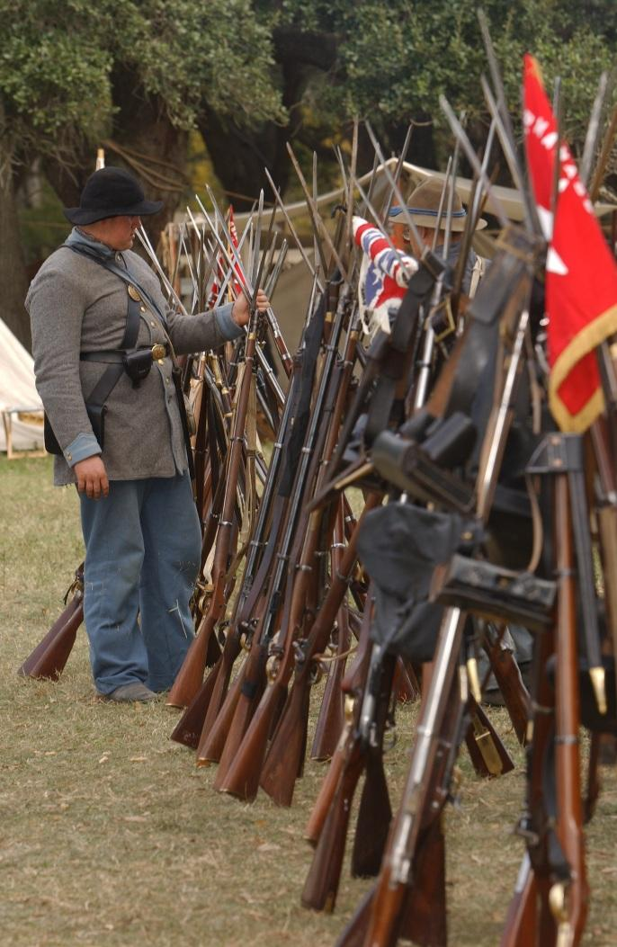

This page intentionally left blank.

Safety:
in the Field
&
in Camp

Safety in the Field
By Jonah Begone
edited by wrg

This article originally appeared in the April, 1991 issue of Camp Chase Gazette (Vol. XVIII, No.5)

Heaven knows I don't have the brains to set myself up as yet another Black Powder Expert, but in the interest of a safe and happy reenactment fraternity, please read and heed.

- Magnum rounds are un-cool. No one can pick out your individual shot in company and battalion firing anyway, so why waste the powder? (And if they can, you might get the reputation for being a fool and neither you nor your unit needs that kind of attention.) 60 grains 2Fg is the standard load for National Park Service weekends. Fight the temptation to use more than a sensible and frugal 80 grains 2Fg elsewhere.

- Clean out that barrel! Why? Because there is a direct relationship between the dirtiness of the inside of your barrel and the possibility of a "cook-off." If you don't do a thorough job of cleaning out the black powder goo that accumulated from the last event, after a shot or two sparks can reside therein and give you an unpleasant surprise when you next pour powder! By the way, remove the barrel from the stock when you clean - you'll do a better job.

- Avoid a sloppy "right shoulder shift" you know, when you're not keeping the butt end of your rifle snug against the upper part of your chest. What happens - and you can't see it - is that your rifle barrel threatens to bop the guy behind you. This can be a real problem when you're loaded, in "company front" and running. The guy behind you is then looking right down your barrel. Not a reassuring sight. (Note: if your right shoulder shift is comfortable, you're probably not doing it correctly!)

- Get some firing space between you and the enemy! Why make 'em mad? Give it 50 yards at the closest, and then elevate your musket.

- The definition of a combat "safe" musket: At the half-cock, cap off nipple. Your half-cock can be tested by supporting your rifle's weight upside down by the trigger; it passes if the hammer doesn't release to strike the nipple. And never run around with the hammer down onto an unexploded cap - you could drop the rifle on its hammer and have it go off.

- Discharge weapon before taking a hit. You can never tell where that thing will end up pointing to (could be your face), and one good kick could set it off. Then you'd really take a hit! This also goes when "charging" an enemy position. If you have a "hot" weapon when the order to "charge" is given, dump the load and flip the cap off..

- Never use your ramrod in a battle. The reasoning here is that you could get frenzied and careless with the realism of it all and accidentally send your ramrod flying into someone (it has happened). Even if you're the cool type, other guys can see you ram and get nervous about it, and once again, your unit probably doesn't want that kind of publicity. If you have a weapon problem, step out of line and see your nearest NCO, or even easier, dump the charge, and take a hit.

- Never use a nipple pick when loaded. You could ignite the powder charge when your rifle is pointing somewhere you rationally wouldn't want it to. Don't believe me? - I saw it happen once! (And if when you're firing the powder charge doesn't go off, re-cap and try again. If you're still firing duds, dump powder and then pick.).

Remember these kindly little hints and watch out for one another.

Safety on the Line (wrg)

Safety in the field is paramount in reenacting, and that means primarily weapon safety. For the Cavalryman, specifically musket AND pistol safety. YOU are responsible for the integrity of your weapons. If you feel a piece is NOT in a safe working order, do not use it. Go through the Safety Tips, and the Event Safety Standards. Practice the loadings and firings. I will attempt here to put the logic behind the sequence.

While attending the School of the Soldier, you will go through a process of loading and firing. This process is designed to make the firing of the piece as safe as possible, and to make the piece safe, even between firings.

LOADING LONG ARMS Unloaded musket, and unfired. Firing by the Nines. The safety is built into the procedure.

LOAD- Left foot on the line and right foot behind and to the right about one foot, and turned outward, Place the butt inside the left foot. With the barrel to the front; seize it with the left hand near the muzzle, which should be about 20 degrees away from the body; carry the right hand to the cartridge box.

Handle-CARTRIDGE
Tear-CARTRIDGE
Charge- CARTRIDGE

PRIME- Half-cock. Remove the old cap with one of the fingers of the right hand.

ARMS at the READY- Bring the musket to the "Ready" position.

PRESENT - Raise and cock the piece. Instructors will be careful to observe that they aim at some distinct object.. e.g. the top of a tree line beyond the opposing force… the closer the "target" the higher the elevation.

FIRE- Pull the trigger upon hearing the "F" ine "Fire"

This process is repeated for subsequent firings. When firing independently, the identical process is used, but independent of firing commands and at the individual soldier's pace. Notice that when charging the weapon, the hammer should be down, on an exploded cap. This serves the same function as covering the vent on an artillery piece. It prevents air (oxygen) from getting into the barrel, suppressing potential sparks that could ignite the next powder charge.

Become accustomed to the order of events! It's for your own safety!

Revolvers
Pistols are also a primary safety issue. They should be carried in a military style flap holster, or in an open holster that secures the weapon in place by a strap, which precludes the cocking of the piece.

Some style pistols have a safety notch between chambers, Colts and others do not. When a pistol is fully loaded, the hammer should ALWAYS be placed half way between two chambers. After the firing sequence, it will lie safely on an exploded cap. When returning your piece to its holster, it should be secured in one of these two conditions.

NEVER put a pistol in a holster with the hammer resting on an unfired chamber!!!
Again, the firing sequence is designed for optimum safety.

- Prepare to Withdraw REVOLVERS. At which time the trooper will un-flap his holster with the left hand and grasp the piece, by the grip, with his right hand. The left hand will then drop to position

- Withdraw REVOLVERS - At this command the trooper will pull the piece from it's holster, and raise it, so that his upper arm is parallel to the ground, and his forearm is perpendicular to it, with the muzzle pointed directly up. (At this time the trooper should be selecting a target)

- PRESENT - At this command, the trooper will lower his forearm, while simultaneously cocking the piece with his thumb, and taking aim at his intended target. Note: at this point we will always fire. the only thing that might stop it is an un-safe act (e.g. some one runs in front of the squad or company) and the Capt. or whoever is giving the firing command will shout something to the effet of "Halt, belay that order!"

- FIRE - Once fired the troopert will raise his forearm to the perpendicular position, awaiting the next command.

- Recover REVOLVERS - Open the holster flap with the left hand and return the piece to it's place, secure the flap.

Once the "Present" command is issued, the piece will ALWAYS be fired. By following these instructions, the pistol can, after firing, always be ordered "Recovered" in a safe condition to be replaced in the holster. The exception being a misfire, where the cap did not explode.. Then the soldier must be extremely careful to half-cock and rotate the cylinder half way to the next chamber and set the hammer down prior to returning it to the holster.

MUZZLE INTEGRITY! Always know where your muzzle is pointed, and make it NOT at others. A sling for your musket is HIGHLY recommended, so that when commanded "Arms at Will" you can sling the piece over your right shoulder with the muzzle pointing directly down.

IF YOU ARE EVER HURT on the field, holler MEDIC! This is a non-period cry for help, and will bring the EMT's and 1st Aiders within the unit running.

Safety in the Camp

- Fires should ALWAYS be in a pit, or in a fire box, and of a size according to need.

- Weapons, unless in you hands, should ALWAYS remain in your tent and out of sight of the public, or others wandering through the camp. Not just for safety, but for the issue of something just.. walking away. It happened at Gettysburg, and again at Raymond.

- NEVER let someone "handle" your weapon, loaded or unloaded. A lot of events are required to acknowledge this for insurance purposes. And it's ALWAYS a requirement when giving demonstrations in schools.

- Keep an eye out for your pards, and an ear open for others. Just ask Trooper Paleschic about Chickamauga.

- Sergeants have fire extinguishers know where they are.

These rules are not all-inclusive. The most important thing is common sense, you have it...USE IT.

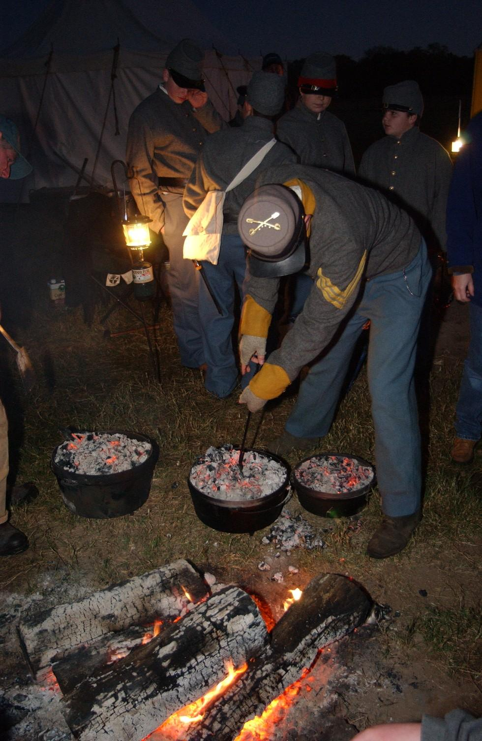
Cadets cooking their own meal

Always follow the published Safety Tips, and remember the Golden Rule..

Don't do it to, or at, others, if you wouldn't like it done to you!
~~~~~~~~~~~~~~~~~

Safety in Camp
By Fannie & Vera

Like any outdoor sport or activity, you need to be aware of possible hazards involved. A few precautions and preparations can insure that you always have a GOOD time at reenactments.
- Heatstroke and Dehydration
- Fire Safety
- Healthy, Hearty Eating
- The Great Outdoors
- Nature's Creatures
- Respect Horses, Weapons, and Sharp Stuff
- First Aid Kit & Emergency Preparedness
- Child Safety
- Pets

Heatstroke & Dehydration
The number one safety problem at reenactments is heat stroke. Government records of Civil War deaths count 313 deaths caused by sunstroke. To prevent heat stroke and improve your energy level you need to drink water. Lots of water! Experts recommend eight ounces or half a cup of cold water every 15 minutes, before, during and after exercise. Cold water is absorbed out of the stomach and into the blood stream faster. The benefit is that it quickly re-hydrates and cools the body. Have a glass of electrolyte replacement i.e. Gatorade, for every 6-8 glasses of water. You will need to replace the minerals that you lose through sweating.

When taken during exercise, fruit juice can slow the absorption of fluid into the blood stream because of its high sugar content. However, it's fine after exercising. Carbonated drinks can make you drink less because the gas in them makes your stomach feel full. They can also cause an upset stomach. The caffeine in coffee and soft drinks works as a diuretic and can cause you to lose more fluid from your system. When the weather is excessively hot (and you are running around in a wool coat and pants or fully crinolined) you will experience a greater increase in your body temperature and therefore loose more fluid.

I found out the hard way what happens when you don't drink enough water while re-enacting. By the time I realized that I was getting really thirsty it was already too late. Our bodies' thirst mechanism lags behind our actual need for liquids by about one third. And as we get older, it gets slower. Fluid loss causes an increase in your heart rate and a drop in blood pressure. It can make you feel dizzy and cause cramps or nausea.
Before events, freeze water in half-gallon jugs and keep them in your ice chest rather than a bag of ice. It is a good supply of ice water as it melts. Be neighborly and remind your fellow re-enactors to drink a lot of water, too.

Keep Cool. Stay in the shade during the hottest parts of the day. Do your living history presentation under shade or a fly. When you are walking around, use your parasol or wear a large hat to keep the sun off in a period correct manner. When it gets really hot, soak your chemise in ice water--as it is worn next to the skin it will keep you very comfortable. Drop a few ice cubes down your corset. Another trick for keeping cool if you are going to be sitting for a while, take a gallon jug of ice and slip it into a little bag made from old sheeting. Use it for a footstool or just keep it under your hoop. It will be as if your hoop was an air-conditioned little room.

Use sunscreen and lip balm to keep from getting sun burned. Don't forget to apply sunscreen to the part in your hair. Nothing itches worse than a sunburn on the top of your head. You can apply sunscreen and then pat your face with powder to give yourself that period correct lily-white skin.

Fire Safety
In the era of the hoop it was not uncommon to hear of women burned to death when their skirts caught fire. It is rather difficult to stop, drop and roll with a hoop on. Be very careful around the fire. This is a good reason to avoid hoop skirts made from polyester. Synthetic fabrics will either burst into flame or melt and leave red-hot blobs sticking to you.

Kids are fascinated by the campfire and will have an irresistible compulsion to toss little sticks and things in it. Please do not allow this. Every time, almost without fail, they will get their hands too close to the flames and burn themselves, or their clothing will catch on fire. This became such a regular problem that we now enforce the rule that no one may toss anything in the fire.
Never throw glass or metal in a fire, they don't burn and glass can shatter. Don't throw plastic trash into the fire - it creates poisonous fumes. (You're not supposed to have any farby old plastic around anyway!)

If you find yourself in the toilsome duty of camp cook build some fire safety into your outfit. Keep your skirt width small, use cotton material and wear a large apron. Keep a few wet cotton kitchen towels handy while you are cooking. They are good for wiping your face and hands or to tie over your nose and mouth when the fire is very hot or smoky. Wrap your head in wet towels to keep your head cool and your hair clean.

Food
As a former camp cook, the best advice I can give you is to avoid cooking, by all means, whenever possible. Tell your soldier boys that it will be more historically correct if they eat jerky and hardtack. Then take yourself over to the town site and enjoy the good company of other kind ladies.

When it comes to food, think of a re-enactment as a two day picnic.

Food Handling Safety When preparing food, always wash your hands with soap and warm water. If this is not to be had, use some hand sanitizer. Do you really want to be responsible for making everyone at your dinning table ill? Pack meals that don’t need to be cooked if possible. Make sure perishables are kept on ice. You don’t want to spend the weekend running back and forth to the porta-potty with a period correct case of dysentery...

Breakfast Morning is a busy time devoted to dressing and setting up impressions. I usually have a quick, uncooked breakfast of fresh fruit and bread or cereal. Miss Vera opts for a glass of instant breakfast, her idea of a balanced meal. Since you will be snacking during the day, a light meal at breakfast works well at reenactments.

If you are going to cook, make a one pot meal and keep it simple. Hot cereal or a skillet of sausage, potatoes and scrambled eggs all in one pan.

Dinner (AKA lunch) The public will be in camp during this meal, so make it as authentic as possible. The mid-day meal was traditionally the largest meal of the day, but in the heat of summer, big meals can really bog you down.

We usually prepare a lovely picnic meal and take extra pains to make it look nice. Use your nice serving dishes, table cloths and napkins. Our favorite is a big bowl of fresh seasonal fruit and a huge sandwich. We take a round loaf of un-sliced sourdough, split it in half and pile it with sliced meats and cheeses. Each diner cuts off a wedge of this sandwich to eat with their fruit. Fruits such as grapes and melons have a high water content and can help re-hydrate thirsty reenactors.

Dill pickles are popular. Sometimes we bring a big jar of pickled eggs for their decorative effect and delectable flavor. Pickling was a basic period food preservation method, so any food you pickle and serve in a crock will be right at home. A big pitcher of lemonade or a decanter of "wine" (red or grape Gatorade) tops off this repast.

If you must cook, bring a pre-cooked meal that you can put in your Dutch oven and reheat. Too much time over a fire in the heat of day is just asking for a collapse. And breathing all that smoke is bad for your health.

Snacks Frequent nibbles are a good habit at reenactments. It's easy to get busy and neglect eating, and in the heat big meals are unappealing.
Keep a basket or bowl of apples and seasonal fruit in reach at all times. The kids, especially, will be hungry often and need to refuel. Goobers (AKA peanuts) were a favorite goodie in Civil War times and make a dandy snack today. Keep the goober bowl full. Crackers and cheese are a quick and substantial munch. Avoid candy or sugary treats during the heat of day.

Drink, drink, drink Keep lots of good, cool water around and keep drinking it. Get yourself a period crock or jug to keep your water supply within easy reach. If you have to go into that hot tent to get a drink of water from a plastic bottle, you won't do it often enough to be healthy. Make lemonade and tea to tempt thirsty folks. Herb tea is better for you in the heat, it looks like real tea to visitors.

Supper (AKA dinner) Although camp visitors will not be around in the evening, do not spoil the magical illusion of times past by bringing out the hot dogs, hamburgers and marshmallows for your evening meal. If you or the kids want such fare, get thee to the local McDonalds.

This is the time to relax after a busy day and enjoy the companionship of your reenacting friends. It is perfectly acceptable to have another nice picnic style meal, with cold chicken or sandwiches to avoid cooking. You really can survive for two days on uncooked meals. If you will be cooking, bring a prepared meal from home that you can reheat in the Dutch oven; you will be too tired for a big production.

In winter and early spring, we often enjoy a pot of stew or beans cooked from scratch. If it is cold at night, THEN it is nice to have an excuse to hang out around the fire for hours...

The Great Outdoors
Camp life, idyllic as it is, hides a few risks. Be aware of those little things that will trip you up--tent ropes take a delight in tripping both the unsuspecting reenactor and the general public. Period correct boxes and unused gear can be placed between tent ropes to make them more visible. Don't pitch your tent in such a way as to have a rope cross a pathway. Don't build your campfire too close to the path, if you do, you can be sure that someone will trip over it in the dark.

Late at night, when you are up to answer nature's call, by all means use a flashlight. It's hard enough to walk around in the dark at home let alone in some strange field.

Remember when walking that you are not on a paved sidewalk. Beware of the likes of gopher holes and rocks that can cause you to take a tumble. Ladies, you had better have your drawers on if you go head over heels...

Nature's Creatures
Creepy Crawlers Always carefully check the ground you have chosen for erecting your tent. An anthill in the middle of your tent can make things pretty jumpy in the middle of the night. Some types of hornets (called yellow jackets or meat bees in these parts) live in holes in the ground. Burrows could harbor varmints or reptiles. Get a canvas floor for your tent, not only will this help keep the bugs out, but you will not lose jewelry or small items in the grass.

Be sure to look above if you set up under a tree. Trees can harbor wasps nests and bee hives. Ticks can dive bomb you en masse during tick season. Pines can drop big, heavy cones on your head and big, sticky blobs of pitch on your tent. Be sensitive to nesting birds in the spring. And a special California treat--Jays dining on blackberries in the fall can gift your tent with a plethora of purple poops providing permanent prints.

Ticks During certain times of the year tick infestations are very heavy. Avoid setting up near bushes during this season. Don’t let your kids run wild in the underbrush. I have picked a tick or two off some younger reenactors over the years. If you know infestation is heavy, check yourself and your kids when dressing and undressing. Be sure to shake out your skirts regularly, skirts dragging on the ground give ticks a great jumping on site.

If you have a tick bite, don't be shy about asking for assistance with removing the tick as soon as possible. Lyme disease is a real threat, but quick tick removal is the best preventative for this hazard. If you get a tick bite that gives you ANY kind of rash see a doctor ASAP. Lyme disease is curable if treated promptly, but if not treated within a reasonable amount of time, it can mean a lifetime of illness.

Snakes If you are city folk, a lesson in good and bad snakes is recommended for yourself and your children. Nothing is more reassuring than that Friday afternoon comment from the site manager "Yeah, we saw a couple of rattlesnakes out here this morning when we brought the hay bales in."
If your bedding is on the floor, check under the blankets before you get into bed. At one event I happened to look into my tent and notice the last 8 inches of a 4-foot gopher snake disappearing under my quilt. Now that would have been a surprise after dark!
Most snakes will avoid a bunch of noisy reenactors, so this is rarely a problem in camp. Keep the kids in camp if you have been advised of snake sightings, as they are more likely to encounter snakes in the surrounding wilds. The best advice to give them is to leave ALL snakes alone. Even non-poisonous snakes can bite, and handling can injure or kill the snake.

Furry Critters Most animals will avoid a noisy camp full of reenactors and weapons that go boom, so they are rarely a problem. If the locals have warned you that nightly raiders frequent your camp area, take these precautions:

Be sure to store your ice chest and grocery bags OUTSIDE of your tent at night. Be sure to take your trash to the cans or dumpster before retiring. Some State or County parks may have regulars (usually raccoon, skunk or bear) who nightly raid the camp for victuals and do not fear humans. If they are going to grub your groceries, so much better for them to chow down outside the tent, than to come inside and help themselves. Protect your provisions from raccoons by placing them in your sturdiest boxes.

If bears are the neighborhood bad boys, I also recommend that you DO NOT store groceries or trash in your car. I have seen bears peel open some sizable sedans for the snacks inside. If they are determined to devour your cooler, then by all means, let them have it. A cooler is much cheaper to replace than a Chrysler. Making lots of noise will usually shoo them away, but don't press the issue. Bears are bigger and stronger than you and they are quite secure in that knowledge.

Be Safe Around Livestock & Weapons
All reenactment organizations have safety rules. Usually, only battlefield combatants are required to read and be tested on these rules. All civilians, young and old, should read these rules and know them by heart. Even if you never go onto the battlefield, you will be around weapons & artillery and will need to know this information to insure your safety.

Know the standard safety distances and do not violate them. Combatants are very careful, but you are responsible for your own safety - do not depend on them to watch out for you.

Never handle or touch another reenactor's weapon without their express permission and presence.

Reenacting horses are well trained, so respect them and train yourself to use care in their presence. Even the most gentle animal may accidentally injure you. Tell your children not to touch or feed a horse without the owner's permission and presence. Do not make any sudden movements or noises that may startle an animal. Should a horse spook and start to run loose, don't try to stop it, just get out of the way and let someone with horse experience round up the horse.

First Aid Kit and Medical Emergencies
Many units have a first aid kit available for emergencies. Do not depend on this resource for your every need. Everyone should have a basic first aid kit for their own use, with the bare necessities well stocked. Packing a small bag or box with some remedies can be very helpful.

Basic Kit Contents
- Band-Aids
- Neosporin or antibiotic cream
- Tylenol, Aspirin or Motrin (any all purpose pain reliever and fever reducer)
- Insect repellent: Avon Skin-So-Soft, Citronella Oil, or commercial spray
- Sunscreen and a lip balm with sunscreen
- A couple of moist towelettes - water is not always handy for cleaning up an owie
- Pump bottle of hand sanitizer for use after visiting the porta-potty and before handling food.

Optional items that you might consider: Ace bandage, gauze & tape, aloe gel for sunburn, hydrocortisone cream for itches, sting-kill swabs, burn ointment, chemical cold packs, triangular bandage. I also add a few strips of cotton sheeting to wrap over Band-Aids for period correct camouflage on my boo-boos.

Medications If you are on a regular medication, be sure to bring enough for the entire reenactment + a couple of extra days. If you drop a pill in the grass and can't find it, it is good to have spares. Anyone who is allergic to bee stings should have an EpiPen handy and let your friends know about your allergy in case of an emergency. If you can, pack your medications with your first aid kit well in advance of the reenactment, so you can't forget.

Emergency Personnel All clubs and many units have members who are trained Emergency Response Personnel. Don't wait until you have an emergency to meet these folks. Ask veteran members to introduce these folks to you, and then if you need someone you know whom to seek. In our club, the RACW, if you need medical help in an emergency situation you can holler MEDIC. Other club members will respond with help or will track down the nearest EMT.

Child Safety
Parents, please educate your children on the safety rules for your organization. Know where they are and have them check in with you regularly. Children should never do anything, even go to the restroom, alone. They must know to stay with you or their designated buddies at all times. Teach them to be cautious around strangers and to seek out any reenactor in costume for assistance in an uncomfortable situation.

Remind your child that it is period correct for children to always obey adults and do exactly what they're told. It may be years before they see through that story.

In an ideal world, kids would always do what they are told. Reenactors, if you see anyone's child in jeopardy or breaking safety rules, step in and correct the situation yourself, immediately. There is always time to tell their parents later, but children can get into a risky situation all too quickly.

A Word about Pets at Reenactments
Please leave your pets at home or with a sitter during a reenactment. There is a lot of noise and confusion at events that can traumatize a sensitive schnauzer. Unless you can effectively restrain your pet and keep them under your eye at all times, they can become a pest to others.

Many clubs ban all pets at reenactments other than horses necessary for battles. This is because for every well behaved pet and responsible pet owner, there is a pet that is allowed to bark, whine, run loose and tinkle on the tents.

If your club allows pets, please be considerate and have a period correct collar, harness and leash. Keep your pet on the leash and in your presence at all times.

This page intentionally left blank.

