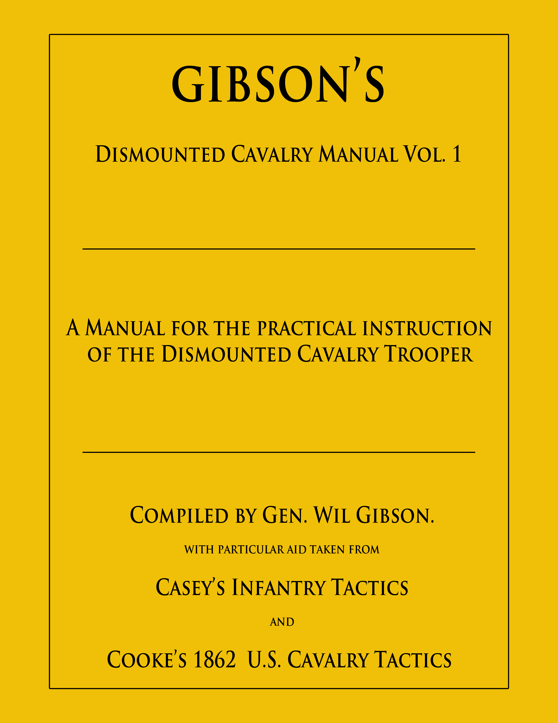

School of the Soldier

Preface
The individual instruction of the soldier is the foundation upon which the structure of the army rests. If it is complete, the operations of the army, aided by military science, may be calculated with mathematical accuracy; and unless it is carried to a certain point at least, the management on an army is a mere matter of chance, and success the result only of fortuitous circumstances.

Heretofore the enlisted soldier has been dependent upon tradition for knowledge of his specific duties; for justice he has been at the mercy of his superiors.

This manual has been designed to place the knowledge in the hands of the enlisted trooper, to help in his duties, and if desirous, to rise in rank and responsibility.

The Soldier

The soldier commands respect in proportion to his capacity and length of service. A youth of military pride and bearing, who wears his uniform with neatness and grace, and does his duty faithfully and with energy and determination, deserves admiration, and generally receives it; but the veteran whose scars and wounds are the reminders of many battles, and whose numerous service-chevrons and gray hairs mark a life devoted to the service of his country, chains the listening ear of the citizen to the story of his heroic life, and the greatest chieftain will raise his hat in respect to return his punctilious salute.

In the fullest sense, any man or woman in the military who receives pay, whether sworn in or not, is a soldier, because he/she is subject to military law. Under this general head, laborers, washerwomen, teamsters, Sutlers, chaplains, etc. are soldiers. In a more limited sense, a private soldier is a man enlisted in the military service to serve in the cavalry, infantry, or artillery. He is said to be enlisted when he has been examined, his duties of obedience explained to him, and after he has taken the prescribed oath.

“Any male person above the age of sixteen, being at least five feet three inches high; effective, able-bodied, sober, free from disease, of good character and habits, and with a competent knowledge of the English language, may be enlisted as a soldier.” (Reg. 929) This regulation makes exceptions for musicians, and grandfathers those who have served one enlistment and may be under the prescribed height.

In the case of a minor under the age of eighteen, the written consent of the parents or guardian must be appended.

The term of enlistment in this regiment is two years. A service-chevron will be awarded for each enlistment period achieved, and are to be worn on the right sleeve.
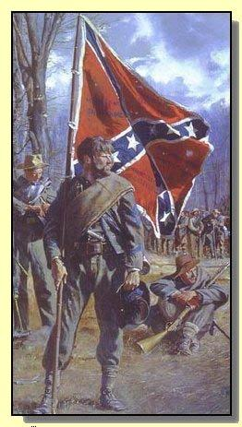
The “Typical” Johnny Reb
From the Confederate Veteran, Volume I, No. 12, Nashville, TN, Dec. 1893
Nearly thirty-three years have passed since the alarm of war called from their peaceful pursuits the citizens who were to make name and fame as Confederate soldiers. The stirring scenes and the dreadful carnage of a memorable conflict have been removed by the lapse of time into the hazy past, and a new generation, however ready it may be to honor those who fought the battles of the South, is likely to form its idea of their appearance from the conventional military type. The Confederate soldier was not an ordinary soldier, either in appearance or character. With your permission I will undertake to draw a portrait of him as he really appeared in the hard service of privation and danger.

A face browned by exposure and heavily bearded, or for some weeks unshaven, begrimed with dust and sweat, and marked here and there by the darker stains of powder - a face whose stolid and even melancholy composure is easily broken into ripples of good humor or quickly flushed in the fervor and abandon of the charge; a frame tough and sinewy, and trained by hardship to surprising powers of endurance; a form, the shapeliness of which is hidden by its encumberments, suggesting in its careless and unaffected pose a languorous indisposition to exertion, yet a latent, lion-like strength and a terrible energy of action when aroused. Around the upper part of the face is a fringe of unkempt hair, and above this an old wool hat, worn and weather-beaten, the flaccid brim of which falls limp upon the shoulders behind, and is folded back in front against the elongated and crumpled crown. Over a soiled shirt, which is unbuttoned and button less at the collar, is a ragged grey jacket that does not reach to the hips, with sleeves some inches too short. Below this, trousers of a nondescript color, without form and almost void, are held in place by a leather belt, to which is attached the cartridge box that rests behind the right hip, and the bayonet scabbard which dangles on the left. Just above the ankles each trouser leg is tied closely to the limb - a la Zouave - and beneath reaches of dirty socks disappear in a pair of badly used and curiously contorted shoes. Between the jacket and the waistband of the trousers, or the supporting belt, there appears a puffy display of cotton shirt which works out further with every hitch made by Johnny in his effort to keep his pantaloons in place. Across his body from his left shoulder there is a roll of threadbare blanket, the ends tied together resting on or falling below the right hip. This blanket is Johnny's bed. Whenever he arises he takes up his bed and walks, within this roll is a shirt, his only extra article of clothing. In action the blanket roll is thrown further back, and the cartridge is drawn forward, frequently in front of the body. From the right shoulder, across the body pass two straps, one cloth the other leather, making a cross with blanket roll on breast and back. These straps support respectively a greasy cloth haversack and a flannel-covered canteen, captured from the Yankees. Attached to the haversack strap is a tin cup, while in addition to some odds and ends of camp trumpery, there hangs over his back a frying pan, an invaluable utensil with which the soldier would be loath to part.

With his trusty gun in hand - an Enfield rifle, also captured from the enemy and substituted for the old flint-lock musket or the shotgun with which he was originally armed - Johnny reb, thus imperfectly sketched, stands in his shreds and patches a marvelous ensemble - picturesque, grotesque, unique - the model citizen soldier, the military hero of the nineteenth century. There is none of the tinsel or trappings of the professional about him. From an esthetic military point of view he must appear a sorry looking soldier. But Johnny is not one of your dress parade soldiers. He doesn't care a copper whether anybody likes his looks or not. He is the most independent soldier that ever belonged to an organized army. He has respect for authority, and he cheerfully submits to discipline, because he sees the necessity of organization to affect the best results, but he maintains his individual autonomy, as it were, and never surrenders his sense of personal pride and responsibility. He is thoroughly tractable, if properly officered, and is always ready to obey necessary orders, but he is quick to resent any official incivility, and is a high private who feels, and is, every inch as good as a general. He may appear ludicrous enough on a display occasion of the holiday pomp and splendor of war, but place him where duty calls, in the imminent deadly breach or the perilous charge, and none in all the armies of the earth can claim a higher rank or prouder record. He may be outré and ill-fashioned in dress, but he has sublimated his poverty and rags. The worn and faded grey jacket, glorified by valor and stained with the life blood of its wearer, becomes, in its immortality of association, a more splendid vestment than mail of medieval knight or the rarest robe of royalty. That old, weather-beaten slouch hat, seen as the ages will see it, with its halo of fire, through the smoke of battle, is a kinglier covering than a crown. Half clad, half armed, often half fed, without money and without price, the Confederate soldier fought against the resources of the world. When at last his flag was furled and his arms were grounded in defeat, the cause for which he had struggled was lost, but he had won the faceless victory of soldiership.

Duties of the Soldier

Deportment and Military Courtesy
One of the first things a soldier has to learn on entering the army, is a proper deportment towards his superiors in rank; this is nothing more than the military way of performing the courtesies required from a well-bred man in civil life, an a punctual performance of them is a much to his credit as the observance of the ordinary rules of common politeness.

When a soldier without arms, or with side arms only, meets an officer, he is to raise his right hand to the right side of the visor of his cap, palm to the front, elbow raised as high as the shoulder, looking at the same time in a respectful and soldier-like manner at the officer, who will return the compliment thus offered.

A non-commissioned officer or soldier being seated, and without particular occupation, will rise on the approach of an officer, and make the customary salutation. If standing he will turn toward the officer for the same purpose. If the parties remain in the same place or on the same ground, such compliments need not be repeated.

When at assigned work detail, or marching in the ranks, a soldier is not required to salute unless ordered.

In Camp or Garrison
It is the duty of the soldier, under all circumstances, to always be present with his company for duty, and attend all the standing roll-calls and exercises, unless specially excused by his commanding officer, or sick and excused by the surgeon, or is absent on duty.

The various duties to which a soldier is subject are matters of regular detail - each soldier taking his regular tour of each as it comes, and consist, in the main, of the following:
i. Guards
ii. Working Parties or Fatigue
iii. Daily Duty

The rooster for these details is kept by the first sergeant, and the longest off are the first to be detailed. The details are usually published to the company at retreat roll call for the next day.

Freely adapted from the Customs of Service for Non-Commissioned Officers and Soldiers
Kuntz – 1864

The Settee, or Comrades at Battles is the smallest military unit of infantry and cavalry, in the Army. It is the smallest unit used during the American Civil war era. A settee consists of four soldiers and are usually grouped into a squad or section.

The concept of the Settee is based on the need for tactical flexibility. A Settee is capable of autonomous operations as part of a larger unit, as in Skirmish Drill. Successful Settee employment relies on quality small unit training for soldiers, experience of members operating together, sufficient communications infrastructure, and a quality non-commissioned officer corps to provide tactical leadership for the team.

Settee team members are more effective as they build experience over time working together and building personal bonds. Each settee is lead by a Corporal, as many as four to six settees report to a Sergeant. The settee is also, in essence, a mess. The members work together, eat and sleep together and fight together.

The creation of effective Settees is essential in creating an effective professional military, as they serve as a primary group. Psychological studies have indicated that the willingness to fight is more heavily influenced by the desire to avoid failing to support other members of the Settee than by abstract concepts. Historically, those armies with an effective Settee style organization have had significantly better performance from their units in combat than those limited to operations by larger units.

General Rules and Division of the School of the Soldier as taken from Hardee's School of the Soldier and Cooke's manual.
Created for the specialized needs of the Strategically Dismounted Cavalryman

This School of the Soldier was assembled for the reenactor, strategically dismounted cavalryman. Its content is derived from a part of Col. Parson’s (12 Texas Cavalry) memoirs where he wrote of having to “take away the regiment’s horses and “fight as infantry”. He further details that because his men had been drilled in the way of the horse, that he had to find a way to maintain that rather than re-teach all they had learned. So in this vein, he sat down and in a weeks time took the proper elements of Cooks Cavalry Manual and Hardee’s School of the Soldier. I have never found a copy of this manual, so I sat down and recreated his process. Low and behold, it took about a week of evening editing to complete the work that follows.
~~~~~~~~~~~~~~~~~~~~~~~~~~~~~~~~~~~~~~~~~~
The object of this School is being the individual and progressive instruction of recruits. The instructor will never require a movement to be executed until he has given an exact explanation of it and then executes, himself, the movement that he commands, so as to join example to precept. He accustoms the recruit to take, by himself, the position that is explained, teaches him to rectify it only when required by his want of knowledge, and sees that all the movements are performed without precipitation.

Each movement should be understood before passing to another. After they have been properly executed in the order laid down in each lesson, the instructor no longer confines himself to that order; on the contrary, he should change it that he may judge of the intelligence of the men.

The instructor allows the men to rest at the end of each part of the lessons, and oftener, if he thinks proper, especially at the commencement; for this purpose he commands REST.

At the command REST, the soldier is no longer required to preserve immobility, or to remain in his place. If the instructor wishes merely to relieve the attention of the recruit, he commands, "in place-REST"; the soldier is then not required to preserve his immobility, but he always keeps one of his feet in its place.

When the instructor wishes to commence the instruction, he commands ATTENTION; at this command the soldier takes his position, remains motionless, and fixes his attention.

The School of the Soldier will be divided into three parts. The first, comprehending what ought to be taught to recruits without arms. The second is the manual of arms, and the loadings and firings. The third, the principles of alignment, the march by the front, the different steps, the march by the flank, the principles of wheeling and those of change of direction; also, long marches in quick time, double quick time and the run.

Each part will be divided into lessons, as follows:

PART FIRST (School of the Soldier)
Lesson 1.Position of the soldier without arms - Eyes right, left and front.
Lesson 2.Counting.
Lesson 2.Facings.
Lesson 3.Principles of the direct step in common and quick time.
Lesson 4.Principles of the direct step in double quick time and the run.
Lesson 5.Principles of the quick step, double quick, and the run

PART SECOND (School of the Soldier)
Lesson 1.Principles of shouldered arms.
Lesson 2.Manual of arms.
Lesson 3.To load and fire in nine times and at will.
Lesson 4.Firings, direct, oblique, by file and by rank.
Lesson 5.To fire and load, kneeling and lying.
Lesson 6.The principles of the revolver.

PART THIRD (School of the Company)
Lesson 1.Union of eight or twelve men for instruction in the principles of alignment.
Lesson 2.The direct march, the oblique march, and the different steps.
Lesson 3. The march by the flank.
Lesson 4.Principles of wheeling and change of direction.
Lesson 5.Long marches in quick time, double quick time, and the run, with arms.

Part First
This will be taught, if practicable, to four recruits at a time. The recruits will be placed in a single rank, at one pace from each other. In this part, the soldiers or new recruits will be without arms.
Lesson I Position of the soldier.
- Heels on the same line, as near each other as the conformation of the mail will permit;
- The feet turned out equally, and forming with each other something less than a right angle;
- The knees straight without stiffness
- The body erect on the hips, inclining a little forward;
- The shoulders square and falling equally;
- The arms hanging naturally;
- The elbows near the body;
- The palm of the hand turned a little to the front, the little finger behind the seem of the, pantaloons;
- The head erect and square to the front, without constraint;
- The chin near the stock, without covering it;
- The eyes fixed straight to the front, and striking the ground about the distance of fifteen paces.
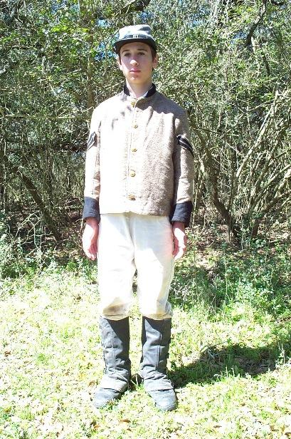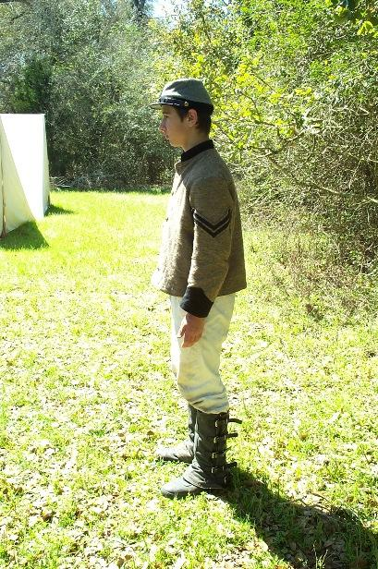
Remarks on the Position of the Soldier
Heels on the same line
Because, if one were in the rear of the other, the shoulder on that side would be thrown back, or the position of the soldier would be constrained.
Heels more or less closed
Because, men who are knock-kneed, or who have legs with large calves, cannot, without constraint, make their heels touch while standing.
The feet equally turned out, and not forming too large an angle,
Because, if one foot were turned out more than the other, a shoulder would be deranged, and if both feet be too much turned out, it would not be practicable to incline the upper part of the body forward without rendering the whole position unsteady.
Knees extended without stiffness;
Because if stiffened, constraint and fatigue would be unavoidable.
The body erect on the hips;
Because it gives equilibrium to the position. The instructor will observe that many recruits have the bad habit of dropping a shoulder, of drawing in a side, or of advancing a hip, particularly the right, when under arms. These are defects he will labor to correct.
The upper part of the body inclining forward ;
Because, commonly, recruits are disposed to do the reverse, to project the belly and to throw back the shoulders, when they wish to hold themselves erect, from which result great inconveniences in marching. The habit of inclining forward the upper part of the body is so important to contract, that the instructor must enforce it at the beginning, particularly with recruits who have naturally the opposite habit.
Shoulders square;
Because if the shoulders be advanced beyond the line of the breast, and the, back arched (the defect called round -shouldered, not uncommon with recruits,) the man cannot align himself, nor use his piece with address. It is important, then, to correct this defect, and necessary to that end that the coat should set easy about the shoulders and arm pits - but in correcting this defect, the instructor should take care that the shoulders be not thrown too much to the rear, which would cause the belly to project, and the small of the back to be, curved.
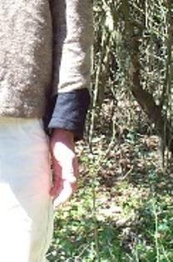
The arms hanging naturally, elbows near the body, the palm of the hand a little turned to the front, the little finger behind the seam of the pantaloons;
Because these positions are equally important to the shoulder arms, and to prevent the man from occupying more space in a rank than is necessary to their free use of the piece; they have, moreover, the advantage of keeping in the shoulders.

The face straight to the front, and without constraint;
Because, if there be stiffness in the latter position, it would communicate itself to the whole of the upper part of the body, embarrass its movements and give pain and fatigue.

Eyes direct to the front;
Because, this is the surest means of maintaining the shoulders in line- an essential object, to be insisted on and attained.

The instructor having given the position of the soldier without arms will now teach him the turning of the head and eyes. He will command:
1. Eyes RIGHT
2. FRONT.
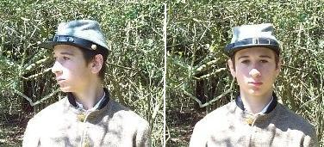
- At the word right, the recruit will turn the head gently, so as to bring the inner corner of the left eye in it line with the buttons of the coat, the eyes fixed on the line of the eyes of the men in, or supposed to be in, the same rank.
- At the second command the head will resume the direct or habitual position.
- The movement of Eyes LEFT will be executed by inverse means.
- The instructor will take particular care that the movement of the head does not derange the squareness of the shoulders, which will happen if the movement of the former be too sudden.

When the instructor shall wish the recruit to pass from the State of attention to that of ease, he will command:

REST.
TO cause a resumption of the habitual position, the instructor will command:

1. SQUAD
2. Attention
At the first word, the recruit will fix his attention; at the second, he will resume the prescribed position with steadiness.

Lesson II Counting
Each time a Squad or Company is called to form up, there will be a count. This count will give the recruit his position in rank and file, and later, on the Line. As Cavalry, the count is done in Fours. The instructor will command the Squads Attention, and further command:

1. Count by Fours
2. COUNT
At the first word, the Squad will perform Eyes Right, with the exception to the recruit furthest to the right, who will maintain his attention fixed to the Front.

At the second word, the recruit furthest to the right will loudly, and with a crisp voice say "One", to which the next recruit will respond "Two" as he returns and his fixes attention to the Front, the next, "Three" and the last "Four". When combined with other Squads, this process will continue down the line until all have been counted. The counting, when constrained by numbers, can also be done in the same manner, by “Twos”

Lesson III Facings
Facings to the right or left will be executed in two times. The instructor will command:
Squad.
1. By File
2. Right (or left) FACE.
At the second command, raise the right foot slightly, turn on the left heel raising the toes a little, and then replace the right heel by the side of the left, and on the same line.

When the words "By File" are omitted (General Rule), the Squad will at the second command wheel to the right by fours, the number 1 position being the guide. Note: "By Twos" may also be used. This will be further developed in Part Third of The Lessons.

The full face to the rear (or front) will be executed in two times. The instructor will command:
Squad.
1. About
2. FACE.

1. (First time.) At the word about, the recruit will turn on left heel, bring the left toe to the front rear, the hollow opposite to, and full heel, the feet Square to each Other.
2. (Second time.) At the word face, the recruit will turn on both heels, raise the toes a little, extend the hams, face to-the rear, bringing, at the same time, the right heel by the side of the left.
3. The instructor will take care that these motions do not derange the position of the body.

Author’s Note on the Common Step.
Common Time can still be seen in the modern military, usually in funeral processions. It is very slow and was the prevalent marching beat during the Revolutionary War. In the 1700s, the infrastructure of roads was not as well developed as during the 1860s and armies were moved across rough terrain. A slower beat was needed to be able to take each step as sure footed as possible. During the Civil War, it was less used as roads accommodated the use of quick time. In today’s reenacting, almost all marching is done at the quick step.

Lesson IV Principles of the common step
The length of the step, or pace in common time, will be twenty-eight inches, reckoning from heel to heel, and, in swiftness, at the rate of ninety in a minute.

The Instructor, seeing the recruit confirmed in his position, will explain to him the principle and mechanism of this step-placing himself six or seven paces from and facing to the recruit. He will himself execute slowly for the way of illustration, and then command:

Squad
1. forward.
2. MARCH (Quick Time)
At the first command, the recruit will throw the weight of the body on the right leg, without bending the left knee.

At the second command, he will smartly, but without a jerk, carry straight forward the left foot twenty-eight inches from the right, the sole near the ground, the ham extended, the toe a little depressed, and, as also the knee slightly turned out.- He will, at the same time, throw the weight of the body forward, and plant flat the left foot, without shock, precisely at the distance where it finds itself from the right. When the weight of the body is brought forward, the whole of which will now rest on the advanced foot. The recruit will next, in like manner, advance the right foot and plant it as above; the heel twenty-eight inches from the heel of the left foot. Thus he will continue to march without crossing the legs, or striking the one against the other, without turning the shoulders and preserving always the face directly to the front.

When the instructor shall wish to arrest the march, he will command:

1. Squad.
2. HALT
At the command Halt, which will be given at the instant when either foot is coming to the ground, the foot in the rear will be brought up, and planted by the side of the other, without shock.

The instructor will indicate, from time to time, to the recruit the cadence of the step, by giving the command one at the instant of raising a foot, and two at the instant it ought to be planted, observing the cadence of ninety steps in a minute. This method will contribute greatly to impress upon the mind the two, notions into which the Step is naturally divided.

Common time will be employed in the first and second parts of the School of the Soldier. As soon as the recruit has acquired steadiness, has become established in the principles, of shouldered arms and the mechanism, length and swiftness of the step in common time, will he be practiced in the quick time, double quick time, and the run.

The principles of the step in quick time are the same as for common time, but its swiftness is at the rate of one hundred and ten steps per minute.
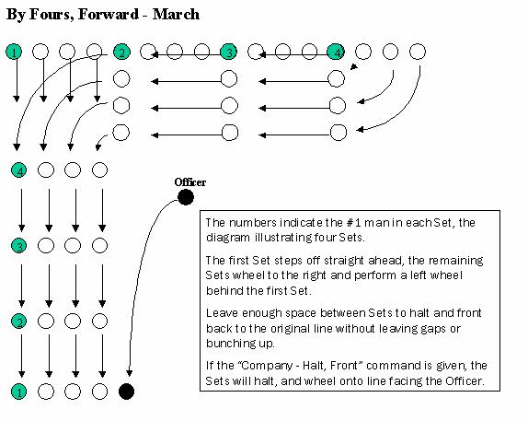

Lesson V Principles of the quick step, double quick, and the run
The length of the quick step is thirty-three inches, and its swiftness at the rate of one hundred and sixty-five steps per minute.

The instructor wishing to teach the recruits the principles and mechanism of the double quick step, will command:

1. Squad, forward at the quick step.
2. MARCH.
At the first command, the recruit will raise his hands to a level with his hips, the hands closed, the nails toward the body, the elbows to the rear.

At the second command, he will raise to the front his left leg bent, in order to give to the knee the greatest elevation. The part of the leg between the knee and the instep vertical, and the toe depressed. He will then replace his foot in its former position with the right leg he will then execute what has just been prescribed for the left, and the alternate movement of the legs will be continued until the command:

1. Squad. HALT.
At the second command, the recruit will bring the foot which is raised by the side of the other, and dropping at the same time his hands by his side, will resume the position of the soldier without arms.

The instructor placing himself seven or eight paces from, and facing the recruit, will indicate the cadence by the commands, one and two. These will be given alternately at the instant each foot should be brought to the ground, which is the same as in common time, but its rapidity will be gradually augmented.

The recruit being sufficiently established in the principles of this step, the instructor will command.

1. Squad
2. Forward at the double quick.
3. MARCH.

At the first command, the recruit will throw the weight of his body on the right leg.

At the second command, he will raise his hands to a level with his hips, the hands closed, the nails toward the body, the elbows to the rear.

At the third command he will carry forward the left foot, the leg slightly bent., the knee somewhat raised -will plant his left foot, the toe first, thirty-three inches from the right, and with the right foot will then execute what has just been prescribed for the left. This alternate movement of the leg will take place by 1 throwing the weight of the body on the foot that is planted, and by allowing a natural, oscillatory motion to the arms.

1.The double-quick step may be executed with different degrees of swiftness. Under urgent circumstances the, cadence of this step may be increased to one hundred and eighty per minute. At this rate a distance of four thousand yards would be passed over in about twenty-five minutes.
2.The recruits will be exercised also in running.
3.The principles are the same as for, the double quick step,, the only difference consisting in a greater degree of swiftness.
4.It is recommended in marching at the double quick time, or the run, that the men should breathe as much as possible through the nose, keeping the mouth closed. Experience has proved that, by conforming to this principle, a man can pass over a much longer distance and with less fatigue.

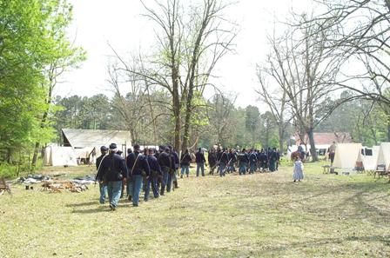
1st TX Volunteer Cavalry, 19th Corps heading to Battle
Part Second
General Rules

The Instructor will not pass the men to this second part until they shall be well established in the position of the body, and in the manner of marching at the different steps

He will then unite a squad of eight, whom he will place in the same rank, elbow to elbow, and instruct them as follows

Lesson 1.Principles of shouldered arms.
Lesson 2.Manual of arms.
Lesson 3.To load and fire in nine times and at will.
Lesson 4.Firings, direct, oblique, by file and by rank.
Lesson 5.To fire and load, kneeling and lying.

Lesson I Principles of shouldered arms
The recruit being placed as explained in the first lesson of the first part, the Instructor will cause him to bend the right arm slightly, and place the piece in it, in the following manner:

The piece in the right hand,-the barrel nearly vertical and resting in the hollow of the shoulder-the guard to the front. The arm hanging nearly at its full length near the body - the thumb, and fore-finger embracing the guard. The remaining fingers closed together, grasping the swell of the stock just under the cock, which rests on the little finger.

Recruits are frequently seen with natural defects in the conformation of the shoulders, breast and hips. These, the instructor will labor to correct in the lessons without arms, and afterwards, by steady endeavors, so that the appearance of the places, in the same line, may be uniform, and this without constraint to the men in their positions.

The Instructor will have occasion to remark that recruits, on first bearing arms, are liable to derange their position by lowering the right shoulder and the right hand, or by sinking the hip and spreading out the elbows.

He will be careful to correct all these faults by continually rectifying the position. He will sometimes take away the piece to replace it the better; he will avoid fatiguing the recruits too much in the evening, but labor by degrees to render this position so natural and easy that they may remain in it a long time without fatigue.

Finally, the instructor will take great care that the piece, at a shoulder, be not carried too high nor too low. If too high, the right elbow would spread out, the soldier would occupy too much space in his rank, and the piece be made to waver. If too low, the files would be too much closed, the soldier would not have the necessary space to handle his piece with facility, the right arm would become too much fatigued, and would draw down the shoulder.

The Instructor, before passing to the second lesson, will cause to be repeated the movements of eyes right, left, front, and the facings.

Lesson II Manual of arms
The manual of arms will be taught to eight men, placed, at first, in one rank, elbow to elbow, and afterwards in two ranks of four.

Each command will be executed in one time (or pause), but this time will be divided into motions, the better to make known the mechanism.

The rate (or swiftness) of each motion, in the manual of arms, with the exceptions herein indicated, is fixed at the ninetieth part of a minute. In order not to fatigue the attention, the instructor will, at first, look more particularly to the execution of the motions, without requiring a nice observance of the cadence, to which he will bring the recruits progressively. In a short time they shall have become a little familiarized with the handling of the piece.

The Instructor will labor to cause these motions to be executed with promptness, and above all, with regularity

The last syllable of the command will decide the brisk execution of the first motion of each time (or pause).The commands two, three, and four, will decide the brisk execution of the other motions. As soon is the recruits shall well comprehend the positions of the several motions of a time, they will be taught to execute the time without resting on its different motions. The mechanism of the time will nevertheless be observed, as well to give a perfect use of the piece, as to avoid the sinking of, or slurring over either of the motions.

The manual of arms will be taught in the following progression: The, instructor will command:
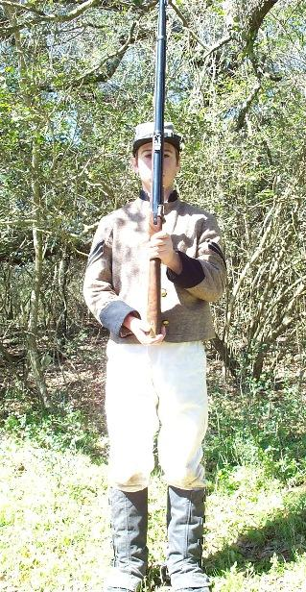
Support- ARMS.
One time and three motions.
(First motion.) Bring, the piece, with the right hand, perpendicularly to the front and between the eyes the barrel to the rear; seize the piece with the left hand at the lower hand, raise this hand as high as the chin, and seize the piece at the same time with the right hand four inches below the cock.
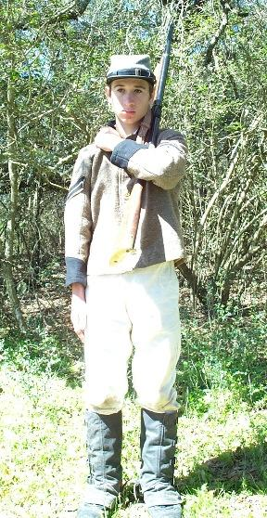
(Second motion.) Turn the piece with the barrel to the front; carry the piece to the left shoulder, and pass the fore-arm extended on the breast between the right hand and the cock; support the cock against the left fore-arm, the left hand resting on the right breast.

(Third motion.) Drop the right hand by the side.

When the instructor may wish to give repose in this position, he will command:

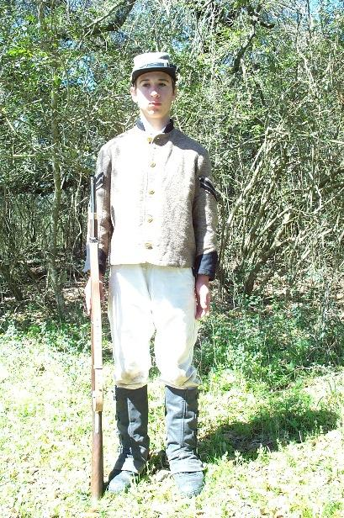
REST.

At this command, the recruits will bring up smartly the right hand to the handle of the piece (small of the stock), when to preserve silence, or steadiness of they will not be required to position.

When the instructor may wish the recruits to pass from this position to that of silence and steadiness, he will command:

1. Attention.
2. SQUAD.
At the Second word., the recruits will resume the position of the third motion of support arms

Shoulder- ARMS.
One time and three motions.

(First motion.) Grasp the piece with the right hand under and against the left fore-arm; seize it with the left hand at the lower band, the thumb extended; detach the piece slightly from the shoulder, the left fore-arm along the stock.

(Second motion.) Carry the piece vertically to the right shoulder with both hands, the rammer to the front. Change the position of the right hand so as to embrace the guard with the thumb and fore-finger. Slip the left hand to the height of the shoulder, the fingers extended and joined, the right arm nearly straight.

(Third motion.) Drop the left hand quickly by the Side.
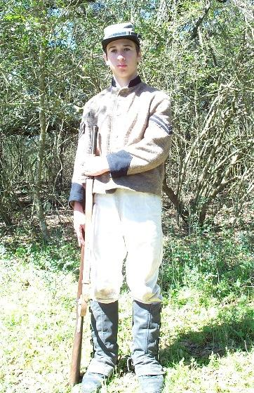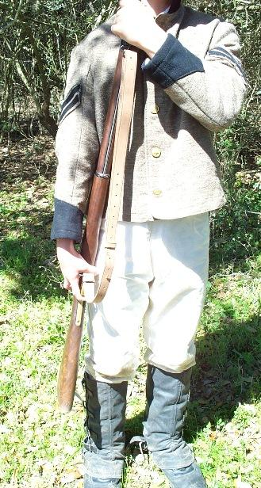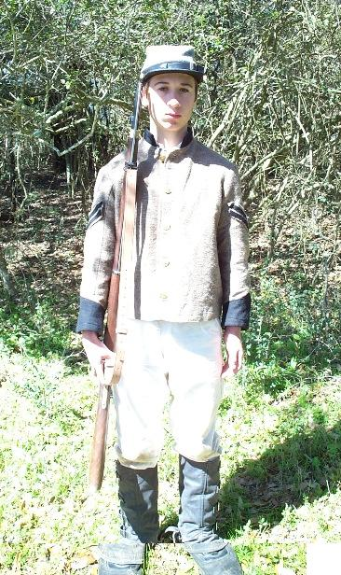

Present- ARMS
One time and two motions.

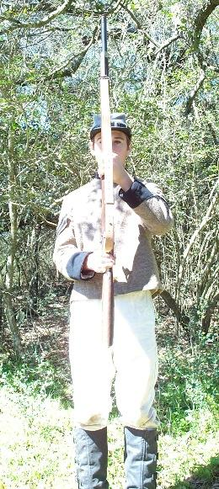
(First motion.) With the right hand bring the piece erect before the center of the body, the rammer to the front; at the same time seize the piece with the left hand half-way between the guide sight and lower band, the thumb extended along the barrel and against the stock, the, fore-arm horizontal and resting against the body, the band as high as the elbow.

(Second motion.) Grasp the small of the stock with the right hand below and against the guard.

Shoulder- ARMS.
One time and two motions.

(First motion.) Bring the piece to the right shoulder, at the same time change the position of the right band so as to embrace the guard with the thumb and fore-finger, slip up the left hand to the height of the shoulder, the fingers extended and joined, the right arm nearly Straight.

(Second motion.) Drop the left hand quickly by the Side.

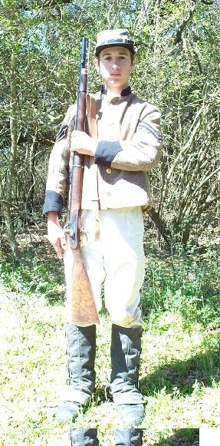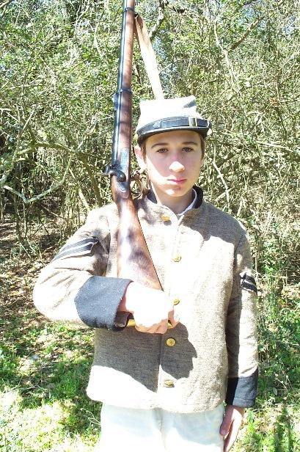

Order- ARMS.
One time and two motions.

(First motion.) Seize the piece briskly with the left hand near the upper band, and detach it slightly from the shoulder with the right hand -loosen the grasp of the right hand, lower the piece with the left, re-seize the piece with the right band above the lower band, the little finger in rear of the barrel, the butt about four inches from the ground, the right hand supported against the hip, drop the left hand by the side.

(Second motion.) Let the piece slip through the right hand to the ground by opening slightly the fingers, and take the position about to be described. Position of order arms

The hand low, the barrel between the thumb and fore-finger extended along the stock; the other fingers extended and joined; the muzzle about two inches from the right shoulder; the rammer in front; the toe (or beak) of the butt, against, and in a line with, the too of the right foot, the barrel perpendicular.

Trail- ARMS
One time and two motions.

(First motion.) The same as the first motion of order arms.
(Second motion.) Incline the muzzle slightly to the front, dip the right shoulder and slide the right hand down the piece to corresponding distance, and re-square the shoulders. The butt of the piece will rise to the rear and about four inches from the ground.

When the instructor may wish to give repose, he will command:

REST.

At this command, the recruits will not be required to preserve silence or steadiness.

When the instructor may wish the recruits to pass from this position to that of silence and steadiness, he will command:

1. Attention. 2.SQUAD.
At the second word, the recruits will resume the position of order arms.

Shoulder- ARMS.
One time and two motions.

(First motion.) Raise the piece vertically with the right hand to the height of the right breast, and opposite the shoulder, the elbow close to the body; seize the piece with the left hand below the right, and drop quickly the right hand to grasp the piece at the Swell of the stock, the thumb and fore-finger embracing the guard; press the piece against the shoulder with the left hand, the right arm nearly straight.

(Second motion.) Drop the left hand quickly by the side.

Right shoulder shift- ARMS.
One time and two motions.

(First motion.) Detach the piece perpendicularly from the shoulder with the right hand, and seize it with the left between the lower band and guide-sight, raise the piece, the left hand at the height of the shoulder and four inches from it; place, at the same time, the right hand on the butt, the beak between the first two fingers, the other two fingers under the butt plate.

(Second motion.) Quit the piece with the left hand, raise and place the piece on the right shoulder with the right hand, the look plate upwards; let fall, at the same time, the left hand by the aide.

Arms- AT WILL.
One time and one motion.

At this command, carry the piece at pleasure on either shoulder, with one or both bands, the muzzle either elevated, or pointing directly down, if slung.

Ground- ARMS.
One time and two motions.

(First motion.) Turn the piece with the right hand, the barrel to the left; at the same time seize the cartridge box with the left hand, bend the body, advance the left foot, the heel opposite the lower band. Lay the piece on the ground with the right hand, the toe of the butt on a line with the right toe, the knees slightly bent, the right heel raised.

(Second motion.) Rise up, bring the left foot by the side of the right, quit the cartridge box with the left hand, and drop the hands by the side.

Recover ARMS
One time and two motions.

(First motion.) Seize the cartridge box with the left hand, bend the body, advance the left foot opposite the lower band, and seize the piece with the right hand.

(Second motion.) Raise the piece., bringing the left foot by the side of the right; turn the piece with the right hand, the rammer to the front; at the same time quit the cartridge box with the left hand, and drop this hand by the side.

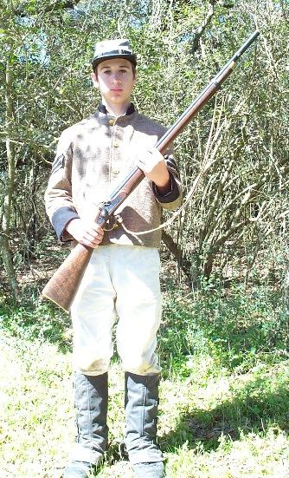
Port Arms Arms at the Ready

Inspection-ARMS.
One time and two motions.

(First motion.) Seize the piece with the left hand below and near the upper band, carry it with both bands opposite the middle of the body, the butt between the feet, the rammer to the rear, the barrel vertical, the muzzle about three inches from the body; grasp the piece with the left hand below and near the upper band, seize the rammer with the thumb and fore-finger of the right band bent, the other fingers closed.

(Second motion.) Draw the rammer, and let it glide to the bottom of the bore, replace the piece with the left hand opposite the right shoulder, and retake the position of ordered arms.

The instructor will then inspect in succession the piece of each recruit, in passing along the front of the rank. Each, as the instructor reaches him, will raise smartly his piece with his right hand, seize it with the left between the lower band and guide sight, the lock to the front, the left hand at the height of the chin, the piece opposite to the left eye; the instructor will take it with the right hand at the handle, and, after inspecting it, will return it to the recruit, who will receive it back with the right hand, and replace it in the position of ordered arms.

When the instructor shall have passed him, each recruit will retake the position proscribed at the command inspection arms, return the rammer, and resume the position of ordered arms.
Lesson III To load and fire in nine times and independently
Editor's note This section deviates from Hardee's only to accommodate the Cavalryman's use of carbines, lack of use of the rammer in reenacting, and the practice of coming to Ready, when loaded.

1.LOAD

Left foot on the line and right foot behind and to the right about one foot, and turned outward, Place the butt inside the left foot. With the barrel to the front; seize it with the left hand near the muzzle, which should be about 20 degrees away from the body; carry the right hand to the cartridge box.
Whenever the loadings and firings are to be executed, the instructor will cause the cartridge box to be brought to the side, adjacent the cap pouch, so as to ride on the right hip.
1. Handle-CARTRIDGE.
One time and one motion.
Seize the cartridge with the thumb and next two fingers, and place it between the teeth.
2. Tear-CARTRIDGE.
One time and one motion.
Tear the paper to the powder, hold the cartridge upright between the thumb and first two fingers, near the top; in this position place it in front of and near the muzzle-- the back of the hand to the front.
3. Charge- CARTRIDGE.
One time and one motion.
Empty the powder into the barrel, and discard
1. RAM
Raise the piece about 6" and strike the Butt-plate against the ground
2. PRIME
One time and two motions.
(First motion.) With the left hand raise the piece till the hand is as high as the eye, grasp the small of the stock with the right hand. Slip the left hand down to the lower band, the thumb along the stock, the left elbow against the body; bring the piece to the right side, the butt below the right forearm the small of the stock against the body and two inches below the right breast, the barrel upwards, the muzzle on a level with the eye.
(Second motion.) Half cock with the thumb of the right hand the fingers supported against the guard and the small of the stock. Remove the old cap with one of the fingers of the right hand. With the thumb and fore-finger of the same hand take a cap from the pouch, place it on the nipple and press it down with the thumb; seize the small of the stock with the right hand.
3. ARMS at the READY
One time and one motion.
(First motion.) Support t the piece with the left hand, barrel at about thirty degrees and pointed straight ahead. Grasp the piece with the right hand at the wrist, thumb on the hammer. Do not insert a finger into the guard.
The Firing Commands.
4. PRESENT
One time and one motion.
Raise the piece with both hands, bringing the piece to FULL COCK. Support the butt against the right shoulder; the left elbow down, the right as high as the shoulder. Incline the head upon the butt, so that the right eye may perceive quickly the notch of the hausse, the front sight, and the object aimed at; the left eye closed, the right thumb extended along the stock, the fore-finger on the trigger.
5. FIRE
One time and one motion.

Press the fore-finger against the trigger, fire, without lowering or turning the head.

Instructors will be careful to observe when the men fire, that they aim at some distinct object, and that the barrel be so directed that the line of fire and the line of sight be in the same vertical plane. They will often cause the firing to be executed on ground of different inclinations, in order to accustom the men to fire at objects either above or below them.

To Load and Independent Fire

LOAD
One time and one motion.

Bring down the piece with both hands, and immediately begin to repeat the above steps.

Commence Independent FIRE.

Fire and repeat the above steps as quickly as possible.

If, the instructor should not wish the recruits to reload, he will command.

Cease FIRING.
The recruit should discontinue firing and hold.

Recover-ARMS.
One time and one motion.

At the first part of the command, withdraw the finger from the trigger; at the command arms, retake the position of the second motion of ready.

The recruits being in the position of the second motion of ready, if the instructor should wish to bring them to it shoulder, he will command:

Lesson IV Firings, direct, and to the oblique
It will become necessary during battle to direct fire, direct (straight ahead), or off to one side or the other (right or left oblique). When necessary, the officer giving firing commands will order the following during step 8 of the sequence of commands.

To the Left (or Right) oblique.

PRESENT

At which time the recruit will move the barrel of the gun about 45 degrees (or to the angle of the target)

FIRE

Lesson V To fire and load kneeling and lying
In this exercise the squad will be supposed unloaded and drawn up in one rank. The instruction will be given to each man individually, without times or motions, and in the following manner.

The Instructor will command:

KNEEL - LOAD

At this command, the recruit will halt; then carry the right foot to the rear and to the right of the left heel, and in a position convenient for placing the right knee upon the ground in bending the left leg. Place the right knee upon the ground, lower the piece, the left fore-arm supported upon the thigh on the same side, the right hand on the small of the stock, the butt resting on the ground in front of the right knee and thus seat himself, comfortably on the right heel with the barrel pointed away from the body about 20 degrees.

Follow the load by nine sequence and when finished, place the right hand behind the trigger guard, grasping the wrist and come to the ready with the butt of the piece resting on the right thigh, the left hand supporting the piece near the lower hand.

The Instructor will command:
FIRE AND LOAD LYING.

In this exercise the squad will be in one rank and loaded: the instruction will be given individually and without times or motions.

At this command the squad will halt. Each recruit, as directed will take three paces forward, drop on both knees, and place himself on the ground flat on his belly. In this position he will support the piece nearly horizontal with the left hand, holding it near the lower band, the butt end of the piece and the left elbow resting on the ground, the barrel uppermost;

PRESENT

Cock the piece with the right hand, and carry this hand to the small of the stock; raise the piece with both hands, press the butt against the shoulder, and resting on both elbows.

FIRE
As soon is he has fired, bring the piece down and turn upon his left side, still resting on his left elbow brim, back the piece until the cock is opposite his breast, the butt end resting on the ground

Take out a cartridge with the right hand; seize the small of the stock with this hand, holding the cartridge with the thumb and two first fingers he will then throw himself on his back still holding the piece with both hands; carry the piece to the rear, place the butt between the heels, the barrel up, the muzzle elevated.

In this position, charge the cartridge, then take the piece in both hands and raise the muzzle of the piece straight in the air and strike the butt to the ground on your right side to "ram" the load.

At this time the recruit will roll back to his left side, half cock and prime, then roll on to his belly and reassume the prone firing position.

RISE

When so ordered the man will rise and resume his position in the ranks.

The second man will be taught what has just been prescribed for the first, and so on throughout the squad.

Lesson VI The principles of the revolver
In this exercise the squad will be drawn up in one rank, composed of men who have been issued, or own, revolvers.

The instructor will command:

Ground - ARMS.
The instruction will be given to each man individually, by having him take three paces forward, and in the following manner.

Prepare to withdraw REVOLVERS.
At which time the recruit will un-flap his holster with the left hand and grasp the piece, by the grip, with his right hand. The left hand will then drop to position.

Withdraw REVOLVERS.
At this command the recruit will pull the piece from it's holster, and raise it, so that his upper arm is parallel to the ground, and his forearm is perpendicular to it, with the muzzle pointed directly up.(At this time the recruit should be selecting a target)

PRESENT
At this command, the recruit will lower his forearm, while simultaneously cocking the piece with his thumb, and taking aim at his intended target.

FIRE
Once fired the recruit will raise his forearm to the perpendicular position, awaiting the next command.

Recover REVOLVERS.
Open the holster flap with the left hand and return the piece to its place, secure the flap.

