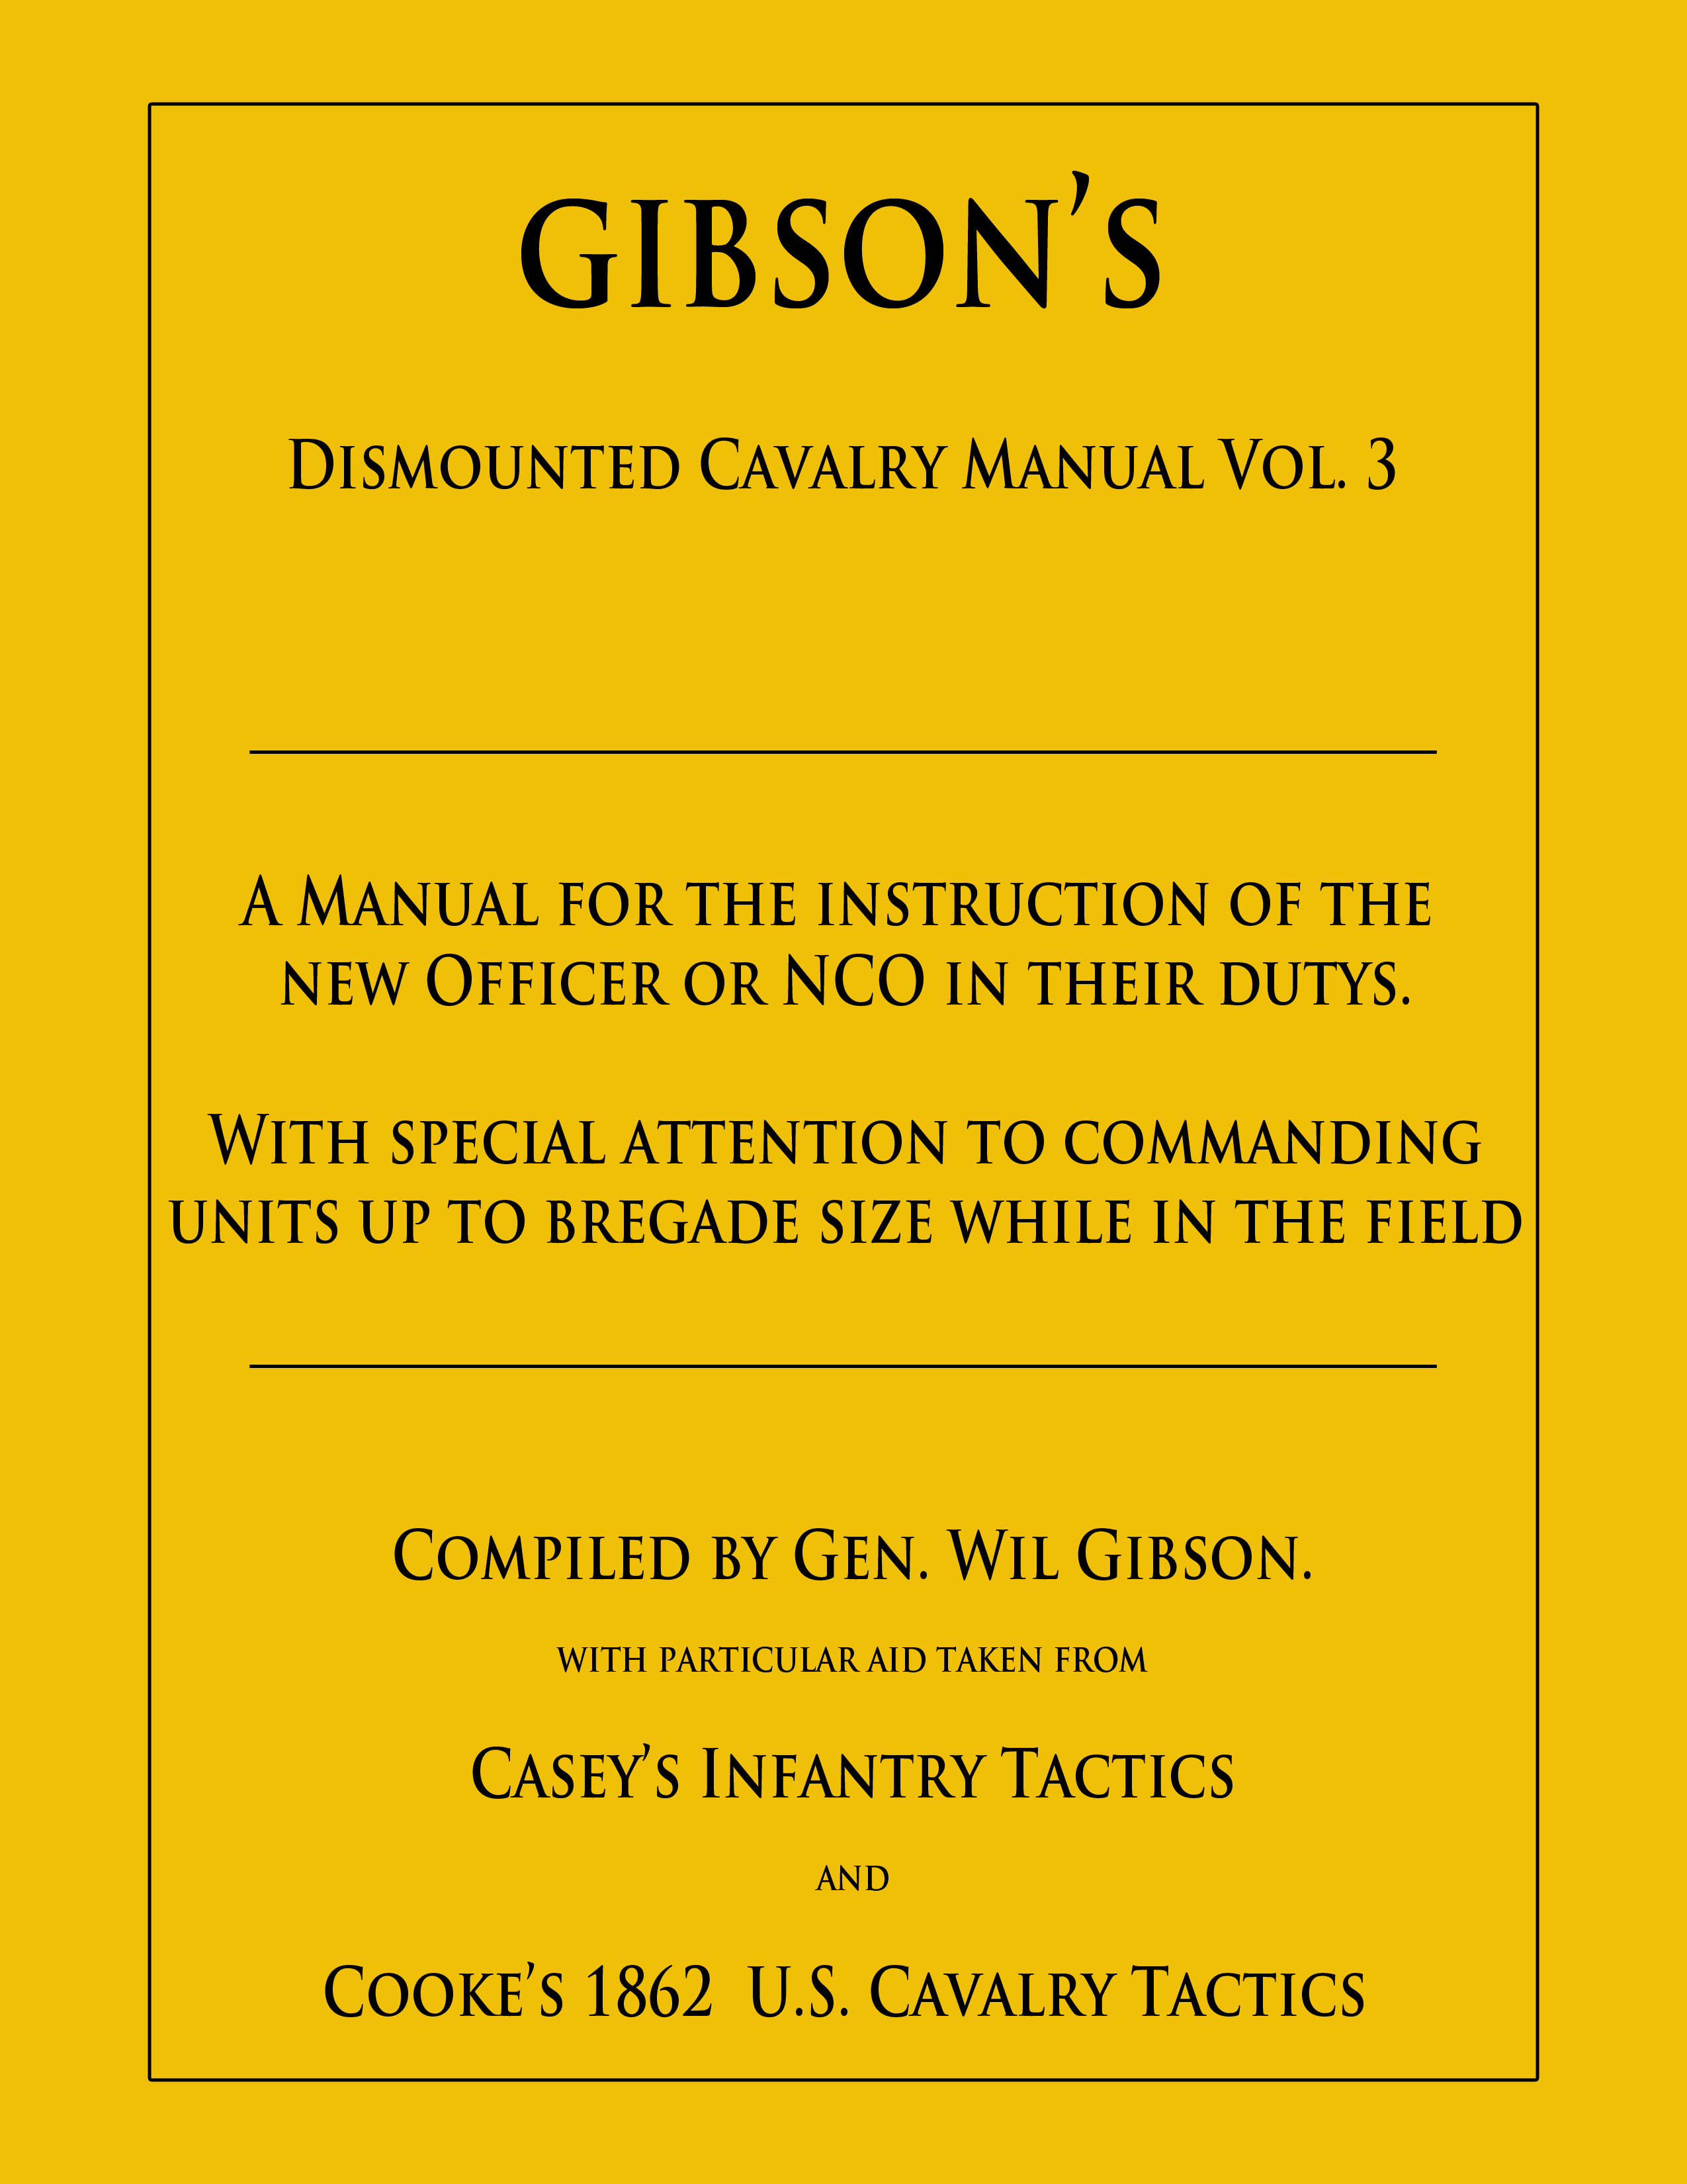

School of the Officer
and NCO

School of the Officer and NCO

History of the NCO
You are a leader in the same Army that persevered at Valley Forge, held its ground at the Little Round Top, turned the tide of a war at St. Mihiel and began the liberation of a continent at Omaha Beach. You lead soldiers from the same Army that burst out of the Pusan Perimeter, won against enormous odds at La Drang Valley, fought with determination at Mogadishu and relieved terrible misery in Rwanda. Leaders like you and soldiers like yours conducted intense combat operations in Afghanistan while only a short distance away others supported that nation’s rebuilding and still others fought fires in the northwestern US. Throughout the history of the Army the NCO has been there, leading soldiers in battle and training them in peacetime, leading by example and always, always – out front.

The Revolution to the Civil War
The history of the United States Army and of the noncommissioned officer began in 1775 with the birth of the Continental Army . The American noncommissioned officer did not copy the British. He, like the American Army itself, blended traditions of the French, British and Prussian armies into a uniquely American institution. As the years progressed, the American political system, with its disdain for the aristocracy, social attitudes and the vast westward expanses, further removed the US Army noncommissioned officer from his European counterparts and created a truly American noncommissioned officer.

The Revolution
In the early days of the American Revolution, little standardization of NCO duties or responsibilities existed. In 1778, during the long hard winter at Valley Forge, Inspector General Friedrich von Steuben standardized NCO duties and responsibilities in his Regulations for the Order and Discipline of the Troops of the United States (printed in 1779). His work, commonly called the Blue Book, set down the duties and responsibilities for corporals, sergeants, first sergeants, quartermaster sergeants and sergeants major, which were the NCO ranks of the period. The Blue Book also emphasized the importance of selecting quality soldiers for NCO positions and served a whole generation of soldiers as the primary regulation for the Army for 30 years. In fact, part of Von Steuben’s Blue Book is still with us in FM 22-5, Drill and Ceremonies and other publications.

Von Steuben specified duties of the noncommissioned officer. The Sergeant Major served as the assistant to the regimental adjutant, keeping rosters, forming details and handling matters concerning the "interior management and discipline of the regiment." The Sergeant Major also served “at the head of the noncommissioned officers.” The Quartermaster Sergeant assisted the regimental quartermaster, assuming his duties in the quartermaster's absence and supervising the proper loading and transport of the regiment's baggage when on march. The First Sergeant enforced discipline and encouraged duty among troops, maintaining the duty roster, making morning report to the company commander and keeping the company descriptive book. This document listed the name, age, height, place of birth and prior occupation of every enlisted man in the unit.

The day-to-day business of sergeants and corporals included many roles. Sergeants and Corporals instructed recruits in all matters of military training, including the order of their behavior in regard to neatness and sanitation. They quelled disturbances and punished perpetrators. They forwarded sick lists to the First Sergeant. In battle, NCOs closed the gaps occasioned by casualties, encouraged men to stand their ground and to fire rapidly and accurately. The development of a strong NCO Corps helped sustain the Continental Army through severe hardships to final victory. Von Steuben’s regulations established the foundation for NCO duties and responsibilities from 1778 to the present.

During the early stages of the American Revolution the typical Continental Army NCO wore an epaulet to signify his rank. Corporals wore green and sergeants wore red epaulets. After 1779, sergeants wore two epaulets, while corporals retained a single epaulet. From the American Revolution to World War II the noncommissioned officer received his promotion from the regimental commander. Entire careers were often spent within one regiment. If a man transferred from one regiment to the next, he did not take his rank with him. No noncommissioned officer could transfer in grade from one regiment to another without the permission of the General in Chief of the Army; this was rarely done. Without permanent promotions of individuals, stripes stayed with the regiment.

The Purple Heart
Three NCOs received special recognition for acts of heroism during the American Revolution. These men, Sergeant Elijah Churchill, Sergeant William Brown and Sergeant Daniel Bissell, received the Badge of Military Merit, a purple heart with a floral border and the word "merit" inscribed across the center. In practice this award was the precursor to the Medal of Honor introduced during the Civil War. After a long period of disuse, Badge of Military Merit was reinstituted in 1932 as the Purple Heart and is a decoration for members of the armed forces wounded or killed in action or as a result of a terrorist attack.

Rank Insignia
In 1821 the War Department made the first reference to noncommissioned officer chevrons. A General Order directed that sergeants major and quartermaster sergeants wear a worsted chevron on each arm above the elbow; sergeants and senior musicians, one on each arm below the elbow; and corporals, one on the right arm above the elbow. This practice ended in 1829 but returned periodically and became a permanent part of the NCO’s uniform before the Civil War.
In 1825 the Army established a systematic method for selecting noncommissioned officers. The appointment of regimental and company noncommissioned officers remained the prerogative of the regimental commander. Usually regimental commanders would accept the company commander's recommendations for company NCOs unless there were overriding considerations. The Abstract of Infantry Tactics, published in 1829, provided instructions for training noncommissioned officers. The purpose of this instruction was to ensure that all NCOs possessed "an accurate knowledge of the exercise and use of their firelocks, of the manual exercise of the soldier and of the firings and marchings."

Field officers and the adjutant frequently assembled noncommissioned officers for both practical and theoretical instruction. Furthermore, field officers ensured that company officers provided proper instruction to their noncommissioned officers. The sergeant major assisted in instructing sergeants and corporals of the regiment. Newly promoted corporals and sergeants of the company received instruction from the First Sergeant. The first sergeant of that time, like today, was a key person in the maintenance of military discipline.

The Civil War
During the 1850's major changes occurred in US Army weaponry. Inventors developed and refined the percussion cap and rifled weapons. Weapons like the Sharps carbine added greatly to fire power and accuracy. The increased lethality of weapons did not immediately result in different tactics. The huge numbers of casualties in the American Civil War proved that technological advances must result in changes to battlefield tactics. Operationally, the Civil War marked a distinct change in warfare. No longer was it sufficient to defeat an enemy’s army in the field. It was necessary to destroy the enemy’s will and capacity to resist through military, economic and political means. This became the concept of total war. The war required a large number of draftees and unprecedented quantities of supplies.

During the Civil War, noncommissioned officers led the lines of skirmishers that preceded and followed each major unit. NCOs also carried the flags and regimental colors of their units. This deadly task was crucial to maintain regimental alignment and for commanders to observe their units on the field. As the war progressed, organizational and tactical changes led the Army to employ more open battle formations. These changes further enhanced the combat leadership role of the noncommissioned officer. New technology shaped the Army during the Civil War: railroads, telegraph communications, steamships, balloons and other innovations. These innovations would later impact the noncommissioned officer rank structure and pay.

Since its founding on 14 June 1775, the Army normally expanded in wartime with volunteers, with the professional soldiers forming the basis for expansion. The Civil War in particular brought a huge increase in the number of volunteer soldiers. This policy endured to some extent until world commitments and the stationing of troops overseas in the 20th century required the Nation to maintain a strong professional force.

In the post-Civil War era the Artillery School at Fort Monroe reopened to train both officers and noncommissioned officers. In 1870 the Signal Corps established a school for training officers and noncommissioned officers. Because both the Artillery and the Signal Corps required soldiers to have advanced technical knowledge to operate complex equipment and instruments, these were the first schools established. Efforts to provide advanced education for noncommissioned officers in other less technical fields, however, failed to attract supporters. Army leaders thought experience and not the classroom made a good NCO.

Duties and Responsibilities of Officers and NCOs
Captains will be held responsible for the theoretical and practical instruction of their noncommissioned officers, and the adjutant for the instruction of the non-commissioned staff. To this end, they will require these tactics to be studied and recited, lesson-by-lesson; and when instruction is given on the ground, each noncommissioned officer, as he explains a movement, should be required to put it into practical operation.

The non-commissioned officers should also be practiced in giving commands. Each command, in a lesson, at the theoretical instruction, should first be given by the instructor, and then repeated, in succession, by the non-commissioned officers, so that while they become habituated to the commands, uniformity may be established in the manner of giving them.

In the school of the soldier, the company officers will be the instructors of the squads; but if there be not a sufficient number of company officers present, intelligent sergeants maybe substituted; and two or three squads, under sergeant instructors, be superintended, at the same time) by an officer.

In the school of the company, the lieutenant colonel and the majors, under the colonel, will be the principal instructors, substituting frequently, the captain of the company, and sometimes one of the lieutenants; the substitute, as far as practicable, being superintended by one of the principals.

Individual instruction being the basis of the instruction of companies, on which that of the regiment depends, and the first principles having the greatest influence upon this individual instruction, classes of recruits should be watched with the greatest care.

Instructors will explain, in a few clear and precise words, the movement to be executed; and not to overburden the memory of the men, they will always use the same terms to explain the same principles.

They should often join example to precept, should keep up the attention of the men by an animated tone, and pass rapidly from one movement to another, as soon as that which they command has been executed in a satisfactory manner.

Instruction of Officers

Officers and Non-Commissioned officers are entitled to implicit obedience from the soldiers, and they should be obeyed and respected by the men.

The confidence of the soldiers in the integrity of officers and NCOs can only be obtained by his being rigidly just and impartial to those under him, and by keeping his temper on all occasions, and discharging his duty without passion or feeling. An officer or NCO who cannot control himself will find difficulty in controlling those whom he is placed in command over.

Confidence and energy are the progressive traits of officers and NCOs who will be successful. Let him first feel he is right, and acting in obedience to orders and instructions, and then do his duty with decision and firmness; and success will be more certain, and failure much less discreditable.

The instruction of officers can be perfected by joining theory to practice. The colonel will often practice them in marching and in estimating distances, and he will carefully endeavor to cause them to take steps equal in length and swiftness.

The instruction of officers will include all the Titles in this system of drill, as well as a perfect knowledge of the system of firing.

Every officer will make himself perfectly acquainted with the bugle signals. This knowledge, so necessary in general instruction, becomes of vital importance on actual service in the field.

Commissioned Officers
“The utmost attention will be paid by commanders of companies to the cleanliness of their men, as you their persons, clothing, arms, accouterments, and equipments, and also as to their quarters or tents." Regulations for the Army of the Confederate States, 1863

Colonel
A Colonel In the United States Army is a field grade officer rank. A colonel ranks above lieutenant colonel and below brigadier general. Colonel is equivalent to the rank of captain in the other uniformed services.

The rank of Colonel was relatively rare in the early 19th century, due in part that the United States Army was very small in size and the rank of Colonel was usually obtained only after long years of service. During the War of 1812, many temporary Colonels were appointed but these commissions were either considered brevet ranks or the commissions were canceled at the war’s conclusion.
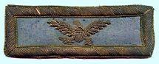
Shoulder Strap from an infantry Colonel in the Union Army.
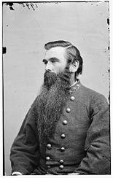
A Colonel of the Confederate Army wearing the three star insignia.

The American Civil War saw a large influx of Colonels as the rank was commonly held in both the Confederate Army and Union Army by those who commanded a regiment. Since most regiments were state formations and were quickly raised, the Colonels in command were known by the title “Colonel of Volunteers”, in contrast to Regular Army Colonels who held ranks from the “old school” of the professional army before the Civil War.

During the Civil War, the Confederate Army maintained a unique insignia for Colonel being that of three stars worn on the collar of a uniform. Robert E. Lee wore this insignia in respect to his former rank in the United States Army. Lee refused to wear the insignia of a Confederate General, stating that he would only accept permanent promotion when the South had achieved independence.

After the Civil War, the rank of Colonel again became rare as the forces of the United States Army became extremely small in number. Many Brevet Colonels also appeared during the Spanish American War, chief among them Theodore Roosevelt.

Lt Colonel
The rank of lieutenant colonel was first created during the Revolutionary War, when the position was held by aides to Regiment Colonels, and was sometimes known as "Lieutenant to the Colonel." The rank of Lieutenant Colonel had existed in the British Army since at least the 16th century.

During the 19th century, lieutenant colonel was often a terminal rank for many officers, since the rank of "full colonel" was considered extremely prestigious reserved only for the most successful of officers. Upon the outbreak of the Civil War, the rank of Lieutenant Colonel became much more common and was used as a "stepping stone" for officers who commanded small regiments or battalions and were expected, by default, to be promoted to full Colonel once the manpower of a regiment grew in strength. Such was the case of Joshua Lawrence Chamberlain, who commanded a Maine Regiment as both a lieutenant colonel and later as a colonel.

After the Civil War ended, those officers remaining in the U.S. armed forces found lieutenant colonel to again be a terminal rank, although many lieutenant colonels were raised to higher positions in a brevet status. Such was the case with George A. Custer, who was a lieutenant colonel in the regular army, but held the brevet rank of major general.

The 20th century saw lieutenant colonel in its present day status although, during the 1930s, many officers again found the rank to be terminal as the rank of colonel was reserved for only a select few officers. Such was not the case during World War II, when lieutenant colonel became one of the most commonly held officer ranks in the U.S. Army.

Major
A major in the U.S. Army typically serves as a battalion executive officer or as the battalion operations officer. A major can also serve as a primary staff officer for a brigade in the areas concerning personnel, logistical and operations. In addition, majors command augmented companies in Combat Service and Service Support units. U.S. Army majors also command U.S. Army Special Operations companies such as a Special Forces Operational Detachment Bravo (ODB), Civil Affairs (CA) company or Psychological Operations company.

American Civil War (Union)
During the American Civil War the Union forces continued to use the same rank structure previously established for the Army and Marine Corps.

American Civil War (Confederate)
Prior to the American Civil War the rank structure for the military forces of the United States were modeled after the British rank insignia. After the southern states seceded and became the Confederate States of America, the Confederate Army developed their own system of rank identification for its officers.

The new confederate rank of Major was to be indicated on the collar and in rows of gold lace forming an Austrian knot on each sleeve. Previously, the United States military at that time indicated rank by systems using epaulettes, chevrons, or shoulder straps so this new style differed greatly from the system used by Union forces.

Aide-de-Camp
Aides-de-camps are specifically appointed to general-grade officers only. For those general officers with more than one aide, the senior-ranking aide is usually considered to be the senior aide and serves in the capacity of coordinating the other aides and the others of the general's personal staff such as his driver, orderlies, et cetera.

The following is a listing of the accepted number of aides allotted a general officer:
- Brigadier General: 1 First Lieutenant
- Major General: 1 Captain; 1 Lieutenant
- Lieutenant General: 1 Major; 1 Captain
- General: 1 Lieutenant Colonel, 1 Major, 1 Captain
- General of the Army: 1 Colonel, 1 Lieutenant Colonel, 1 Major

Lieutenant Colonels and Colonels commanding units do not have aides, but it is generally accepted that the unit's adjutant also serves the commanding officer as an aide.

The Aide-de-Camp handles brigade paperwork, including making required reports to Brigade Headquarters, and letters and reports as required. Receives company morning reports at events where consolidated morning reports are required. Produces or oversees production of a daily consolidated brigade morning report for Brigade headquarters as required in the field. Signs for orders received from higher headquarters and passes them on to the Brigadier. Produces daily schedule and posts it on battalion bulletin board. Attends meetings at higher headquarters as required. Stands in for field-grade brigade officers at meetings at higher headquarters as needed. Reviews guard mount when formal guards are required. Places company markers for formal reviews as directed by reviewing officer. Attends to the Brigadier in the field, doing duty at his pleasure as brigade marker, messenger, and overall assistant. Refers to Regulations and General Orders to resolve potential problems as they arise. Takes primary responsibility for the brigade colours.

In some circles of the military, an Aide-de-Camp is known as a dog-robber, because the aide is expected to rob anyone including the family dog, to get his general what he wants.

Ordinance Officer
Oversees weapons inspections as assigned by higher headquarters. Inspects weapons within the brigade as required. Makes field repairs on weapons or suggests needed repairs as needed. Produces report to higher headquarters at events on condition of weapons inspected as needed. He instructs brigade personnel on use and care of weapons as needed. Liaisons with chief ordnance officer at higher headquarters at each event to learn specific needs.

Engineer
Receives word from the Aide-de-Camp about number of men and tents scheduled to appear at upcoming events. Arrives early at event sites and lays out camp area as directed by higher headquarters, applying numbers received. When required, produces requisitions for material supplied by higher headquarters such as wood and straw and assigns it to companies as needed. Oversees stockpiling of wood and straw in situations where such is required as needed. Liaisons with chief quartermaster officer at higher headquarters at each event to learn specific needs. Supervises any enlisted personnel assigned as needed. Maps battlefield and reports details of enemy strength and movement to the Brigadier. Oversees the building of rifle pits when necessary.

Surgeon
Attends to injured personnel as needed and legally or otherwise possible. Makes suggestions to colonel involving health and welfare of battalion personnel. Supervises battalion hospital and/or medical area and personnel.
Chaplain
Attends to spiritual needs of battalion personnel. Holds Sunday and other services as required and possible. Makes suggestions involving the spiritual welfare of brigade personnel.

Captain

" Captains or commanders of companies fill one of the most important stations in the service, when they are viewed in relation to the direct influence they exercise upon the soldiery; to them attaches the high responsibility of the instruction, good order, efficiency, and discipline of their companies; and no one should be willing to accept the post who is not qualified, or ready to qualify himself, for a faithful discharge of all the duties of the office." -Manual for Volunteers and Militia, 1861.

The rank of Captain is an officer rank historically corresponding to command of a company of soldiers. Today a captain is typically in command, of a company or squadron.

Captain is one rank above a lieutenant (or first lieutenant) and one below a major (or commandant). The rank of captain should not be confused with the naval rank of captain or with the commonwealth air force rank of Group Captain, both of which are more senior.

For purposes of a re-enacting company, the Captain is the man in charge of the tactical implementation of his company. He will attend officer's call, develop a plan based on the available information, and give verbal and written commands to his lieutenants and NCOs to make sure that his plan is accomplished. The Captain is the head of the company and ultimately, it is his responsibility to make sure that the company is where it needs to be, and is doing what needs to be done. The Captain must know and be able to teach the School of the Soldier, the School of the Company, and have some working knowledge of the School of the Battalion or Regiment. He should be prepared to assume command of a wing of the brigade if called upon to do so by the brigade commander. He must maintain a neat appearance, and maintain his composure in front of the men because he serves as an example to the rest of the soldiers. A good Captain will communicate with his NCOs and keep them informed as to what is going on. The Captain is the point of contact for events. The Captain is not only the person in charge of the company on the field; he is in charge of his company at all times. From the time setup of camp begins, to the time the last tent comes down, the Captain is the one is command. When in column formation, he will march at the head of the column and one step out to the left. All soldiers will show the Captain proper respect during the hours that the camp is open to the public. This includes the use of the word "sir" and saluting when speaking to the Captain. The Captain should be obeyed and respected, and possess the confidence in the company that he commands.

Lieutenant

"Each subaltern officer will be charged with a squad for the supervision of its order and cleanliness; and Captains will require their Lieutenants to assist them in the performance of ALL Company duties." - Paragraph 83, Regulations for the Army of the Confederate States, 1863

The first lieutenant is the second-lowest ranking commissioned officer. It is one grade above the rank of second lieutenant and one grade below a captain. Second lieutenants are usually promoted to first lieutenant between 18 months to 24 months of commissioned service.

The difference between the two ranks of Lieutenant is slight, primarily being experience and higher pay. It is not uncommon to see officers moved to positions requiring more experience sometime after promotion to first lieutenant. For example, in the Army these positions can include leading a specialty platoon, or assignment as the executive officer for a company-sized unit (65-150 soldiers). Lieutenants have many of the same job duties as the Captain of the company. They must be able to take over for the Captain in his absence and therefore must be involved in the running of the company. They must be able to teach the School of the Soldier, the Drill for Skirmishers, and the School of the Company. The Lieutenant will post himself to the left rear of the company when in a line of battle. The Lieutenant should assist the Captain in the running of the company on the field as much as possible including the relaying of commands from senior officers and adjusting the line if necessary. He should not parrot commands unless the soldiers cannot hear the commands.

The Non-Commissioned Officer Corps
"The Choice of non-commissioned officers is an object of the greatest importance: The order and discipline of a regiment depend so much on their behavior, that too much care cannot be taken in preferring none to that trust but those who by their merit and good conduct are entitled to it. Honesty, sobriety, and a remarkable attention to every point of duty, with a neatness in their dress, are indispensable requisites…" - Baron Von Stubbing, Regulations for the Order and Discipline of the Troops of the United States, 1794

A non-commissioned officer, also known as an NCO, is an enlisted member of an armed force who has been given authority by a commissioned officer. The NCO corps includes all the grades of sergeant and, corporals.

The non-commissioned officer (NCO) corps is often referred to as "the backbone" of the Army. NCOs are the primary and most visible leaders for the bulk of Service personnel -- the enlisted corps. Additionally, NCOs are the primary military leaders responsible for executing the military organization's mission, and for training the personnel in an organization so they are prepared to execute the mission. NCO training and education is rigorous and includes leadership and management as well as Service-specific and combat training. Another critical role NCOs play is providing advice and guidance to the officer corps at all levels. This role is particularly important for junior officers, who begin their careers in a position of authority but lack practical experience, commanders at all levels and flag officers (generals and admirals). Senior NCOs, with their wealth of leadership and mission training and experience, are the primary link between the bulk of the enlisted personnel and the officers in any military organization.

In the Army, all ranks of Sergeant are termed NCOs, as are Corporals. The rank of Corporal in the Army is a junior NCO, and is to be shown the same respect as any other NCO. Junior NCOs function as first tier supervisors and technical leaders.

Senior NCOs are expected to exercise leadership at a more general level. They lead larger groups of service members, mentor junior officers, and advise senior officers on matters pertaining to their areas of responsibility.
Sergant Major (also Quartermaster Sgt)
Sergeant Major refers to both a military rank and to a specific administrative position. The rank refers to the highest enlisted rank, just above First Sergeant. The leadership position, Sergeant Major, is the senior enlisted advisor to the commanding officer and carries with it certain ceremonial functions such as caring for the unit's Colours (flag). Additionally, they serve as monitors for, and advocates of, the enlisted men in the command. This position exists in units of brigade size and larger.
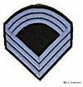
Confederate Sergeant Major stripes shown in infantry blue pattern.
An alternative usage of Command Sergeant Major is the senior NCO of a headquarters unit at battalion level or above; the soldier filling this position should carry the rank of Sergeant Major, but personnel shortages may, from time to time, force this sergeant major position to be held by a senior First Sergeant or Master Sergeant.
Colour Sergeant
A non-commissioned rank, ranking above Sergeant and below Warrant Officer. It is equivalent to Staff Sergeant in other corps of the Army.

The rank was introduced into the British Army during the Napoleonic Wars to reward long-serving sergeants. By World War I it had given way to Company Sergeant Major and Company Quartermaster Sergeant, but it was later reintroduced.

Historically, Colour Sergeants of line regiments were tasked with protecting Ensigns, the most junior officers who were responsible for carrying their battalions' Colours (flag or insignia) to rally troops in battles. For this reason the Colour Sergeant rank was considered a prestigious one given normally to courageous Sergeants who had attained accomplishments in battles. This tradition continues today as Colour Sergeants form part of a Colour Party in military parades.

Colour Sergeants are referred to and addressed as "Colour Sergeant", never as "Sergeant". Unusually, NCOs with the rank of Colour Sergeant may also hold the appointment of Company Quartermaster Sergeant are still addressed and referred to by their rank, not their appointment

First Sergeant

"The duties of the First Sergeant are peculiar to his position, and require capacity and knowledge superior to those of the other NCOs. His position is one of the most responsible and honorable that a non-commissioned officer can occupy. He has the immediate supervision of the company. He gets his orders from the Captain or officer commanding the company, and sees that they are performed in the company. He is, in fact, the foreman; and the men are the artisans. He lays out and superintends the details of work which the Captain has directed to be executed." - Customs of Service, August V. Katz, 1864

First Sergeants can be identified by the presence of a "French lozenge" (diamond shaped figure of four equal sides) on their rank insignia.
The rank of First Sergeant is below the rank of Sergeant Major. Upon reassignment to a non-First Sergeant billet, the soldier reverts back to their original rank of Sergeant. First Sergeants are generally the senior non-commissioned officers of company (battery, troop) sized units, and are unofficially but commonly referred to as "Top", "Top Kick", or "Top Hat", due to their seniority and their position at the top of the company's enlisted ranks. They are also sometimes referred to as "Second Hat," in recognition that even though a company includes several lieutenants, it is more often the First Sergeant that the Company Commander will turn to when entrusting important responsibilities
First Sergeants handle the leadership and training of their Non-Commissioned officers, manage the promotable soldiers within the company, and are the first step in an Article 15 (Non-Judicial Punishment) proceeding, as well as have a host of other responsibilities.
A First Sergeant holding or temporarily filling the position of Sergeant Major will be referred to as "Sergeant Major"

American Civil War

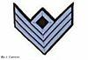
Confederate First Sergeant stripes in blue infantry pattern.

The rank was used by both the Union Army and the Confederate Army during the American Civil War. The same rank insignia was used by both armies. Both armies varied the color of the stripes by assigning red for artillery, yellow for cavalry, and blue for infantry. Some Confederate militia units varied these colors even further and had other colors including black stripes for various units. The rank was just below Ordnance Sergeant and just above Sergeant.

To be a First Sergeant in this company, you are required to be able to teach the School of the Soldier, Drill for Skirmishers, and have a working knowledge of the School of the Company. The First Sergeant must be prepared to take over command of the company should the Captain or other officers become unavailable. The First Sergeant is in charge of the entire company and it's compliment of NCOs. He is the TOP soldier of the company and answers to the commanding officer of the company. A good company commander will let the First Sergeant run the company in its daily routine and details, but only if the First Sergeant is capable of performing these tasks.

The First Sergeant is in charge of training and drilling the company in the School of the Soldier and Company. He oversees and supervises the company drill, and ensures that the section corporals properly drill their men in their care.

The First Sergeant is in charge of maintaining accurate records on attendance at drills and at events in the company book. He will keep this book on him at all times, and in his absence, the next senior NCO will be responsible for recording attendance.

At roll call, the First Sergeant takes his place six to eight paces in front of the company facing towards it. He calls the company to attention and orders the men to "shoulder arms." He then orders the men to "support arms." The First Sergeant will then call the roll, beginning with the Sergeants, then to the Corporals, and finally to the Privates who will be called in alphabetical order. As each name is called, the soldier will reply, "Here First Sergeant" and move their weapons to "shoulder arms" and then to "order arms" immediately upon answering to their names.

After roll has been called, the First Sergeant turns to the commanding officer and reports the absentees by name. If none are absent without proper authority, he reports all present and accounted for. If the officer then takes charge of the company, the First Sergeant takes his post and acts as the right guide of the company in a line. In column formation, the First Sergeant will march at the head of the column in the first file on the right. He should NOT march in any other position then at the front left of the company when in column.

Other duties of the First Sergeant include filling out the morning report, supervising the Quartermaster Sergeant, the Company Clerk, and Commissary Sergeant in their duties, and supervising the other NCOs in their duties.

"The most important task of the first sergeant relates to the government of the company and the preservation of good order and military discipline. This depending on chiefly on innate qualifications, definite rules, cannot be easily given. A complete control of temper, good judgment, and a strong sense of justice are essential; whilst a due application to duty and attention to the necessities of the men are also of the highest importance." August V. Katz, Customs of Service, 1864

The Sergeant

"It is difficult to draw the line between the duties of the Corporal and the duties of the Sergeant. There is really no great difference in their duties. Sergeants generally have larger details under their charge, and have corporals under their direction to assist them.

They are usually interested with more responsible duties, and they are suppose to have greater experience, and to approach nearer the commissioned officer in a knowledge of all military matters." August V. Katz, Customs of Service, 1864

The rank was used by both the Union Army and the Confederate Army during the American Civil War. The same rank insignia was used by both armies. Both armies varied the color of the stripes by assigning red for artillery, yellow for cavalry, and blue for infantry. Some Confederate militia units varied these colors even further and had other colors including black stripes for various units. The rank was just below First Sergeant and just above Corporal.
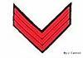
CS Sgt’s Stripes in red artillery pattern are shown here.

To be a Sergeant requires the ability to teach the School of the Soldier, a familiarity with the Drill for Skirmishers, and some basic knowledge of the School of the Company. He should be able to take over for the First Sergeant in his absence.

The most important duty for a Sergeant is that of a file closer in line. Posted to the rear of the company when it is paraded, it is his duty to see that the men pay attention to their duty, preserve order, march properly, and keep the files closed up. In time of battle, it is his duty to keep men in ranks and not allow them to fall out for any reason. It is his duty to shoot down men if they attempt to run in times of danger. He must prevent the men from falling out to help wounded comrades. The battle must be won first, and then the wounded men can properly be cared for.

Additional duties of the Sergeant include making sure the men have full canteens of water, supervise the corporals in their duties, act as Sergeant of the guard when called upon, lead a skirmish squad, act as color sergeant of the regiment or battalion, and lead a scouting patrol into enemy territory. The position of Sergeant is elected only if the company has 21-25 men consistently attend events.

As the discipline and efficiency of a company materially depend on the conduct and character of its sergeants, they should be selected with care, and properly instructed in all the duties appertaining to their rank.

Sergeants shall habitually maintain Shoulder Arms. That is, at all times, even while marching, the Sgt. will carry his weapon at Shoulder Arms, no matter what the order is to the rest of the Company, Regiment or Brigade.

Their theoretical instruction should include the School of the Soldier, the School of the Company, and the Drill for Skirmishers; and also knowledge of the principles of firing. They should likewise be well instructed in their duties as brigade guides.

The Captain selects from the corporals in his company, those whom he judges fit to be admitted to the theoretical instruction of the sergeants.

The Corporal

"The appointment to Corporal is the first step to promotion in the army, and may lead to the highest distinction in the military service. The sergeants are appointed from the corporals and they should therefore look upon their position as one of probation, and should seek to perform well their part, in order that they may be advanced." August V. Katz, Customs of Service, 1864

August Kautz in The Customs of Service for Non-Commissioned Officers and Soldiers describes the Corporal as below.

The duties of a corporal are simple, and depend for their successful performance mainly upon his capacity to control and direct soldiers in the performance of their duty. They take charge of the smaller details for fatigue and police duty in camp and garrison duty: their most important duty is that of Corporal of the Guard. They frequently succeed to the responsibilities of sergeant in his absence, and should therefore be familiar with his duties.
Corporals should be living examples for the soldiers in the neatness and cleanliness of their clothing, arms, and accoutrements. They should be the first to fall into ranks at roll-calls, and should have their tents or bunks, wherever their quarters, always systematically in order.
They should be familiar with the "School of the Soldier," and capable of instruction the recruits in the elementary principles of tactics.
In the field, where it is sometimes difficult to cook for the entire company, it is divided into messes and the non-commissioned officers placed in charge of the different messes pro rata. They are held responsible for the conduct of the mess-mates in the keeping of their tents and the care of the camp and garrison equipage in their charge."²
Each Corporal should have a book in which he can take down the names of the men in his fatigue, and take notes on orders from the 1st Sergeant. This requirement is a must for every NCO.

The rank of Corporal is preceded by the rank of Private. A Corporal is a junior non-commissioned officer and may direct the activities of other soldiers. Corporals are found in many combat units. It is common for a Corporal to lead a Settee, or Comrades in Battle. Their theoretical instruction should include the School of the Soldier, and knowledge of firing.

The rank of Corporal is the only rank in the United States Army that has never been removed from the NCO Corps since its earliest days.

To be a Corporal you must be able to teach the School of the Soldier, have a working knowledge of the Drill for Skirmishers, and be familiar with the School of the Company. The Corporal is the closest NCO to the private in the ranks and his first and primary concern is the welfare of the men in his care. He should be familiar with the Sergeant and First Sergeant positions as he may need to perform those duties in the absence of a Sergeant. Off the field, the Corporal is responsible for calling all the members in his settee and informing them of upcoming events and activities.

The field duties of the Corporal are very simple. They must have the capacity to control and direct the soldiers in the performance of their duties. Corporals need to have as much direct contact as possible with the men. He needs to camp and eat with the men in his settee.

Corporals should be a living example for the soldiers in the neatness and cleanliness of their clothing, arms, and accouterments. They should always be the first to fall into ranks for roll call, and should always have their tent or campsite in order.

The Corporal should be very familiar with the School of the Soldier and be capable of instructing the men in his settee in both the school of the soldier and the elementary principles of tactics. He should also be familiar with the Drill for skirmishers. He will be responsible for assuring that his section can perform the school of the soldier drill and will drill his settee at assigned times.

The Corporal needs to keep his men informed. He should have an idea of what is happening and what is going to happen. He needs to explain to the men any changes in their orders as soon as possible and be the source of knowledge for their section.

He needs to know the symptoms of heat and cold injuries and check the health of the men at regular intervals. Ensure that they are drinking enough to ward off hot weather injuries and that they have sufficient clothing to protect themselves from cold weather injuries. A good rule to follow is to have your men drink a canteen of water before going out on the field.

Finally, the corporal is responsible for ensuring that every man in his section cleans his weapon immediately following the battle and they he takes proper care of his weapon on the field. If a weapon in your section needs maintenance, the corporal needs to take charge of the weapon and make the repair himself or find someone that can repair it. After a firing demonstration or battle, you need to ensure that there is enough hot water and cleaning materials to clean the mess gear and the weapons. No man in your section should be allowed out of camp without first cleaning his musket! It is your responsibility to inspect each man in your section before allowing him to leave the camp. The position of Second Corporal is elected only if the company has 16-20 men consistently attend events.

The captain selects from his company a few privates, who may be admitted to the theoretical instruction of the corporals.

As the instruction of sergeants and corporals, is intended principally to qualify them for the instruction of the privates, they should be taught not only to execute, but to explain intelligibly every thing they may be required to teach.

Private

Personnel with no command authority bear the title Private. In some countries and services, personnel in different branches have different titles. These may have a variety of grades, but these usually only reflect variations in pay, not increased authority.

The Officer

Overview
The purpose of this School is to detail the duties and skills required for each rank required in the running of a Civil War era company. It is intended as a resource for all military members of the 11th - to be used as reference, guide, and to generate questions that can be answered or further researched at events. Ideally we will set time aside at each event to hold mini-NCO/Officer Schools and to discuss the finer points of drill. This will be a work in progress for some time to come.
Responsibilities
Rank in both the 11th and Ector’s Brigade is a position of responsibility. You must show a willingness to learn the impression, and demonstrate leadership. You must be willing to attend events when possible, accept the duties of the position and be willing to perform them in the field. Lastly rank is given by the unit membership; remember this is a hobby and that all authority is tacit and the idea is for everyone to have fun.

The responsibilities for each rank can be considered like building blocks. The skills of each rank build upon the previous one. Therefore, each rank is responsible for knowing and teaching the duties of the rank below, as well as performing the extra requirements, duties, and skills of the rank held. In addition, persons holding rank should be looking at the duties of the rank above so they can perform those duties when called upon. Thus a Corporal needs to be able to teach the skills of a Private and be prepared to step up as a Sergeant, and a Sergeant must be able to teach the skills of a Corporal and be prepared to step up as a Lieutenant and so on up the ladder.
A Synopsis of the Responsibilities for each Rank as Follows:
"Sergeants and Corporals, being in closest contact with the rank and file, must deal with the men on a personal level. Squad drill, camp cleanliness, guard and fatigue details, as well as the duties of file closer are their responsibilities. They must see that their company is running smoothly when their captain takes command. The company officers should not have to distract themselves with the many small details to run the company. This is the NCOs job.
Company Officers must be free to maneuver their companies and pay the closest attention to the field officers. Company officers must oversee all the activities of their NCOs in company will be expected to command various details at times. Their main responsibility, however, is to be totally familiar with company and brigade drill and to train their men in the skills they need to function as part of the brigade.

Field and Staff have the ultimate responsibility for the success or failure of the brigade. Although they are dependent upon the efforts of the NCOs and line officers, the field and staff must assure that all the elements come together to form a smoothly running machine. In camp, the Aide-de-Camp, Officer of the Day, and Sergeant Major must coordinate all activities and deal with the problems that arise. On the drill field and in battle the field officers must be as completely familiar with the methods of controlling the brigade as a pilot is with his airplane. The tactics of Civil War era centralize tremendous authority and responsibility into the hands of a few men.

Manual of the Sword

"Draw me not without reason,
Sheath me not without honor"

Introduction
Officers on all duties under arms draw and return sword without waiting for any command. All commands given to soldiers under arms are given with the sword or sabre drawn. [5]
Nomenclature of the Sword / Sabre
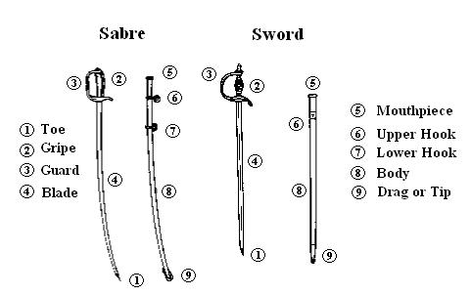

How the Sword is Worn
When on duty, the sword will be hooked up by the upper hook, the sword reversed, edge to the rear, gripe (grip) forward. [2, 3]

We must start by hanging the scabbarded sword properly from the slings on the sword belt.

The novice always seems to hang the sword from the hook on the belt, but hangs it the same way it hangs from the straps - guard forward and drag to the rear. This gets in the way while walking, interferes with ladies dresses or other persons walking close by, hits the ground, is inconvenient when sitting down, and can bang on the steps or trip the wearer while going up or down ladders or stairs.

The hook hanging from the left side of the belt at the top of the front sword strap is to carry the sword while not drawn from the scabbard (all branches). There is not a reference in Naval Regulations or in Hardee's concerning carrying or hanging officers' swords. However, period naval, marine and army photos show the accepted manner.

The proper way to hang the sword when not in use is to seize the upper ring between the thumb and the fore finger of the left hand, back of the hand up, raising the scabbard, whilst turning the hilt toward the body, until it points to the rear; passing the ring over the hook attached to the waist-belt. It is obvious that elevating the sword and hanging it with the drag (point) forward was the desired result more than the guard to the rear. The left elbow can be slightly pressed against the body and forward of the properly hung sword guard while walking. This keeps the drag forward and resting slightly across the left leg and out of the way of feet and people in the rear. The left hand falls naturally on the scabbard to rotate the drag of the sword further up and forward out of the way when sitting down and going up and down stairs. See figures 1 through 3. This manner may be observed in period photos in The Image of War, Vols. I and III.

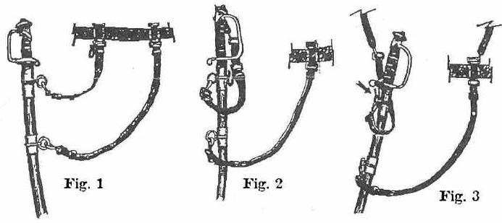
To Draw the Sword (in two motions)
Bring the right hand quickly to the position of salute [with arms] - palm to the left; at the same movement seize the scabbard (between the mouthpiece and upper hook) with the left hand and turn the sword, bringing the guard to the front; pass the right hand through the sword knot (if you have one), and seize the gripe. Draw the sword from the scabbard by extending the right arm easily; turn the hand and bring the sword to the position about to be described below (The Carry). [3]

The Carry (Shoulder Arms)
The arm nearly extended, back of the blade against the shoulder; sword supported by the thumb and two first fingers, extended and placed on the gripe in such a manner that in raising the sword to the salute, etc., the fingers can be introduced inside the guard, and a firm grasp of the sword obtained without effort. [3] The right hand will be supported against the right hip. [4]
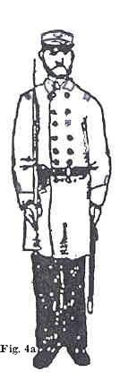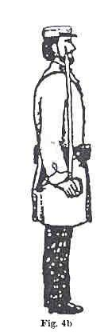

To Return the Sword (in two motions)
Raise the sword perpendicularly, point up, the flat of the blade opposite the right eye, the guard at the height of the shoulder-elbow supported by the body; carry the hand to the left opposite the left shoulder, and reverse the sword; insert the point of the blade in the scabbard which is held by the left hand. - Insert the blade, withdraw the hand from the sword knob; with the left hand turn the sword, back of the blade to the front, hilt behind the arm; drop the hands by the side. [3]

The Salute Three times (or pauses).
To salute with the sword or sabre [from Shouldered Arms]

1st At the distance six paces from the person to be saluted, raise the sword or sabre perpendicularly, the point up, the flat of the blade opposite to the right eye, the guard at the height of the shoulder, and the elbow supported on the body.

2nd Drop the point of the sword or sabre by extending the arm, so that the right hand may be brought to the side of the right thigh, and remain in that position until the person to whom the salute is rendered shall be passed, or shall have passed, six paces.

3rd Raise the sword or sabre smartly and place the back of the blade against the right shoulder. [3,4]
Present
For Present Arms, Upton specifies two movements. At “Present,” the 1st motion of the Salute is executed. At “Arms,” the blade is
dropped [4].Thesword is kept at the 2d position as long as the men are at Present Arms. Officers return to the Carry at “1.
Shoulder (Carry). 2. Arms.” [1]

Order Arms from Shoulder (Carry) Arms:
Drop the sword to the front, the edge down, point three inches from the ground. [1]
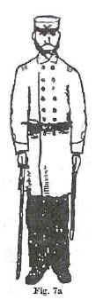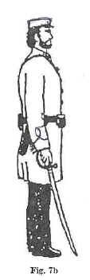

Parade Rest
Step back with the right foot. Reverse the sword; rest the point on the toe sole of the left boot (do not [ever] allow the point to go into the ground); clasp the left hand over the right, both resting on the guard [edge to the right]. [2,3]

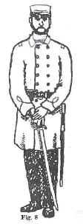
In-Place Rest from Shouldered or Support Arms:
Carry the right hand to the left and clasp it with the left hand - blade in the hollow of the right arm. [2,3] or fold the arms, sword hand under the left elbow, sword hanging down the left hip.

Rest or Stack Arms
At the command, “REST,” or “Stack Arms,” return the sword to the scabbard. At attention, draw it. [2]

The Support
Blade diagonally across the body, supported by the left hand, which is held opposite the shoulder [2] [the gripe is in the right hand.

1st Raise the sword hand as the [sic] high as the right breast, edge to the left.

2nd Raise the left hand as high as the shoulder, fingers closed, turn the edge to the front, and drop the sword between the thumb and joint of fore finger of left hand, and lower the right hand to the hip.

Right Shoulder Shift
Point downward, held a little above the ground - back of the blade to the left - sword held easily by the right hand. [2]

Double Quick Time
In marching in double time, the sword is carried diagonally across the breast, edge to the front, the point in front of and at the height of the left shoulder; the left hand steadies the scabbard. [5]
Route Step
In route marches the sword can be carried in the scabbard, or over the right shoulder, with the toe grasped by the right hand; the left hand steadies the scabbard. [5]

Sources:
1. Berriman, M.W., Militiaman’s Manual and Sword-Play without a Master, New York: D. Van Nostrand, 1858, 1864, pp. 7,8,11.
2. DeWitte, J.H., Baxter’s Zouave Light Infantry Tactics, 1861, pp. 107-108.
3. Ellsworth, E.E., Manual of Arms for Light Infantry Adapted to the Rifled Musket, 1859, pp.71-75 (see DeWitte’s work).
4. Hardee, William J., Rifle and Light Infantry Tactics, Philadelphia: J.B. Lippincott, 1861, p 214.
5. Upton, Emory, Infantry Tactics, New York: D. Appleton and Co., 1874, Paras. 755-758, 760-761.

How to Command
a
Civil War Battlefield

How to Command a Civil War Battlefield
By Mark Grimsley
Edited by WRG

Commanding a battlefield has six components:
First, you must have a firm grasp of the organization of Civil War armies. Second, you must be familiar with the basic battlefield functions of Civil War leaders. Third, you must have a working knowledge of Civil War tactics. Fourth--and critically--you must develop a good eye for terrain and see the ground as Civil War commanders would have seen it. Fifth, you need to be able to estimate distance and know the typical ranges at which Civil War weapons were employed. Finally, you need to have done some previous reading about battles and, if possible, you should bring along, or draw when you’ve arrived, plenty of good maps.

The Organization of Civil War Armies
Each army (40,000-100,000 men) typically consisted of two or more corps (10,000-25,000 men). An army was usually commanded by a full General on the Confederate side and a Major General on the Union side.

Each corps typically consisted of two to four divisions (3,000-5,000 men). A corps was usually commanded by a Lieutenant General on the Confederate side and a Major General on the Union side.

Each division consisted of two to four brigades, usually three (1,200-2,500 men). Divisions were usually commanded by major generals.

Each brigade consisted of three to five regiments (300-800 men). A brigade was usually commanded by a Brigadier General.

The authorized strength of each regiment was about 1,000 men, but in practice they rarely maintained their full strength for very long. Regiments were usually commanded by colonels.

The Basic Battlefield Functions of Civil War Commanders
In combat environments, the duties of Civil War leaders divided into two main parts: decision-making and moral suasion. Although the scope of their decisions varied according to rank and responsibilities, they generally dealt with the movement and deployment of troops, artillery, and logistical support (signal detachments, wagon trains, and so on). Most of the decisions were made by the leader himself. While his staff assisted with administrative paperwork, in combat they functioned essentially as glorified clerks who did almost nothing in the way of sifting intelligence or planning operations.

Once made, decisions were transmitted to subordinates either by direct exchange or by courier, with the courier either carrying a written order or conveying the order verbally. More rarely, signal flags were used to send instructions. Except in siege operations, when the battle lines were fairly static, the telegraph was almost never used in tactical situations.

Moral suasion, simply put, was the art of persuading troops to perform their duties and dissuading them from a failure to perform them. This was often done by personal example, and conspicuous bravery was a vital attribute of any good leader. It is therefore not surprising that 8 percent of Union generals--and 18 percent of their Confederate counterparts--were killed or mortally wounded in action. (By contrast, only about 3 percent of Union enlisted men were killed or mortally wounded in action.)

Although any commander might be called upon to intervene directly on the firing line, army, corps, and division commanders tended to lead from behind the battle line, and their duties were mainly supervisory.

In all three cases, their main ability to influence the fighting, once it was underway, was by the husbanding and judicious commitment of troops held in reserve.

Army Commanders principally decided the broad questions--whether to attack or defend, where the army's main effort(s) should be made, and when to retreat (or pursue). In effect, they made most of their key choices before and after an engagement rather than during it. Once battle was actually joined their ability to influence the outcome diminished considerably. They might choose to wait it out or they might choose, temporarily and informally, to exercise the function of a subordinate leader. In various Civil War battles army commanders conducted themselves in all sorts of ways: as detached observers, "super" corps commanders, division commanders, and so on, all the way down to de facto colonels trying to lead through personal example.

Corps Commanders chiefly directed main attacks or supervised the defense of large, usually well-defined sectors. It was their function to carry out the broad (or occasionally quite specific) wishes of the army commander. They coordinated all the elements of their corps (typically infantry divisions and artillery battalions) in order to maximize its offensive or defensive strength. Once battle was actually joined, they influenced the outcome by "feeding" additional troops into the fight--sometimes by preserving a reserve force (usually a division) and committing it at the appropriate moment, sometimes by requesting additional supports from adjacent corps or from the army commander.

Division Commanders essentially had the same functions as corps commanders, but on a smaller scale. When attacking, however, their emphasis was less on "feeding" a fight than husbanding the striking power of their divisions as much as possible. The idea was to strike one hard blow rather than a series of lesser ones.

The commanders below were expected to conduct actual combat; to close with and destroy the enemy.

Brigade Commanders principally conducted the actual business of attacking or defending. They accompanied the attacking force in person or stayed on the firing line with the defense. If they had five regiments at their disposal, they typically placed three abreast of one another with the other two in immediate support. Their job was basically to maximize the fighting power of their brigades by ensuring that these regiments had unobstructed fields of fire and did not overlap. During an attack it often became necessary to expand, contract, or otherwise modify the brigade frontage to conform with the vagaries of terrain, the movements of adjacent friendly brigades, and/or the behavior of enemy forces. It was the brigade commander's responsibility to shift his regiments as needed while preserving, as far as possible, the unified striking power of the brigade.

Regiment Commanders were chiefly responsible for making their men do as the brigade commanders wished, and their independent authority on the battlefield was quite limited. For example, if defending they might order a limited counterattack, but they usually could not order a retreat without approval from higher authority. Assisted by company commanders, they directly supervised the soldiers, giving specific, highly concrete commands: move this way or that, hold your ground, fire by volley, forward, and so on. Commanders at this level were expected to lead by personal example and to display as well as demand strict adherence to duty.

Civil War Tactics
Civil War armies basically had three kinds of combat troops: infantry, cavalry and artillery. Infantrymen fought on foot, each with his own weapon. Cavalrymen were trained to fight on horseback or dismounted, also with their own individual weapons. Artillerists fought with cannon.

Infantry
Infantry were by far the most numerous part of a Civil War army and were chiefly responsible for seizing and holding ground. The basic Civil War tactic was to put a lot of men next to one another in a line and have them move and shoot together. By present-day standards the notion of placing troops shoulder-to-shoulder seems insane, but it still made good sense in the mid-19th century.

There were two reasons for this: First, it allowed soldiers to concentrate the fire of what were still rather limited weapons. Second, it was almost the only way to move troops effectively under fire. Most Civil War infantrymen used muzzle-loading muskets capable of being loaded and fired a maximum of about three times a minute.

Individually, therefore, a soldier was nothing. He could affect the battlefield only by combining his fire with that of other infantrymen. Although spreading out made them less vulnerable, infantrymen very quickly lost the ability to combine their fire effectively if they did so. Even more critically, their officers rapidly lost the ability to control them.

For most purposes, the smallest tactical unit on a Civil War battlefield was the regiment. Although theoretically composed of about 1,000 officers and men, in reality the average Civil War regiment went into battle with about 300-600 men. Whatever its size, however, all members of the regiment had to be able to understand and carry out the orders of their colonel and subordinate officers, who generally could communicate only through voice command.

Since in the din and confusion of battle only a few soldiers could actually hear any given command, most got the message chiefly by conforming to the movements of the men immediately around them. Maintaining "touch of elbows"--the prescribed close interval--was indispensable for this crude but vital system to work. In addition, infantrymen were trained to "follow the flag"--the unit and national colors were always conspicuously placed in the front and center of each regiment.

Thus, when in doubt as to what maneuver the regiment was trying to carry out, soldiers could look to see the direction in which the colors were moving. That is one major reason why the post of color bearer was habitually given to the bravest men in the unit. It was not just an honor; it was insurance that the colors would always move in the direction desired by the colonel.

En route to a battle area, regiments typically moved in a column formation, four men abreast. There was a simple maneuver whereby regiments could very rapidly change from column to line once in the battle area; i.e., from a formation designed for ease of movement to a formation designed to maximize firepower. Regiments normally moved and fought in line of battle--a close-order formation actually composed of two lines, front and rear.

Attacking units rarely "charged" in the sense of running full-tilt toward the enemy; such a maneuver would promptly destroy the formation as faster men outstripped slower ones and everyone spread out. Instead a regiment using orthodox tactics would typically step off on an attack moving at a "quick time" rate of 110 steps per minute (at which rate it would cover about 85 yards per minute). Once under serious fire the rate of advance might be increased to a so-called "double-quick time" of 165 steps per minute (about 150 yards per minute).

Only when the regiment was within a few dozen yards of the defending line would the regiment be ordered to advance at a "run" (a very rapid pace but still not a sprint). Thus a regiment might easily take about ten minutes to "charge" 1,000 yards, even if it did not pause for re-alignment or execute any further maneuvers en route. In theory an attacking unit would not stop until it reached the enemy line, if then.

The idea was to force back the defenders through the size, momentum, and shock effect of the attacking column. (Fixed bayonets were considered indispensable for maximizing the desired shock effect).
In reality, however, the firepower of the defense eventually led most Civil War regiments to stop and return the fire--often at ranges of less than 100 yards. And very often the "charge" would turn into a stand-up fire fight at murderously short range, until one side or the other gave way.

It is important to bear in mind that the above represents a simplified idea of Civil War infantry combat. As you will see when you visit specific battlefields, the reality could vary significantly.

Artillery
Second in importance to infantry on most Civil War battlefields, was the artillery. Not yet the "killing arm" it would become during World War One, when 70 percent of all casualties would be inflicted by shellfire, artillery nevertheless played an important role, particularly on the defense. Cannon fire could break up an infantry attack or dissuade enemy infantry from attacking in the first place. Its mere presence could also reassure friendly infantry and so exert a moral effect that might be as important as its physical effect on the enemy.

The basic artillery unit was the battery, a group of between 4 and 6 fieldpieces commanded by a captain. Early in the war, batteries tended to be attached to infantry brigades. But over time it was found that they worked best when massed together, and both the Union and Confederate armies presently reorganized their artillery to facilitate this. Eventually both sides maintained extensive concentrations of artillery at corps-level or higher. Coordinating the fire of twenty or thirty guns on a single target was not unusual, and occasionally (as in the bombardment that preceded Pickett's Charge at Gettysburg) concentrations of well over hundred guns might be achieved.

Practically all Civil War fieldpieces were muzzle-loaded and superficially appeared little changed from their counterparts in the 17th and 18th centuries. In fact, however, Civil War artillery was quite modern in two respects.

First, advances in metallurgy had resulted in cannon barrels that were much lighter than their predecessors but strong enough to contain more powerful charges. Thus, whereas the typical fieldpiece of the Napoleonic era fired a 6-pound round, the typical Civil War era fieldpiece fired a round double that size, with no loss in ease of handling.

Second, recent improvements had resulted in the development of practical rifled fieldpieces that had significantly greater range and accuracy than their smoothbore counterparts.

Civil War fieldpieces could fire a variety of shell types, each with its own preferred usage.
Solid shot was considered best for battering down structures and for use against massed troops (a single round could sometimes knock down several men like ten pins).

Shell--rounds that contained an explosive charge and burst into fragments when touched off by a time fuse--were used to set buildings afire or to attack troops behind earthworks or under cover.

Spherical case was similar to shell except that each round contained musket balls (78 in the case of a 12-pound shot, 38 for a 6-pound shot); it was used against bodies of troops moving in the open at ranges of from 500 to 1,500 yards.

At ranges of below 500 yards, the round of choice was canister, essentially a metal can containing about 27 cast-iron balls, each 1.5 inches in diameter. As soon as a canister round was fired, the sides of the can would rip away and the cast-iron balls would fly directly into the attacking infantry. In desperate situations double and sometimes even triple charges of canister were used.

As recently as the Mexican War, artillery had been used effectively on the offensive, with fieldpieces rolling forward to advanced positions from which they could blast a hole in the enemy line. The advent of the rifled musket, however, made this tactic dangerous--defending infantry could now pick off artillerists who dared to come so close--and so the artillery had to remain farther back.
In theory the greater range and accuracy of rifled cannon might have offset this a bit, but rifled cannon fired comparatively small shells of limited effectiveness against infantry at a distance. The preferred use of artillery on the offensive was therefore not against infantry but against other artillery--what was termed "counter battery work." The idea was to mass one's own cannon against a few of the enemy's cannon and systematically fire so as to kill the enemy's artillerists and dismount his fieldpieces.

Cavalry
"Whoever saw a dead cavalryman?" was a byword among Civil War soldiers, a pointed allusion to the fact that the battlefield role played by the mounted arm was often negligible. For example, at the Battle of Antietam--the single bloodiest day of the entire war--the Union cavalry suffered exactly 5 men killed and 23 wounded. This was in sharp contrast to the role played by cavalry during the Napoleonic era, when a well-timed cavalry charge could exploit an infantry breakthrough, overrun the enemy's retreating foot soldiers, and convert a temporary advantage into a complete battlefield triumph.

Why the failure to use cavalry to better tactical advantage? The best single explanation might be the fact that for much of the war there was simply not enough of it to achieve significant results. Whereas cavalry had comprised 20 to 25 percent of Napoleonic armies, in Civil War armies it generally averaged 8 to 10 percent or even less.

The paucity of cavalry may be explained, in turn, by its much greater expense compared with infantry. A single horse might easily cost ten times the monthly pay of a Civil War private and necessitated the purchase of saddles, bridles, stirrups, and other gear as well as specialized clothing and equipment for the rider. Moreover, horses required about 26 pounds of feed and forage per day, many times the requirement of an infantryman. One might add to this the continual need for remounts to replace worn-out horses and the fact that it took far more training to make an effective cavalryman than an effective infantryman, as well as the widespread belief that the heavily-wooded terrain of America would limit opportunities to use cavalry on the battlefield.

All in all, it is perhaps no wonder that Civil War armies were late in creating really powerful mounted arms. Instead, cavalry tended to be used mainly for scouting and raiding, duties that took place away from the battlefields. During major engagements their mission was principally to screen the flanks or to control the rear areas. By 1863, however, the North was beginning to create cavalry forces sufficiently numerous and well-armed to play a significant role on the battlefield. At Gettysburg, for example, Union cavalrymen armed with rapid-fire, breach-loading carbines were able to hold a Confederate infantry division at bay for several hours. At Cedar Creek in 1864 a massed cavalry charge late in the day completed the ruin of the Confederate army, and during the Appomattox Campaign in 1865 Federal cavalry played a decisive role in bringing Lee's retreating army to bay and forcing its surrender.

Terrain
Understanding the terrain is basic to understanding almost every aspect of a battle. Terrain helps to explain why commanders deploy their troops where they do, why attacks occur in certain areas and not in others, why some attacks succeeded and others do not.

When defending, Civil War leaders often looked for positions with as many of the following characteristics as possible:

First, the position obviously had to be ground from which they could keep the enemy from getting at whatever it was they were ordered to defend.

Second, it should be elevated enough so as to provide good observation and good fields of fire--they wanted to see as far as possible and sometimes (though not always) to shoot as far as possible. The highest ground was not necessarily the best, however, for it often afforded an attacker defilade (areas of ground which the defenders' weapons could not reach). For that reason leaders seldom placed their troops at the very top of a ridge or hill (the "geographical crest"). Instead they placed them a bit forward of the geographical crest at a point from which they had the best field of fire (the "military crest). Alternatively, they might even choose to place their troops behind the crest. This concealed the size and exact deployment of the defenders from the enemy and offered protection from long-range fire. It also meant that an attacker, upon reaching the crest, would be silhouetted against the sky and susceptible to a sudden, potentially quite destructive fire at close range.

Third, the ground adjacent to the chosen position should present a potential attacker with obstacles. Streams and ravines made good obstacles because they required an attacker to halt temporarily while trying to cross them. Fences and boulder fields could also slow an attacker. Dense woodlands could do this too, but they offered concealment for potential attackers and were therefore less desirable. In addition to its other virtues, elevated ground was prized because attackers moving uphill had to exert themselves more and got tired faster. Obstacles were especially critical at the end of a unit's position--the flank--if there were no other units beyond to protect it. That is why commanders "anchored" their flanks, whenever possible, on hills or the banks of large streams.

Fourth, a good position had to offer ease of access for reinforcements to arrive and, if necessary, for the defenders to retreat.

Fifth, a source of drinkable water--the more the better--had to be immediately behind the position if possible. This was especially important for cavalry and artillery units, which had horses to think about as well as men.

When attacking, the concerns of Civil War commanders were different:

First, they looked for weaknesses in the enemy's position, especially "unanchored" flanks. If there were no obvious weaknesses they looked for a key point in the enemy's position--often a piece of elevated ground whose loss would undermine the rest of the enemy's defensive line.

Second, they searched for ways to get close to the enemy position without being observed. Using woodlands and ridgelines to screen their movements was a common tactic.

Third, they looked for open, elevated ground on which they could deploy artillery to "soften up" the point to be attacked.

Fourth, once the attack was underway they tried, when possible, to find areas of defilade in which their troops could gain relief from exposure to enemy fire. Obviously it was almost never possible to find defilade that offered protection all the way to the enemy line, but leaders could often find some point en route where they could pause briefly to "dress" their lines.

Making the best use of terrain was an art that almost always involved trade-offs among these various factors--and also required consideration of the number of troops available. Even a very strong position was vulnerable if there were not enough troops to defend it. A common error among Civil War generals, for example, was to stretch their line too thin in order to hold an otherwise desirable piece of ground.

Estimating Distance
Estimating distance can help you estimate how long it takes troops to get from Point A to Point B or to visualize the points at which they would have become vulnerable to different kinds of artillery fire. There are several easy tricks to bear in mind.

1. Use reference points for which the exact distance is known. Locate such a reference point, then try to divide the intervening terrain into equal parts. For instance, say the reference point is 800 yards away. The ground about halfway in between will be 400 yards; the ground halfway between yourself and the midway point will be 200 yards, and so on.

2. Use the football field method. Visualize the length of a football field, which of course is 100 yards. Then estimate the number of football fields you could put between yourself and the distant point in which you're interested.

3. Use cars, houses, and other common objects that tend to be roughly the same size. Most cars are about the same size and so are many houses. Become familiar with how large or small such objects appear at various distances--300 yards, 1000 yards, 2000 yards, etc. This is a less accurate way of estimating distance, but can be helpful if the lay of the land makes it otherwise hard to tell whether a point is near or far. Look for such objects that seem a bit in front of the point. Their relative size can give you a useful clue.

Maximum Effective Ranges of Common Civil War Weapons
Smoothbore musket: 150 yds.
Rifled musket: 400 yds. (but in practice, seldom used in battle beyond 250 yds.)
Breech-loading carbine: 300 yds.

Napoleon 12-pounder smoothbore: Solid shot: 1,700 yds. Shell: 1,300 yds. Spherical case: 500-1,500 yds. Canister: 400 yds.
Parrott 10-pounder rifle: Solid shot: 6,000 yds.
3-inch ordnance rifle: Solid shot: 4,000 yds.

This page intentionally left blank.

Strategy & Tactics

Strategy & Tactics
Strategy
In this military art, troops are maneuvered outside the battlefield to achieve success in a large geographic area. That geographic expanse can be a "front" (in the Civil War, part or all of one state) or a "theater" (several contiguous states possessing geographical, geopolitical, or military unity). When the expanse encompasses an entire country, the corresponding waging of war on the largest scale to secure national objectives is called "grand strategy."
"Offensive strategy" carries war to the enemy, either directly by challenging his strength or indirectly by penetrating his weakness." Defensive strategy" protects against enemy strategic offensives. And "defensive-offensive strategy" (which Confederates often practiced) uses offensive maneuvers for defensive strategic results (e.g., Gen. R. E. Lee and Maj. Gen. Thomas J. "Stonewall" Jackson took the offensiveMay-June 1862 to defend Richmond and Virginia).
Strategic objectives include defeating, destroying, or forcing enemy armies to retreat; seizing enemy strategic sites (supply lines, depots, arsenals, communications centers, and industry) crucial to his military effort; capturing the enemy capital; disrupting his economy; and demoralizing his will to wage war. While seeking such goals, the strategist must correspondingly protect his own army, strategic sites, capital, economy, and populace. He must strike proper balance between securing his rear and campaigning in his front. Supply lines and homelands must be guarded; especially in war between 2 republics, which the Civil War really was, the compelling necessity of protecting the political base cannot be ignored. Yet if too many troops are left in the rear, too few remain to attack or even defend against enemy armies at the front.
Of these objectives, European experience, from which Civil War strategic doctrine derived, emphasized 3 strategies: destroying the enemy's army in 1 battle, seizing strategic sites, and capturing the enemy's capital. In the Civil War, attacking and defending Richmond and Washington consumed much effort, but their actual strategic importance, though great, was more symbolic than substantial, since neither was its country's nerve center, as European capitals were. Also illusory were quests for victory through seizing strategic sites and cutting "lines of communication" (supply lines); only a few Civil War campaigns, such as Holly Springs and Second Bull Run, were decided or even significantly affected by such captures. Most chimerical of all were hopes of annihilating the enemy's army in 1 great Napoleonic victory.
Rather, Civil War strategists used a series of battles--each of them indecisive but cumulatively effective--to cripple the enemy, drive him back, and overrun or protect territory. Some strategies aimed directly at such battles. Other strategies sought first to maneuver so as to gain advantage of ground or numbers and only then to give battle under such favorable conditions. Whatever the overall numbers in the theater, strategy strove to assure numerical superiority on the battlefield; this principle was called "concentrating masses against fractions." Both sides practiced it, but it was especially important to the overall weaker Secessionists, as when Jackson performed it so effectively in the Shenandoah Valley.
Again, each side, particularly the Confederates, used "interior lines" to move forces from quiet fronts through the interior to threatened fronts more quickly than the enemy could move around the military border. But, in practice, Southern supply lines were so primitive and Federal supply lines were so good that, despite longer distance, Northerners often moved in shorter time due to their "superior lateral communications." Even more effective against Confederate reliance on interior lines was Ulysses S. Grants grand strategy of concerting the armed might of the Union for simultaneous advances to pin and defeat Confederate troops on all major fronts.
Besides these approaches, Civil War strategists, especially Union commanders such as William T. Sherman and Philip H. Sheridan, usually reluctantly but increasingly came to make the enemies economy and populace suffer. For the first time since the Thirty Years War, those 2 targets regained legitimacy. While free from the brutality of 1618-48, Federal strategy eventually crippled Southern capability and will to wage war though, to be effective, such strategy could only complement Northern success in maneuver and battle.
Long-range strategic cavalry raids -- in brigade to corps strength -- played some role in such crippling, but those raids rarely had much military effect before collapse became imminent in 1865. Instead, the principal unit of strategic maneuver was the infantry corps, and the basic element of strategic control was the army. And in theaters where I side had several armies, those armies themselves became maneuver units, and control resided at military division headquarters or with the general-in-chief himself.
Whatever the elements and whatever the means, the fundamental goal of strategy remains the same: the overall use of force to accomplish broad military and political objectives.
Source: "Historical Times Encyclopedia of the Civil War" Editor, Patricia L. Faust
Tactics
Tactics is the military art of maneuvering troops on the field of battle to achieve victory in combat. 'Offensive tactics" seek success through attacking; "defensive tactics" aim at defeating enemy attacks.
In Civil War tactics, the principal combat arm was infantry. Its most common deployment was a long "line of battle," 2 ranks deep. More massed was the "column," varying from 1 to 10 or more companies wide and from 8 to 20 or more ranks deep. Less compact than column or line was "open-order" deployment: a strung-out, irregular single line.
Battle lines delivered the most firepower defensively and offensively. Offensive firepower alone would not ensure success. Attackers had to charge, and massed columns, with their greater depth, were often preferable to battle lines for making frontal assaults. Better yet were flank attacks, to "roll up" thin battle lines lengthwise. Offensive tacticians sought opportunity for such effective flank attacks; defensive tacticians countered by "refusing" these flanks on impassable barriers. In either posture, tacticians attempted to coordinate all their troops to deliver maximum force and firepower and to avoid being beaten "in detail" (piecemeal). Throughout, they relied on open-order deployment to cover their front and flanks with skirmishers, who developed the enemy position and screened their own troops.
Open order, moreover, was best suited for moving through the wooded countryside of America. That wooded terrain, so different from Europe's open fields, for which tactical doctrine was aimed, also affected tactical control. Army commanders, even corps commanders, could not control large, far-flung forces. Instead, army commanders concentrated on strategy. And corps commanders handled "grand tactics": the medium for translating theater strategy into battlefield tactics, the art of maneuvering large forces just outside the battlefield and bringing them onto that field. Once on the field, corps commanders provided overall tactical direction, but their largest practical units of tactical maneuver were divisions. More often, brigades, even regiments, formed those maneuver elements. Essentially, brigades did the fighting in the Civil War.
Besides affecting organization, difficult terrain helped relegate cavalry and artillery to lesser tactical roles. More influential there was the widespread use of long-range rifled shoulder arms. As recently as the Mexican War, when most infantry fired smoothbore muskets, cavalry and artillery had been key attacking arms. Attempting to continue such tactics in the Civil War proved disastrous, as infantry rifle power soon drove horsemen virtually off the battlefield and relegated artillery to defensive support. Rifle power devastated offensive infantry assaults, too, but senior commanders, who were so quick to understand its. impact on cannon and cavalry, rarely grasped its effect on infantry. By 1864, infantry customarily did erect light field fortifications to strengthen its defensive battlefield positions and protect itself from enemy rifle power; but when attacking, whether against battle lines or fortifications, infantry continued suffering heavy casualties through clinging to tactical formations outmoded by technology.
But if infantry was slow to learn, other arms swiftly found new tactical roles. The new mission of the artillery was to bolster the defensive, sometimes with 1 battery assigned to each infantry brigade, but more often with I battalion assigned to a Confederate infantry division and 1 brigade to a Federal infantry corps. With long-range shells and close-in canister, artillery became crucial in repulsing enemy attacks. But long-range shelling to support ones own attack had minimal effect, and artillery assaults were soon abandoned as suicidal. Throughout, artillery depended almost entirely on direct fire against visible targets.
Cavalry, in the meantime, served most usefully in scouting for tactical intelligence and in screening such intelligence from the foe. By mid-war, moreover, cavalry was using its mobility to seize key spots, where it dismounted and fought afoot. Armed with breech-loading carbines, including Federal repeaters by 1864-65, these foot cavalry fought well even against infantry. Only rarely did mounted cavalry battle with saber and pistol. Rarer still were mounted pursuits of routed enemies.
Cavalry so infrequently undertook such pursuits chiefly because defeated armies were rarely routed. Size of armies, commitment to their respective causes by individual citizen-soldiers, difficult terrain, and impact of fortifications and technology all militated against the Napoleonic triumph, which could destroy an enemy army--and an enemy country--in just 1 battle. Raised in the aura of Napoleon, most Civil War commanders sought the Napoleonic victory, but few came close to achieving it. 60 years after Marengo and Austerlitz, warfare had so changed that victory in the Civil War would instead come through strategy. Yet within that domain of strategy, not just 1 battle but series of them--and the tactics through which they were fought--were the crucial elements in deciding the outcome of the Civil War.
Source: Historical Times Encyclopedia of the Civil War Editor, Patricia L. Faust

School of the Brigade

School of the Brigade

School of the Brigade Arranged into Lessons
The first thing in drilling any Company, Brigade, or Battalion, is to get the men into marching order.

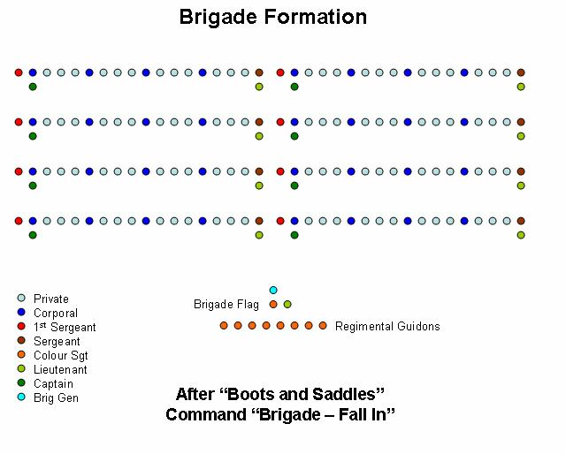
Bring the men to “Attention”
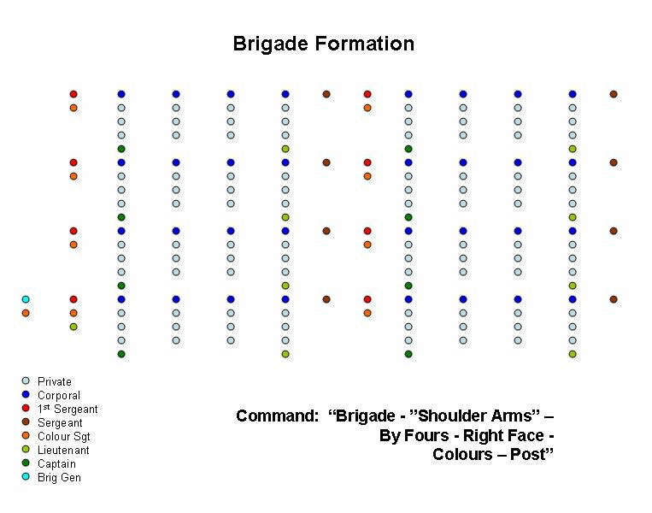

The regiments in sequence await their turn and march at a quarter turn to their place in line.

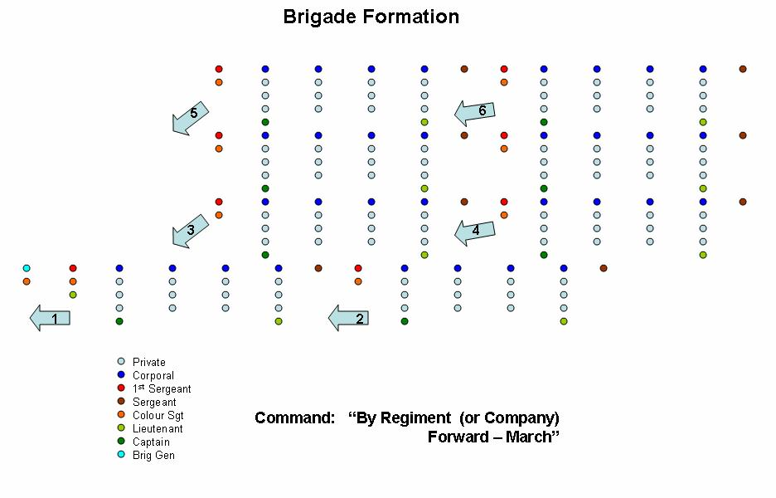
Using the same principles of Company Drill, exercise the Brigade in the following:
By Regiment (or Company) - Forward March
Forming into three wings on the Field
Advancing the colours
The charge
Wheelings
Abouts
Right, left, front onto skirmish lines
Close order firings

Then, all of the below:

Lesson First
ARTICLE I. - Parade the Brigade. Putting the Brigade through all marching orders.

ARTICLE II. – Close Order Firing - Different firings faced by the front rank, and faced by the rear rank.
By Company - odds / evens
By Wing
By Brigade
By Files
By Rank

Lesson Second – Columns
ARTICLE I. - Wheel by company to the right into column, or to the left, “By company, right (left) wheel”
ARTICLE II. - March in column. Change of direction. “Head of Column to the right (left)”. March by column in retreat “Right about”.
ARTICLE III. - Halt the column. Form it to the left or right into line of battle. “Left (right) into line - wheel”. Execute this formation, the column marching.

Lesson Third
ARTICLE I. - Break by company to the rear by the right or left, the brigade being at a halt, or marching.
ARTICLE II. -March in the route step. Cause to be executed, at this gait and in double quick time, the diverse movements incident to the column in route, and cause the cadenced step to be resumed.
ARTICLE III. - Form the column forward into line of battle. Form the column forward into line, and continue the march in this order.
ARTICLE IV. - Form the column on the right (“on the right, into line”), or the left, into line of battle.
ARTICLE V. - March by the flank and form companies into line, marching.
ARTICLE VI. - Change front forward, or in rear, on the right or left of companies, in directions perpendicular or oblique.
ARTICLE VII. - March by the right flank, or by the left flank. Change direction by file. Form the brigade into line of battle, on the right or left by file. “On the right, by file into line.”

Lesson Fourth - Division Drill for Individual Companies
ARTICLE I. - Break by division to the rear, by the right or left, the battalion being at a halt or marching.
ARTICLE II. - March in column by division. Diminish and increase front by company. This is the oblique method, which will cause the distance between companies to be full wheeling distance.
ARTICLE III - Close the column in mass on the headmost or rearmost division.
ARTICLE IV. - Take distances by the head.
ARTICLE V. - The column being by company, form divisions from a halt, or in march.
ARTICLE VI. - The column being by division, to form it to the left or right into line of battle at a halt, or in march. This is the closed in mass method caused by facing to a flank instead of moving at the oblique.
Lesson Fifth - Drill by Wings
ARTICLE I. - The brigade being in line of battle, and at a halt to deploy it by wings into column closed in mass on the right wing or on the left wing or on an interior wing, the right or left in front, deploy the brigade marching in line of battle on the right or left wing.
ARTICLE II. - Execute the countermarch.
ARTICLE III. - Change direction to the right, to the left, by the flank of the column.
ARTICLE IV. - Deploy the column on the right division, on the left division, or on any interior division, the column being at a halt, or marching.
ARTICLE V. - Ploy the brigade by company, closed in mass, and form it on the right or left into line of battle.
ARTICLE VII. - Ploy the brigade into double column closed in mass, the brigade being at a halt, or marching.
ARTICLE VIII. - March in this order, and change direction.
ARTICLE IX. - Deploy the column at a halt, or marching, and without suspending the march.
Lesson Sixth
ARTICLE I. - March in line of battle. Halt the brigade, and align it. “Guides on the Line”
ARTICLE II. - Change direction in line of battle, advancing, or in retreat (the dreaded brigade wheel). Execute passage of obstacles.
ARTICLE III. - Oblique march in line of battle.

ARTICLE IV. - Disperse and rally the brigade in line of battle.

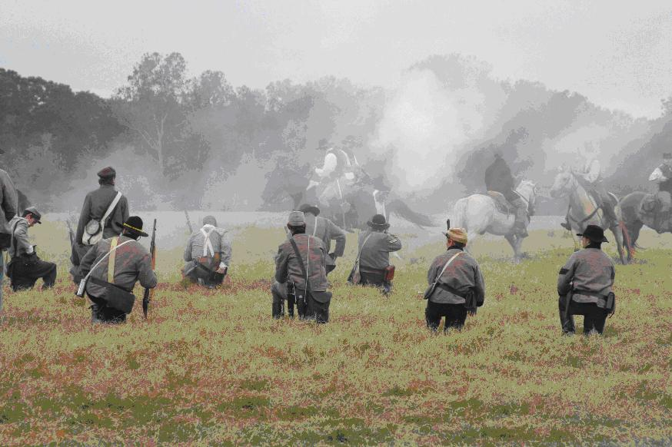

The Charge
Background: This maneuver is based on research conducted by Matt Springer in his seminal PhD thesis “With Zeal and Bayonets Only,” soon to be released by Oklahoma University Press as a book. It is based on his statements on the type of bayonet attacks delivered by British troops throughout the war, but especially by the Army of Canada (Carleton and Burgoyne’s Army.) I have assembled the actual drill from a number of sources in the interest of making the maneuver as SAFE as possible while presenting to the public the kind of attack that British and Loyalist soldiers ACTUALLY delivered, vice the ponderous and slow bayonet attacks we often see. I recommend that every officer and man read Springer to understand how thoroughly the British Army in America disdained any SLOW maneuver. They were always willing to trade good order for speed, a decision that horrified the drillmasters at home.

The basis for the maneuver comes from the “Volley and Charge” of the 1778 manual. The 1778 manual was never employed in America, but there is good reason to believe that it reflected the practice of America in its composition. In addition, the “Port Arms” or “Carry Your Firelocks” position of arms comes from Townshend’s Instructions as well as Instructions for the Volunteer Exercise (1792) which contains the following important quote,

“At one motion throw the musket from the shoulder across the body, to a low diagonal recover, a position known of old in many regiments by the name of porting arms or preparing to charge, in which the lock is turned to the front, and at the height of the breast, the muzzle slanting upwards, so that the barrel may cross opposite the point of the left shoulder, with the butt proportionally depressed, the right hand grasps the small of the butt [the wrist], and the left holds the piece at the swell, close to the lower band, the thumbs of both hands pointing towards the muzzle.”

The Maneuver:
Assume the Brigade is drawn up in two ranks at loose or open order with ranks closed and officers in the ranks. At no point is any officer to depart from the ranks, nor are the men to cheer in any way.

The Brigadier will order, “Prepare to Charge!” and will pace himself at the head of the Brigade, with the colors. At this command, officers will assure themselves that their men are loaded, and all soldiers will come to the “Carry” or “Port” position.

The Brigadier will order, “At the double, march!” The Brigade will set off at the double, with the drums sounding the time, and the best possible dress and order being kept. The Brigadier will lead the brigade to the closest SAFE distance from the enemy—at the Brigade level, this distance will be about thirty yards. (NB—in small units, 30 yards seems very far, but when you have 100+ under your command, an optical illusion occurs and it will seem very close! Commanding officers must practice observing this distance!) At thirty yards, the Brigadier will order “Halt! Make ready!” He should pause long enough to make sure that late arrivals and men breathing hard are not going to spoil his volley (I give a long three count). “Present!” and “Fire!”

• The whole Brigade fires a single volley.
• The Brigadier orders, “Prepare to charge!” and the men return to the ready.
• The Brigadier orders, “Charge!” and the men charge—full out, as fast as they can move, with the following requirements:
1. No man to pass the Brigadier. The Brigadier is responsible for safety, and thus, he will always be the lead man in the attack.
2. No man to come within five yards of a soldier on the opposing side. Five yards is a good long way—roughly four musket lengths. Don’t screw it up.
3. The men are to charge silently, and halt automatically in achieving the ground originally occupied by the retreating enemy, or at the order of the commander.
This maneuver requires that either the cooperation of the enemy has been won, so that they know what is coming and “break” at the moment the volley is fired, or ABSOLUTE control of your men, so that if the enemy is not broken, the charge can be halted.

Retreating by Alternate Ranks (as found in Scott's Manual)

ARTICLE I. - The retreat by alternate, or odd and even companies, will be executed as follows:
The general, intending to execute the retreat by alternate companies, will give information of his purpose to the two next officers in rank, who are respectively to command the lines of odd and even companies, and at the same time indicate to the one who is to commence the movement the position in which he will halt his line. The general will then command:

1. Retreat by alternate companies. 2. Odd (or even) companies, commence the movement.

These commands having been repeated, the officer entitled to command the line of odd companies, and which line it is supposed ought to commence the movement, will command:

1. Odd companies, face to the rear.
This having also been repeated, the captains of the designated companies will cause them to face about.

The commander of the odd companies will then add:
1. The (—) the company of direction.
2. Companies, forward 4. Quick—MARCH.
At the command march, briskly repeated by the captains of the odd companies, these companies will commence the march, and direct themselves perpendicularly to the rear. The captains of the subordinate companies will maintain them abreast with the directing one in conformity with what is prescribed, when the line arrives at the position indicated by the brigadier general, the commander of this line will command:

1. Companies. 2. HALT.

At the second command, the line will halt, each captain will immediately face his company about, the commander of the line will rectify the alignment of the directing company, the other companies will be dressed by that, without constraint, however, as to being absolutely on the same general alignment.
As soon as the odd companies, which form the second line, have faced about, the commander of the first line (of even companies) will command:
1. Face to the rear.
This will be executed as prescribed, the commander of this line will then command:

2. The (—) the company of direction. 3. Companies forward. 4. Quick—MARCH.
The first line will march in retreat by the means prescribed, each company will be directed upon the middle of the corresponding interval in the second line, cross this line, and march perpendicularly to the rear. When it arrives at the position indicated by the Brigadier general, the first line will be halted and faced about, by the commands and means indicated.
The second line, become first, will execute the same movement, and so on alternately.
The Brigadier will superintend both lines, and determine, according to the ground and the distance he may wish to have between the lines, the position each ought successively to occupy.

To re-form the line.
The Brigadier, wishing to re--form the line, will cause the drums to beat a short roll after the first line (the one actually in front) is put in march, which roll will be briskly repeated by all the drums of this line.
The companies of the first line will continue to march, and when they find themselves exactly in their intervals of the second, their respective captains will halt them, face them about and rectify their alignment: the Brigadier will then give a general alignment if he judge it necessary.

Remarks on the retreat by alternate companies
The commander of each line will endeavour to maintain the necessary harmony between its companies, notwithstanding the intervals between them; to this end, he will look to the strict execution of what is prescribed.

He will more particularly see that all the companies, after crossing the second line, direct themselves perpendicularly to the rear, this being the only means by which the intervals can be preserved with sufficient accuracy to enable the two lines to re-form into one.

Remarks on the School of the Brigade (by Wm. Hardee)
In every course of instruction, the first lesson will be executed several times in the order in which it is arranged; but as soon as the brigade shall be confirmed in the principles of the lesson, the fires will be executed after the advance in line, and after the various formations. Into line of battle, and into square. Particular attention will be given to the fire by file, which is that principally used in war.

Every lesson of this school will be executed with the utmost precision; but the second, which comprehends the march in column, and the march in line of battle, being of the most importance, will be the oftenest repeated, especially in the beginning. Great attention ought, also, to be given to the fourth lesson, which comprehends the march in column by division, and the dispositions against cavalry.

The successive formations will sometimes be executed by inversion. In the beginning, the march in column, the march in line of battle, and the march by the flank, will be executed only in quick time, and will be continued until the battalion shall have become well established in the cadence of this step. The non-cadenced step will be employed in this school only in the repetition of the movements incident to a column in route, or when great celerity may be required. When it may be desired to give the men relief, arms may be supported, if at a halt, or marching by the flank. In marching by the front, arms may be shifted to the right shoulder; but not in the march in line of battle until the brigade shall be well instructed. After arms have been carried for some time on the right shoulder, they may be shifted, in like manner, to the left shoulder.

When a battalion is maneuvering, skirmishers will cover all movements. All the companies will be exercised, successively, in this service.

Dress Parade
“There shall be daily one dress parade, at Troop or Retreat, as the commanding officer may direct. A dress parade once a day will not be dispensed with, except on extraordinary and urgent occasions.”

- Refer to the beginning of this chapter to view Brigade Formation. From this formation, the Brigade will be marched to the Battalion Dress Parade and reform.
~~~~~~~~~~~~~~~~~~~~~~~~~~~~~~~~~~~~~~~~~~
A signal will be beat or sounded half an hour before troop or retreat, for the music to assemble on the regimental parade, and each company to turn out under arms on its own parade, for roll-call and inspection by its own officers.

Ten minutes after that signal, the Adjutant's call will be given, when the Captains will march their companies (the band playing) to the regimental parade, where they take their positions in the order of battle. When the line is formed, the Captain of the first company, on notice from the Adjutant, steps one pace to the front, and gives to his company the command, "Order-ARMS! Parade-REST!" which is repeated by each Captain in succession to the left.

The Adjutant takes post two paces on the right of the line; the Sergeant major two paces on the left. The music will be formed in two ranks on the right of the Adjutant. The senior officer present will take the command of the parade, and will take post at a suitable distance in front, opposite the centre, facing the line.

When the companies have ordered arms, the Adjutant will order the music to beat o, when it will commence on the right, beat in front of the line to the left, and back to its place on the right.

When the music has ceased, the Adjutant will step two paces to the front, face to the left, and command,
1. Attention! 2. Battalion. 3. Shoulder-ARMS! 4. Prepare to open ranks! 5. To the rear, open order! 6. MARCH!

Note: In Brigade order, the Dismounted Cav is already in open ranks and does not need to “open”. Maintain attention while the infantry executes this maneuver. At the sixth command of “March” the officers will complete the following, doing so as the Infantry officers move forward:

At the sixth command, the ranks will be opened according to the system laid down in the Infantry Tactics, the commissioned officers marching to the front, the company officers four paces, field officers six paces, opposite to their positions in the order of battle, where they will halt and dress.

The Adjutant, seeing the ranks aligned, will command, FRONT! and march along the front to the centre, face to the right, and pass the line of company officers eight or ten paces, where he will come to the right-about, and command, Present-ARMS! when arms will be presented, officers saluting.

Seeing this executed, he will face about to the commanding officer, salute, and report, "Sir, the parade is formed." The Adjutant will then, on intimation to that effect, take his station three paces on the left of the commanding officer, one pace retired, passing round his rear.

The commanding officer, having acknowledged the salute of the line by touching his hat, will, after the Adjutant has taken his post draw his sword, and command,
1. Battalion. 2. Shoulder-ARMS! and add such exercises as he may think proper, concluding with Order-ARMS! then return his sword, and direct the Adjutant to receive the reports.

The Adjutant will now pass round the right of the commanding officer, advance upon the line, halt midway between him and the line of company officers, and command,
1. First Sergeants, to the front and centre. 2. MARCH!

At the first command, they will shoulder arms as Sergeants, march two paces to the front, and face inward. At the second command, they will march to the centre, and halt. The Adjutant will then order,

1. Front-FACE. 2. Report.

At the last word, each in succession, beginning on the right, will salute by bringing the left hand smartly across the breast to the right shoulder, and report the result of the roll-call previously made on the company (Brigade) parade (Formation).

The Adjutant again commands,
1. First Sergeants, outward-FACE! 2. To your posts-MARCH!

when they will resume their places, and order arms. The Adjutant will now face to the commanding officer, salute, report absent officers, and give the result of the First Sergeants' reports. The commanding officer will next direct the orders to be read, when the Adjutant will face about and announce,
Attention to Orders.
He will then read the orders.

The orders having been read, the Adjutant will face to the commanding officer, salute, and report; when, on an intimation from the commander, he will face again to the line, and announce,
Parade is dismissed.

All the officers will now return their swords, face inward, and close on the Adjutant, he having taken position in their line, the field officers on the flanks. The Adjutant commands,
1. Front-FACE! 2. Forward-MARCH!

when they will march forward, dressing on the centre, the music playing, and when within six paces of the commander, the Adjutant will give the word,
Halt!

The officers will then salute the commanding officer by raising the hand to the cap, and there remain until he shall have communicated to them such instructions as he may have to give, or intimates that the ceremony is finished. As the officers disperse, the First Sergeants will close the ranks of their respective companies, and march them to the company parades, where they will be dismissed, the band continuing to play until the companies clear the regimental parade.

All field and company officers and men will be present at dress parades, unless especially excused, or on some duty incompatible with such attendance.

This page intentionally left blank.

